**Card View**

**Introduction of Card View**

Example 1 :

***Step :- 1 Add Volley Dependency in build.gradle ( Module:app ) file.***

apply plugin: 'com.android.application'  
android {  
 compileSdkVersion 28  
 defaultConfig {  
 applicationId "card.view.com"  
 minSdkVersion 21  
 targetSdkVersion 28  
 versionCode 1  
 versionName "1.0"  
 testInstrumentationRunner "android.support.test.runner.AndroidJUnitRunner"  
 }  
 buildTypes {  
 release {  
 minifyEnabled false  
 proguardFiles getDefaultProguardFile('proguard-android-optimize.txt'), 'proguard-rules.pro'  
 }  
 }  
}  
  
dependencies {  
 implementation fileTree(dir: 'libs', include: ['*.jar'])  
 implementation 'com.android.support:appcompat-v7:28.0.0'  
 implementation 'com.android.support.constraint:constraint-layout:1.1.3'  
 testImplementation 'junit:junit:4.12'  
 androidTestImplementation 'com.android.support.test:runner:1.0.2'  
 androidTestImplementation 'com.android.support.test.espresso:espresso-core:3.0.2'  
  
 implementation 'com.android.support:design:28.0.0'  
 implementation 'com.android.support:cardview-v7:28.0.0'  
}

***Step :- 2 card_view_design.xml file.***

*<?*xml version="1.0" encoding="utf-8"*?>*<android.support.v7.widget.CardView  
 xmlns:android="http://schemas.android.com/apk/res/android"  
 style="@style/CardView.Light"  
 android:layout_width="match_parent"  
 android:layout_height="wrap_content"  
 android:layout_marginTop="8dp"  
 android:layout_marginStart="8dp"  
 android:layout_marginEnd="8dp">  
  
 <LinearLayout  
 android:layout_width="wrap_content"  
 android:layout_height="wrap_content"  
 android:layout_gravity="center_horizontal|center_vertical"  
 android:layout_margin="5dp"  
 android:gravity="center"  
 android:orientation="vertical">  
  
 <ImageView  
 android:id="@+id/imageView"  
 android:layout_width="wrap_content"  
 android:layout_height="wrap_content"  
 android:layout_gravity="center_horizontal"  
 android:background="@drawable/ic_profile"/>  
  
 <TextView  
 android:id="@+id/textView"  
 android:layout_width="wrap_content"  
 android:layout_height="wrap_content"  
 android:gravity="center_horizontal"  
 android:text="Personal Data"  
 android:layout_marginTop="8dp"  
 android:textColor="#3f3f3f"  
 android:textSize="14sp"  
 android:textStyle="bold"/>  
 </LinearLayout>  
</android.support.v7.widget.CardView>

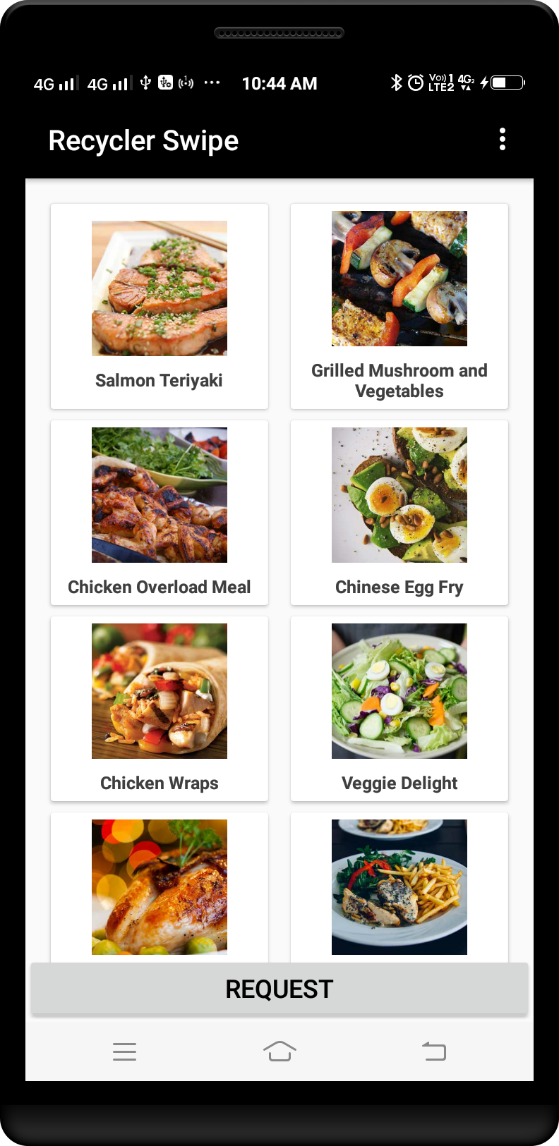

Example 2 :

***Step :- 1 Add Volley Dependency in build.gradle ( Module:app ) file.***

apply plugin: 'com.android.application'  
android {  
 compileSdkVersion 28  
 defaultConfig {  
 applicationId "card.view.com"  
 minSdkVersion 21  
 targetSdkVersion 28  
 versionCode 1  
 versionName "1.0"  
 testInstrumentationRunner "android.support.test.runner.AndroidJUnitRunner"  
 }  
 buildTypes {  
 release {  
 minifyEnabled false  
 proguardFiles getDefaultProguardFile('proguard-android-optimize.txt'), 'proguard-rules.pro'  
 }  
 }  
}  
  
dependencies {  
 implementation fileTree(dir: 'libs', include: ['*.jar'])  
 implementation 'com.android.support:appcompat-v7:28.0.0'  
 implementation 'com.android.support.constraint:constraint-layout:1.1.3'  
 testImplementation 'junit:junit:4.12'  
 androidTestImplementation 'com.android.support.test:runner:1.0.2'  
 androidTestImplementation 'com.android.support.test.espresso:espresso-core:3.0.2'  
  
 implementation 'com.android.support:design:28.0.0'  
 implementation 'com.android.support:cardview-v7:28.0.0'  
}

***Step :- 2 card_view_design.xml file.***

*<?*xml version="1.0" encoding="utf-8"*?>*<android.support.v7.widget.CardView  
 xmlns:android="http://schemas.android.com/apk/res/android"  
 xmlns:card_view="http://schemas.android.com/apk/res-auto"  
 android:id="@+id/cardlist_item"  
 android:orientation="vertical"  
 android:layout_width="match_parent"  
 android:layout_height="wrap_content"  
 android:layout_marginBottom="10dp"  
 android:layout_marginLeft="10dp"  
 android:layout_marginRight="10dp"  
 android:layout_marginTop="10dp"  
 card_view:cardCornerRadius="8dp"  
 android:foreground="?android:attr/selectableItemBackground"  
 card_view:cardBackgroundColor="@android:color/white"  
 card_view:cardElevation="@dimen/cardview_default_elevation">  
  
 <LinearLayout  
 android:id="@+id/top_view"  
 android:layout_width="fill_parent"  
 android:layout_height="wrap_content"  
 android:padding="5dp"  
 android:layout_gravity="center_vertical"  
 android:background="@android:color/white"  
 android:orientation="horizontal">  
  
 <ImageView  
 android:id="@+id/item_image"  
 android:layout_width="80dp"  
 android:layout_height="80dp"  
 android:layout_gravity="center_vertical"  
 android:layout_marginStart="5dp"  
 android:gravity="center_vertical"  
 android:scaleType="fitXY"  
 android:src="#BEBEBE"/>  
  
 <RelativeLayout  
 android:id="@+id/top_icon_detail"  
 android:layout_width="wrap_content"  
 android:layout_height="100dp"  
 android:layout_gravity="center_vertical"  
 android:layout_marginStart="5dp"  
 android:orientation="vertical">  
  
 <TextView  
 android:id="@+id/item_name"  
 android:layout_width="match_parent"  
 android:layout_height="wrap_content"  
 android:layout_marginStart="5dp"  
 android:layout_marginTop="5dp"  
 android:ellipsize="marquee"  
 android:focusable="false"  
 android:freezesText="true"  
 android:marqueeRepeatLimit="marquee_forever"  
 android:scrollHorizontally="true"  
 android:singleLine="true"  
 android:text="Item Name"  
 android:textColor="@android:color/background_dark"  
 android:textSize="15sp" />  
  
 <TextView  
 android:id="@+id/item_short_description"  
 android:layout_width="wrap_content"  
 android:layout_height="wrap_content"  
 android:layout_below="@+id/item_name"  
 android:layout_marginStart="5dp"  
 android:layout_marginTop="5dp"  
 android:ellipsize="marquee"  
 android:focusable="false"  
 android:freezesText="true"  
 android:marqueeRepeatLimit="marquee_forever"  
 android:scrollHorizontally="true"  
 android:singleLine="true"  
 android:text="Item description"  
 android:textColor="@android:color/darker_gray"  
 android:textSize="15sp" />  
  
 <TextView  
 android:id="@+id/item_available"  
 android:layout_width="wrap_content"  
 android:layout_height="wrap_content"  
 android:layout_alignBaseline="@+id/item_short_description"  
 android:layout_alignBottom="@+id/item_short_description"  
 android:layout_alignParentEnd="true"  
 android:layout_marginStart="5dp"  
 android:layout_marginEnd="5dp"  
 android:ellipsize="marquee"  
 android:focusable="false"  
 android:freezesText="true"  
 android:marqueeRepeatLimit="marquee_forever"  
 android:scrollHorizontally="true"  
 android:singleLine="true"  
 android:text="Available"  
 android:textColor="#ff669900"  
 android:textSize="15sp"  
 android:visibility="visible" />  
  
 <TextView  
 android:id="@+id/item_price"  
 android:layout_width="wrap_content"  
 android:layout_height="wrap_content"  
 android:layout_alignParentBottom="true"  
 android:layout_marginStart="5dp"  
 android:layout_marginEnd="5dp"  
 android:layout_marginBottom="10dp"  
 android:ellipsize="marquee"  
 android:focusable="true"  
 android:focusableInTouchMode="true"  
 android:freezesText="true"  
 android:marqueeRepeatLimit="marquee_forever"  
 android:scrollHorizontally="true"  
 android:singleLine="true"  
 android:text="Rs 20"  
 android:textColor="@android:color/background_dark"  
 android:textSize="15sp"  
 android:textStyle="normal" />  
  
 <TextView  
 android:id="@+id/decrease_item"  
 android:layout_width="35dp"  
 android:layout_height="35dp"  
 android:layout_alignParentBottom="true"  
 android:layout_gravity="center_vertical|center_horizontal"  
 android:layout_marginEnd="10dp"  
 android:layout_marginBottom="10dp"  
 android:layout_toStartOf="@+id/number_of_item"  
 android:background="@drawable/decrease_item_qty_text_view_circle_button"  
 android:gravity="center_vertical|center_horizontal"  
 android:text="-"  
 android:textColor="#FF0000"  
 android:textSize="20sp"  
 android:textStyle="bold" />  
  
 <TextView  
 android:id="@+id/number_of_item"  
 android:layout_width="wrap_content"  
 android:layout_height="wrap_content"  
 android:layout_alignParentBottom="true"  
 android:layout_gravity="center_vertical|center_horizontal"  
 android:layout_marginStart="5dp"  
 android:layout_marginEnd="10dp"  
 android:layout_marginBottom="15dp"  
 android:layout_toStartOf="@+id/increase_item"  
 android:ellipsize="marquee"  
 android:focusable="true"  
 android:focusableInTouchMode="true"  
 android:freezesText="true"  
 android:marqueeRepeatLimit="marquee_forever"  
 android:scrollHorizontally="true"  
 android:singleLine="true"  
 android:text="0"  
 android:textColor="@android:color/background_dark"  
 android:textSize="20sp" />  
  
 <TextView  
 android:id="@+id/increase_item"  
 android:layout_width="35dp"  
 android:layout_height="35dp"  
 android:layout_alignParentBottom="true"  
 android:layout_alignParentEnd="true"  
 android:layout_gravity="center_vertical|center_horizontal"  
 android:layout_marginBottom="10dp"  
 android:background="@drawable/increase_item_qty_text_view_circle_button"  
 android:gravity="center_vertical|center_horizontal"  
 android:text="+"  
 android:textColor="#03A14D"  
 android:textSize="20sp"  
 android:textStyle="bold" />  
 </RelativeLayout>  
 </LinearLayout>  
</android.support.v7.widget.CardView>

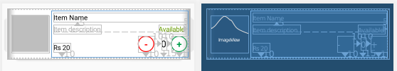

***Step :- 3 increase_item_qty_text_view_circle_button.xml file.***

*<?*xml version="1.0" encoding="utf-8"*?>*<shape xmlns:android="http://schemas.android.com/apk/res/android"  
 android:shape="oval">  
 <corners android:radius="10dip"/>  
 <stroke  
 android:width="2dip"  
 android:color="#03A14D"/>  
 <solid android:color="#FFFFFF"/>  
</shape>

***Step :- 4 decrease_item_qty_text_view_circle_button.xml file.***

*<?*xml version="1.0" encoding="utf-8"*?>*<shape xmlns:android="http://schemas.android.com/apk/res/android"  
 android:shape="oval">  
 <corners android:radius="10dip" />  
 <stroke  
 android:width="2dip"  
 android:color="#FF0000" />  
 <solid android:color="#FFFFFF" />  
</shape>

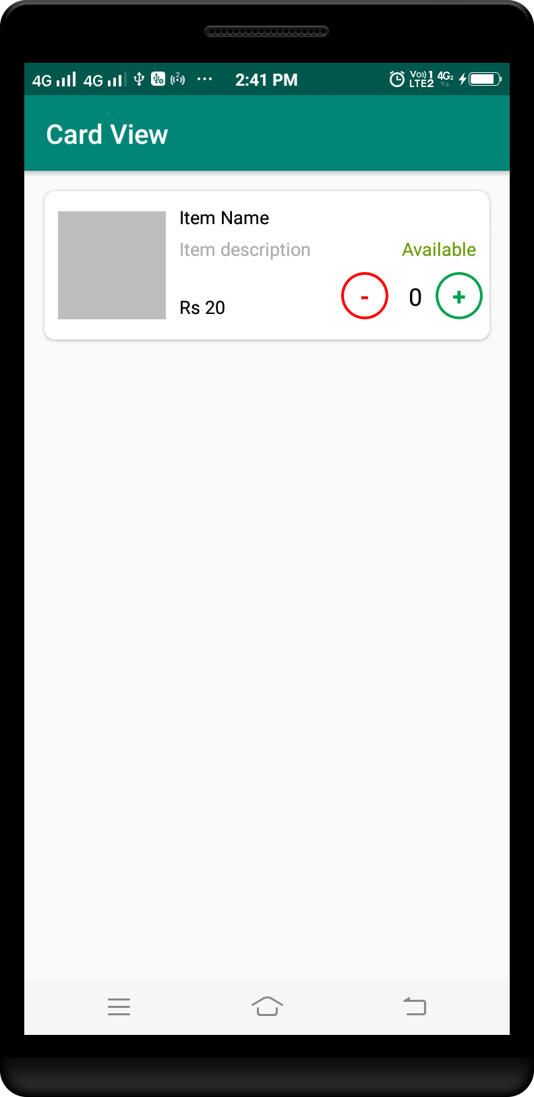

Example 3 :

***Step :- 1 Add Volley Dependency in build.gradle ( Module:app ) file.***

apply plugin: 'com.android.application'  
android {  
 compileSdkVersion 28  
 defaultConfig {  
 applicationId "card.view.com"  
 minSdkVersion 21  
 targetSdkVersion 28  
 versionCode 1  
 versionName "1.0"  
 testInstrumentationRunner "android.support.test.runner.AndroidJUnitRunner"  
 }  
 buildTypes {  
 release {  
 minifyEnabled false  
 proguardFiles getDefaultProguardFile('proguard-android-optimize.txt'), 'proguard-rules.pro'  
 }  
 }  
}  
  
dependencies {  
 implementation fileTree(dir: 'libs', include: ['*.jar'])  
 implementation 'com.android.support:appcompat-v7:28.0.0'  
 implementation 'com.android.support.constraint:constraint-layout:1.1.3'  
 testImplementation 'junit:junit:4.12'  
 androidTestImplementation 'com.android.support.test:runner:1.0.2'  
 androidTestImplementation 'com.android.support.test.espresso:espresso-core:3.0.2'  
  
 implementation 'com.android.support:design:28.0.0'  
 implementation 'com.android.support:cardview-v7:28.0.0'  
}

***ic_favorite_border_black_24dp.xml***

<vector xmlns:android="http://schemas.android.com/apk/res/android"  
 android:width="24dp"  
 android:height="24dp"  
 android:viewportWidth="24.0"  
 android:viewportHeight="24.0">  
 <path  
 android:fillColor="#FF000000"  
 android:pathData="M16.5,3c-1.74,0 -3.41,0.81 -4.5,2.09C10.91,3.81 9.24,3 7.5,3 4.42,3 2,5.42 2,8.5c0,3.78 3.4,6.86 8.55,11.54L12,21.35l1.45,-1.32C18.6,15.36 22,12.28 22,8.5 22,5.42 19.58,3 16.5,3zM12.1,18.55l-0.1,0.1 -0.1,-0.1C7.14,14.24 4,11.39 4,8.5 4,6.5 5.5,5 7.5,5c1.54,0 3.04,0.99 3.57,2.36h1.87C13.46,5.99 14.96,5 16.5,5c2,0 3.5,1.5 3.5,3.5 0,2.89 -3.14,5.74 -7.9,10.05z"/>  
</vector>

***Step :- 2 card_view_design.xml file.***

*<?*xml version="1.0" encoding="utf-8"*?>*<android.support.v7.widget.CardView xmlns:android="http://schemas.android.com/apk/res/android"  
 xmlns:card_view="http://schemas.android.com/apk/res-auto"  
 xmlns:app="http://schemas.android.com/apk/res-auto"  
 android:id="@+id/cardview"  
 android:layout_width="match_parent"  
 android:layout_height="wrap_content"  
 app:cardBackgroundColor="#A5A5A5"  
 app:contentPadding="1dp"  
 card_view:cardElevation="0dp"  
 card_view:cardCornerRadius="2dp">  
  
 <LinearLayout  
 android:id="@+id/layout_item"  
 android:layout_width="match_parent"  
 android:layout_height="wrap_content"  
 android:orientation="vertical"  
 android:background="#FFFFFF">  
  
 <ImageView  
 android:id="@+id/image1"  
 android:layout_width="match_parent"  
 android:layout_height="300dp"  
 android:src="@drawable/items"  
 android:scaleType="fitXY"/>  
  
 <LinearLayout android:id="@+id/layout_item_desc"  
 android:layout_width="match_parent"  
 android:layout_height="wrap_content"  
 android:orientation="horizontal"  
 android:padding="4dp"  
 android:weightSum="2">  
  
 <LinearLayout  
 android:layout_width="0dp"  
 android:layout_height="wrap_content"  
 android:orientation="vertical"  
 android:layout_weight="1.8">  
  
 <TextView  
 android:layout_width="wrap_content"  
 android:layout_height="wrap_content"  
 android:text="Tshirt"  
 android:textSize="10dp"  
 android:textStyle="bold"/>  
  
 <TextView  
 android:layout_width="wrap_content"  
 android:layout_height="wrap_content"  
 android:text="Light Weight"  
 android:textSize="10dp"/>  
  
 <TextView  
 android:layout_width="wrap_content"  
 android:layout_height="wrap_content"  
 android:text="Rs. 8,999"  
 android:textSize="12dp"  
 android:textColor="#4CAF50"/>  
 </LinearLayout>  
  
 <ImageView  
 android:id="@+id/ic_favorite"  
 android:layout_width="wrap_content"  
 android:layout_height="wrap_content"  
 android:layout_weight="0.3"  
 android:layout_gravity="center_vertical"  
 android:src="@drawable/ic_favorite_border_black_24dp"/>  
 </LinearLayout>  
 </LinearLayout>  
</android.support.v7.widget.CardView>

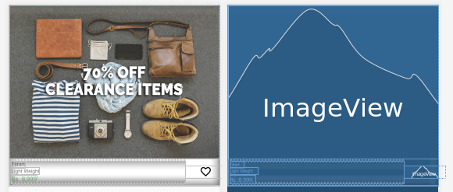

***Step :- 3 activity_main.xml file.***

*<?*xml version="1.0" encoding="utf-8"*?>*<LinearLayout  
 xmlns:android="http://schemas.android.com/apk/res/android"  
 xmlns:card_view="http://schemas.android.com/apk/res-auto"  
 android:id="@+id/layout_item"  
 android:layout_width="match_parent"  
 android:layout_height="wrap_content"  
 android:layout_margin="20dp"  
 android:orientation="vertical">  
  
 *<!-- Load the card view here -->* <include  
 layout="@layout/card_view_design"  
 android:layout_width="match_parent"  
 android:layout_height="wrap_content"/>  
  
 *<!-- Load the card view here -->* <include  
 layout="@layout/card_view_design"  
 android:layout_marginTop="10dp"  
 android:layout_width="match_parent"  
 android:layout_height="wrap_content"/>  
</LinearLayout>

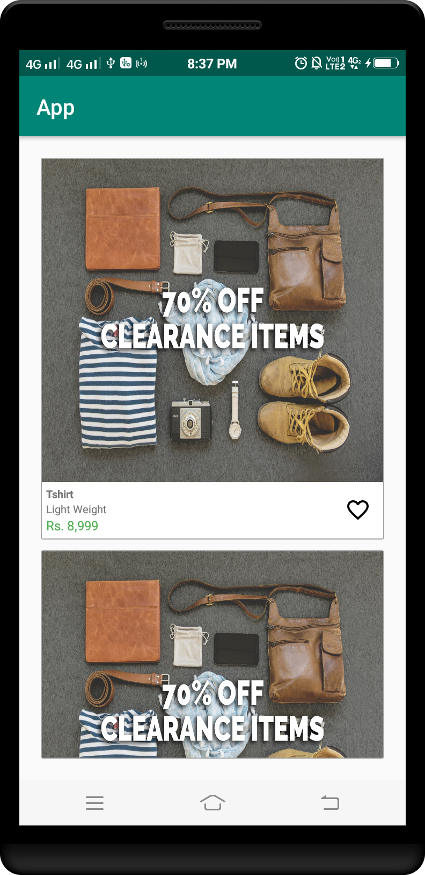

Example 4 :

***Step :- 1 Add Volley Dependency in build.gradle ( Module:app ) file.***

apply plugin: 'com.android.application'  
android {  
 compileSdkVersion 28  
 defaultConfig {  
 applicationId "card.view.com"  
 minSdkVersion 21  
 targetSdkVersion 28  
 versionCode 1  
 versionName "1.0"  
 testInstrumentationRunner "android.support.test.runner.AndroidJUnitRunner"  
 }  
 buildTypes {  
 release {  
 minifyEnabled false  
 proguardFiles getDefaultProguardFile('proguard-android-optimize.txt'), 'proguard-rules.pro'  
 }  
 }  
}  
  
dependencies {  
 implementation fileTree(dir: 'libs', include: ['*.jar'])  
 implementation 'com.android.support:appcompat-v7:28.0.0'  
 implementation 'com.android.support.constraint:constraint-layout:1.1.3'  
 testImplementation 'junit:junit:4.12'  
 androidTestImplementation 'com.android.support.test:runner:1.0.2'  
 androidTestImplementation 'com.android.support.test.espresso:espresso-core:3.0.2'  
  
 implementation 'com.android.support:design:28.0.0'  
 implementation 'com.android.support:cardview-v7:28.0.0'  
}

***Step :- 2 card_view_border.xml file.***

*<?*xml version="1.0" encoding="UTF-8"*?>*<shape  
 xmlns:android="http://schemas.android.com/apk/res/android"  
 android:shape="rectangle">  
  
 <solid android:color="#ffffff"/>  
  
 <stroke  
 android:width="0.5dip"  
 android:color="#000EC7"/>  
  
 <corners android:radius="6dip"/>  
</shape>

***Step :- 3 card_view_design.xml file.***

*<?*xml version="1.0" encoding="utf-8"*?>*<android.support.v7.widget.CardView  
 xmlns:android="http://schemas.android.com/apk/res/android"  
 xmlns:card_view="http://schemas.android.com/apk/res-auto"  
 android:id="@+id/cardview"  
 android:layout_width="match_parent"  
 android:layout_height="wrap_content"  
 card_view:cardElevation="0dp"  
 card_view:cardCornerRadius="6dp">  
  
 <LinearLayout  
 android:id="@+id/layout_item"  
 android:layout_width="match_parent"  
 android:layout_height="wrap_content"  
 android:orientation="vertical"  
 android:background="@drawable/card_view_border">  
  
 <ImageView  
 android:id="@+id/image1"  
 android:layout_width="match_parent"  
 android:layout_height="300dp"  
 android:src="@drawable/items"  
 android:scaleType="fitXY"/>  
  
 <LinearLayout android:id="@+id/layout_item_desc"  
 android:layout_width="match_parent"  
 android:layout_height="wrap_content"  
 android:orientation="horizontal"  
 android:padding="4dp"  
 android:weightSum="2">  
  
 <LinearLayout  
 android:layout_width="0dp"  
 android:layout_height="wrap_content"  
 android:orientation="vertical"  
 android:layout_weight="1.8">  
  
 <TextView  
 android:layout_width="wrap_content"  
 android:layout_height="wrap_content"  
 android:text="Tshirt"  
 android:textSize="10dp"  
 android:textStyle="bold"/>  
  
 <TextView  
 android:layout_width="wrap_content"  
 android:layout_height="wrap_content"  
 android:text="Light Weight"  
 android:textSize="10dp"/>  
  
 <TextView  
 android:layout_width="wrap_content"  
 android:layout_height="wrap_content"  
 android:text="Rs. 8,999"  
 android:textSize="12dp"  
 android:textColor="#4CAF50"/>  
 </LinearLayout>  
  
 <ImageView  
 android:id="@+id/ic_favorite"  
 android:layout_width="wrap_content"  
 android:layout_height="wrap_content"  
 android:layout_weight="0.3"  
 android:layout_gravity="center_vertical"  
 android:src="@drawable/ic_favorite_border_black_24dp"/>  
 </LinearLayout>  
 </LinearLayout>  
</android.support.v7.widget.CardView>

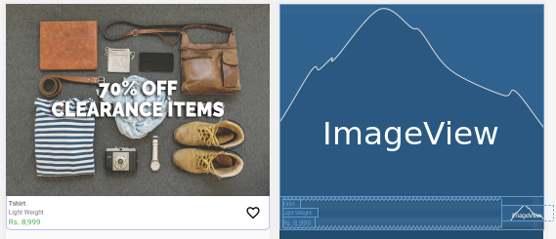

***Step :- 3 activity_main.xml file.***

*<?*xml version="1.0" encoding="utf-8"*?>*<LinearLayout  
 xmlns:android="http://schemas.android.com/apk/res/android"  
 xmlns:card_view="http://schemas.android.com/apk/res-auto"  
 android:id="@+id/layout_item"  
 android:layout_width="match_parent"  
 android:layout_height="wrap_content"  
 android:layout_margin="20dp"  
 android:orientation="vertical">  
  
 *<!-- Load the card view here -->* <include  
 layout="@layout/card_view_design"  
 android:layout_width="match_parent"  
 android:layout_height="wrap_content"/>  
  
 *<!-- Load the card view here -->* <include  
 layout="@layout/card_view_design"  
 android:layout_marginTop="10dp"  
 android:layout_width="match_parent"  
 android:layout_height="wrap_content"/>  
</LinearLayout>

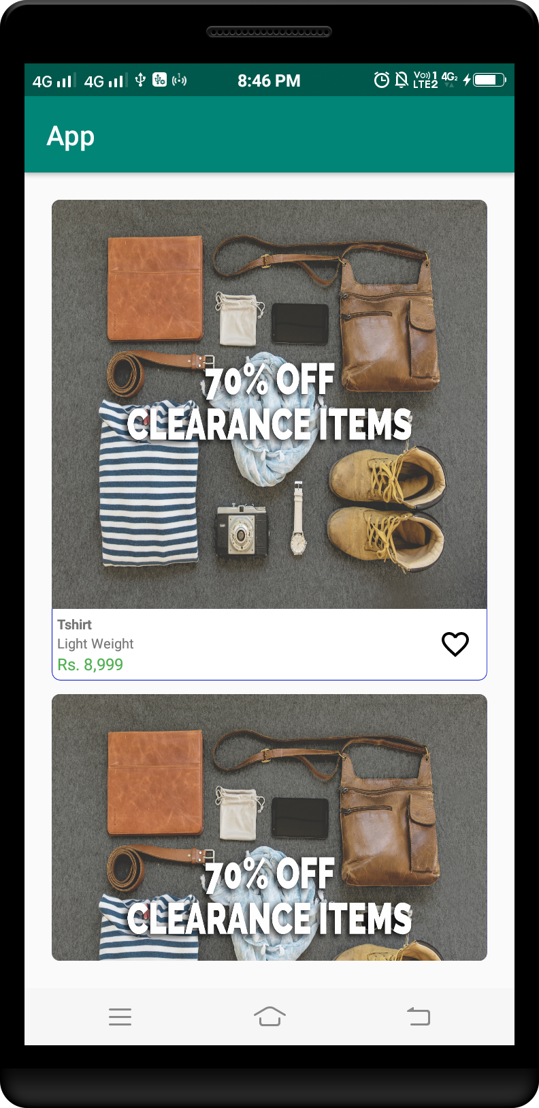

Example 5 :

***Step :- 1 Add Volley Dependency in build.gradle ( Module:app ) file.***

apply plugin: 'com.android.application'  
android {  
 compileSdkVersion 28  
 defaultConfig {  
 applicationId "card.view.com"  
 minSdkVersion 21  
 targetSdkVersion 28  
 versionCode 1  
 versionName "1.0"  
 testInstrumentationRunner "android.support.test.runner.AndroidJUnitRunner"  
 }  
 buildTypes {  
 release {  
 minifyEnabled false  
 proguardFiles getDefaultProguardFile('proguard-android-optimize.txt'), 'proguard-rules.pro'  
 }  
 }  
}  
  
dependencies {  
 implementation fileTree(dir: 'libs', include: ['*.jar'])  
 implementation 'com.android.support:appcompat-v7:28.0.0'  
 implementation 'com.android.support.constraint:constraint-layout:1.1.3'  
 testImplementation 'junit:junit:4.12'  
 androidTestImplementation 'com.android.support.test:runner:1.0.2'  
 androidTestImplementation 'com.android.support.test.espresso:espresso-core:3.0.2'  
  
 implementation 'com.android.support:design:28.0.0'  
 implementation 'com.android.support:cardview-v7:28.0.0'  
}

***ic_clear_black_24dp***

<vector xmlns:android="http://schemas.android.com/apk/res/android"  
 android:width="24dp"  
 android:height="24dp"  
 android:viewportWidth="24.0"  
 android:viewportHeight="24.0">  
 <path  
 android:fillColor="#FF000000"  
 android:pathData="M19,6.41L17.59,5 12,10.59 6.41,5 5,6.41 10.59,12 5,17.59 6.41,19 12,13.41 17.59,19 19,17.59 13.41,12z"/>  
</vector>

***ic_edit_black_24dp.xml***

<vector xmlns:android="http://schemas.android.com/apk/res/android"  
 android:width="24dp"  
 android:height="24dp"  
 android:viewportWidth="24.0"  
 android:viewportHeight="24.0">  
 <path  
 android:fillColor="#FF000000"  
 android:pathData="M3,17.25V21h3.75L17.81,9.94l-3.75,-3.75L3,17.25zM20.71,7.04c0.39,-0.39 0.39,-1.02 0,-1.41l-2.34,-2.34c-0.39,-0.39 -1.02,-0.39 -1.41,0l-1.83,1.83 3.75,3.75 1.83,-1.83z"/>  
</vector>

***Step :- 2 card_view_design.xml file.***

*<?*xml version="1.0" encoding="utf-8"*?>*<LinearLayout  
 xmlns:android="http://schemas.android.com/apk/res/android"  
 android:layout_width="match_parent"  
 android:layout_height="wrap_content"  
 android:orientation="vertical">  
  
 <LinearLayout  
 android:layout_width="match_parent"  
 android:layout_height="wrap_content"  
 android:orientation="horizontal"  
 android:weightSum="3">  
  
 <ImageView  
 android:id="@+id/item_image"  
 android:layout_width="0dp"  
 android:layout_height="fill_parent"  
 android:layout_weight="1"  
 android:layout_gravity="center_vertical"  
 android:scaleType="fitXY"  
 android:src="@drawable/items"/>  
  
 <LinearLayout  
 android:id="@+id/layout_item_desc"  
 android:layout_width="0dp"  
 android:layout_height="wrap_content"  
 android:orientation="vertical"  
 android:layout_weight="2"  
 android:layout_marginStart="5dp">  
  
 <TextView  
 android:layout_width="wrap_content"  
 android:layout_height="wrap_content"  
 android:text="Denim Shirt"  
 android:textSize="18dp"  
 android:textStyle="bold"/>  
  
 <TextView  
 android:layout_width="wrap_content"  
 android:layout_height="wrap_content"  
 android:text="Slim fit, cotton"  
 android:textSize="14dp"/>  
  
 <TextView  
 android:layout_width="wrap_content"  
 android:layout_height="wrap_content"  
 android:text="Delivery charge: FREE"  
 android:textSize="14dp"/>  
  
 <LinearLayout  
 android:layout_width="match_parent"  
 android:layout_height="wrap_content"  
 android:orientation="horizontal">  
  
 <TextView  
 android:layout_width="wrap_content"  
 android:layout_height="wrap_content"  
 android:text="Qty: 1"  
 android:textSize="14dp"/>  
  
 <TextView  
 android:layout_width="wrap_content"  
 android:layout_height="wrap_content"  
 android:text="Size: 41"  
 android:textSize="14dp"  
 android:layout_marginStart="8dp"/>  
 </LinearLayout>  
  
 <TextView  
 android:layout_width="wrap_content"  
 android:layout_height="wrap_content"  
 android:text="Rs. 8,999"  
 android:textSize="14dp"  
 android:textColor="#4CAF50"/>  
 </LinearLayout>  
 </LinearLayout>  
  
 <View  
 android:layout_width="match_parent"  
 android:layout_height="1dp"  
 android:background="#888787"  
 android:layout_marginTop="0.5dp"/>  
  
 <LinearLayout  
 android:layout_width="match_parent"  
 android:layout_height="30dp"  
 android:orientation="horizontal"  
 android:layout_marginTop="8dp"  
 android:weightSum="2">  
  
 <LinearLayout  
 android:id="@+id/layout_action1"  
 android:layout_width="0dp"  
 android:layout_height="match_parent"  
 android:layout_weight="1"  
 android:gravity="center"  
 android:orientation="horizontal"  
 android:weightSum="2">  
  
 <ImageView  
 android:layout_width="wrap_content"  
 android:layout_height="wrap_content"  
 android:src="@drawable/ic_clear_black_24dp"/>  
  
 <TextView  
 android:id="@+id/text_action1"  
 android:layout_width="0dp"  
 android:layout_height="wrap_content"  
 android:layout_weight="1"  
 android:layout_marginStart="8dp"  
 android:text="Remove"  
 android:textSize="12dp"  
 android:textColor="#000000"  
 android:gravity="left"/>  
 </LinearLayout>  
  
 <View  
 android:layout_width="1dp"  
 android:layout_height="match_parent"  
 android:background="#888787"/>  
  
 <LinearLayout  
 android:id="@+id/layout_action2"  
 android:layout_width="0dp"  
 android:layout_height="match_parent"  
 android:layout_weight="1"  
 android:gravity="center"  
 android:orientation="horizontal"  
 android:weightSum="2">  
  
 <ImageView  
 android:layout_width="wrap_content"  
 android:layout_height="wrap_content"  
 android:src="@drawable/ic_edit_black_24dp"/>  
  
 <TextView  
 android:id="@+id/text_action2"  
 android:layout_width="0dp"  
 android:layout_height="wrap_content"  
 android:layout_weight="1"  
 android:layout_marginStart="8dp"  
 android:text="Edit"  
 android:textSize="12dp"  
 android:textColor="#000000"  
 android:gravity="left"/>  
 </LinearLayout>  
 </LinearLayout>  
  
 <View android:layout_width="match_parent"  
 android:layout_height="1dp"  
 android:background="#888787"  
 android:layout_marginTop="8dp"  
 android:layout_marginBottom="8dp"/>  
</LinearLayout>

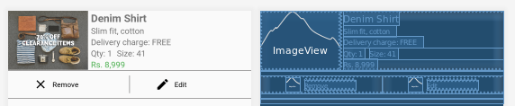

***Step :- 3 activity_main.xml file.***

*<?*xml version="1.0" encoding="utf-8"*?>*<LinearLayout  
 xmlns:android="http://schemas.android.com/apk/res/android"  
 xmlns:card_view="http://schemas.android.com/apk/res-auto"  
 android:id="@+id/layout_item"  
 android:layout_width="match_parent"  
 android:layout_height="wrap_content"  
 android:layout_margin="20dp"  
 android:orientation="vertical">  
  
 *<!-- Load the card view here -->* <include  
 layout="@layout/card_view_design"  
 android:layout_width="match_parent"  
 android:layout_height="wrap_content"/>  
  
 *<!-- Load the card view here -->* <include  
 layout="@layout/card_view_design"  
 android:layout_marginTop="10dp"  
 android:layout_width="match_parent"  
 android:layout_height="wrap_content"/>  
</LinearLayout>

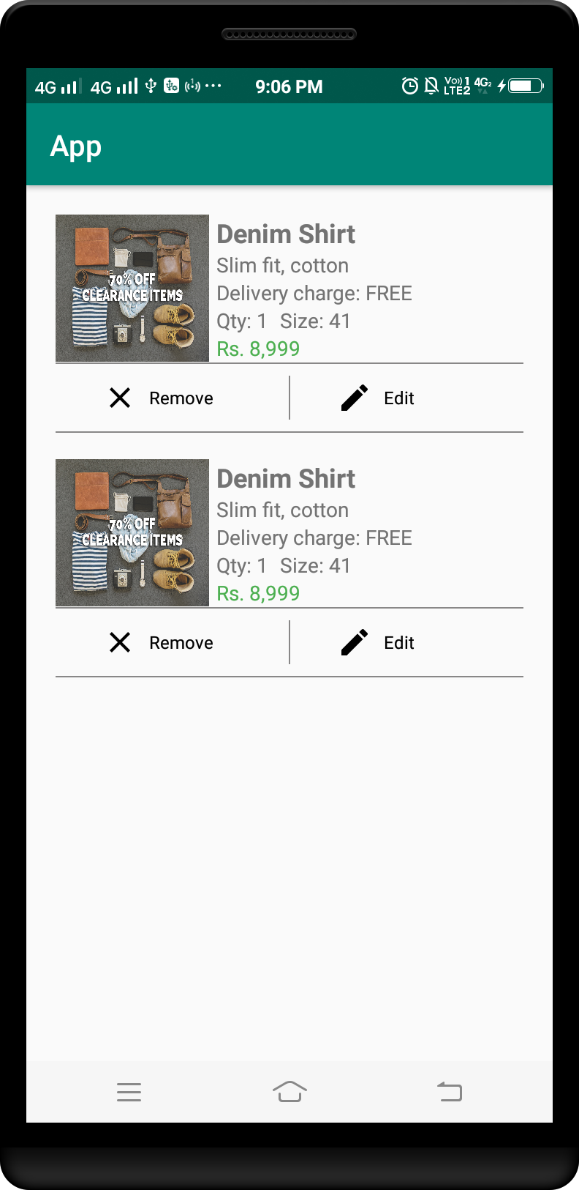

Example 6 :

***Step :- 1 Add Volley Dependency in build.gradle ( Module:app ) file.***

apply plugin: 'com.android.application'  
android {  
 compileSdkVersion 28  
 defaultConfig {  
 applicationId "card.view.com"  
 minSdkVersion 21  
 targetSdkVersion 28  
 versionCode 1  
 versionName "1.0"  
 testInstrumentationRunner "android.support.test.runner.AndroidJUnitRunner"  
 }  
 buildTypes {  
 release {  
 minifyEnabled false  
 proguardFiles getDefaultProguardFile('proguard-android-optimize.txt'), 'proguard-rules.pro'  
 }  
 }  
}  
  
dependencies {  
 implementation fileTree(dir: 'libs', include: ['*.jar'])  
 implementation 'com.android.support:appcompat-v7:28.0.0'  
 implementation 'com.android.support.constraint:constraint-layout:1.1.3'  
 testImplementation 'junit:junit:4.12'  
 androidTestImplementation 'com.android.support.test:runner:1.0.2'  
 androidTestImplementation 'com.android.support.test.espresso:espresso-core:3.0.2'  
  
 implementation 'com.android.support:design:28.0.0'  
 implementation 'com.android.support:cardview-v7:28.0.0'  
}

***Step :- 2 card_button_background.xml file.***

*<?*xml version="1.0" encoding="utf-8"*?>*<shape  
 xmlns:android="http://schemas.android.com/apk/res/android"  
 android:shape="rectangle">  
  
 <stroke android:color="#1ff8e9"  
 android:width="2dp"/>  
</shape>

***item.png***



***Step :- 2 card_view_design.xml file.***

*<?*xml version="1.0" encoding="utf-8"*?>*<LinearLayout xmlns:android="http://schemas.android.com/apk/res/android"  
 android:layout_width="match_parent"  
 xmlns:app="http://schemas.android.com/apk/res-auto"  
 android:orientation="vertical"  
 android:padding="5dp"  
 android:id="@+id/ll_item"  
 android:layout_height="190dp">  
  
 <android.support.v7.widget.CardView  
 app:cardCornerRadius="10dp"  
 android:layout_gravity="center_vertical"  
 android:layout_margin="5dp"  
 android:layout_width="match_parent"  
 android:layout_height="match_parent">  
 <LinearLayout  
 android:layout_width="match_parent"  
 android:orientation="vertical"  
 android:background="#ffffff"  
 android:layout_height="match_parent">  
 <RelativeLayout  
 android:layout_width="match_parent"  
 android:background="#000000"  
 android:layout_height="190dp">  
  
 <ImageView  
 android:alpha="0.5"  
 android:id="@+id/item_img"  
 android:layout_width="match_parent"  
 android:layout_height="match_parent"  
 android:scaleType="centerCrop"  
 android:src="@drawable/item"/>  
  
 <TextView  
 android:layout_marginTop="50dp"  
 android:id="@+id/article_name"  
 android:layout_width="match_parent"  
 android:layout_height="30dp"  
 android:text="My First Article on RecyclerView"  
 android:textColor="#ffffff"  
 android:textSize="18sp"  
 android:textStyle="bold"  
 android:gravity="center"/>  
   
 <TextView  
 android:background="@drawable/card_button_background"  
 android:layout_centerInParent="true"  
 android:layout_below="@+id/article_name"  
 android:layout_width="100dp"  
 android:layout_height="30dp"  
 android:text="Read"  
 android:textSize="18sp"  
 android:textStyle="bold"  
 android:textColor="#1ff8e9"  
 android:gravity="center"/>  
 </RelativeLayout>  
 </LinearLayout>  
 </android.support.v7.widget.CardView>  
</LinearLayout>

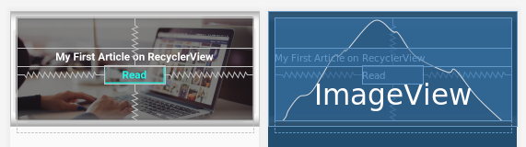

***Step :- 3 activity_main.xml file.***

*<?*xml version="1.0" encoding="utf-8"*?>*<LinearLayout  
 xmlns:android="http://schemas.android.com/apk/res/android"  
 xmlns:card_view="http://schemas.android.com/apk/res-auto"  
 android:id="@+id/layout_item"  
 android:layout_width="match_parent"  
 android:layout_height="wrap_content"  
 android:layout_margin="20dp"  
 android:orientation="vertical">  
  
 *<!-- Load the card view here -->* <include  
 layout="@layout/card_view_design"  
 android:layout_width="match_parent"  
 android:layout_height="wrap_content"/>  
  
 *<!-- Load the card view here -->* <include  
 layout="@layout/card_view_design"  
 android:layout_marginTop="10dp"  
 android:layout_width="match_parent"  
 android:layout_height="wrap_content"/>  
</LinearLayout>

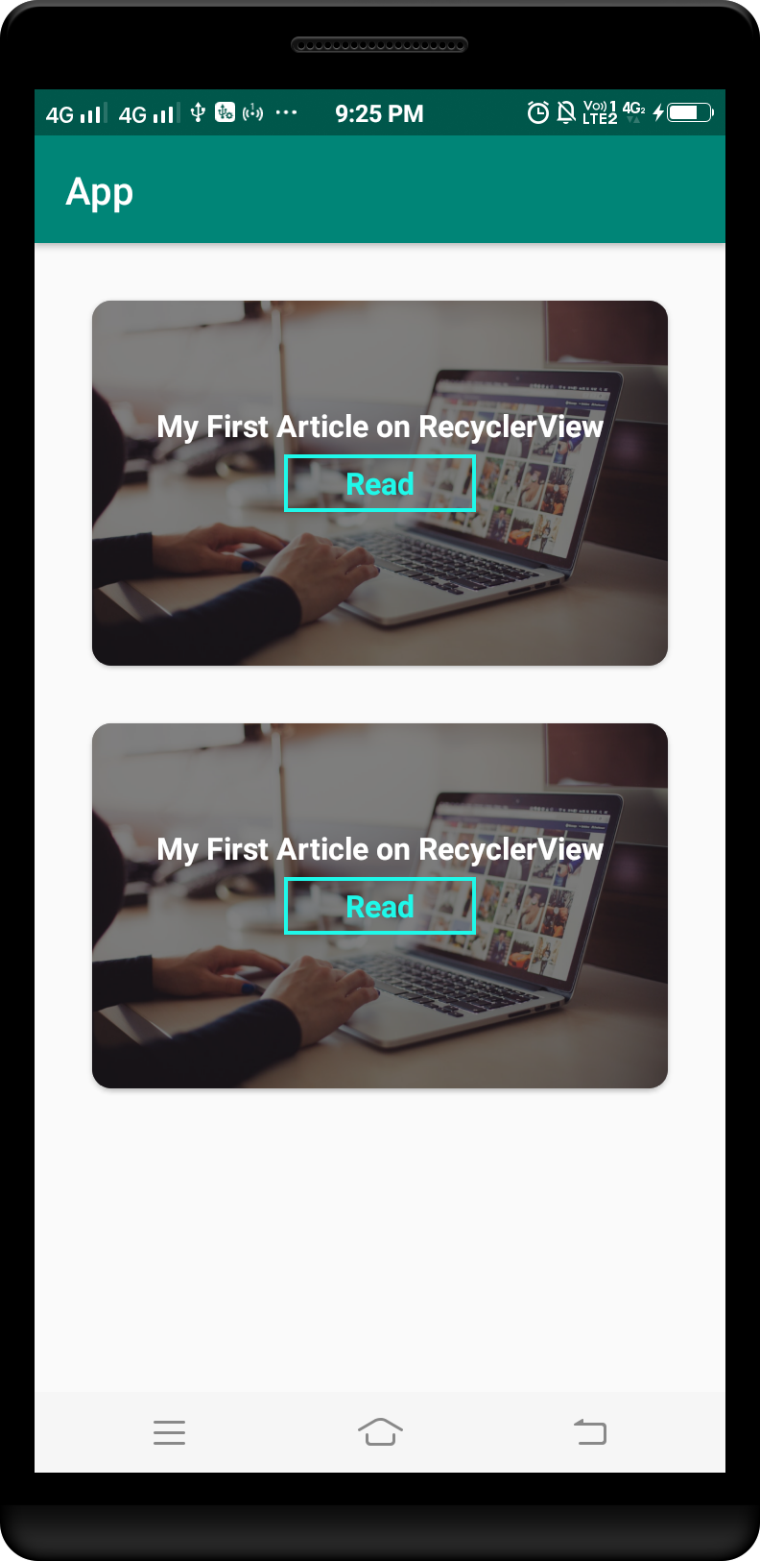

Example 7 :

***Step :- 1 Add Volley Dependency in build.gradle ( Module:app ) file.***

apply plugin: 'com.android.application'  
android {  
 compileSdkVersion 28  
 defaultConfig {  
 applicationId "card.view.com"  
 minSdkVersion 21  
 targetSdkVersion 28  
 versionCode 1  
 versionName "1.0"  
 testInstrumentationRunner "android.support.test.runner.AndroidJUnitRunner"  
 }  
 buildTypes {  
 release {  
 minifyEnabled false  
 proguardFiles getDefaultProguardFile('proguard-android-optimize.txt'), 'proguard-rules.pro'  
 }  
 }  
}  
  
dependencies {  
 implementation fileTree(dir: 'libs', include: ['*.jar'])  
 implementation 'com.android.support:appcompat-v7:28.0.0'  
 implementation 'com.android.support.constraint:constraint-layout:1.1.3'  
 testImplementation 'junit:junit:4.12'  
 androidTestImplementation 'com.android.support.test:runner:1.0.2'  
 androidTestImplementation 'com.android.support.test.espresso:espresso-core:3.0.2'  
  
 implementation 'com.android.support:design:28.0.0'  
 implementation 'com.android.support:cardview-v7:28.0.0'  
}

***Step :- 2 card_view_border.xml file.***

*<?*xml version="1.0" encoding="UTF-8"*?>*<shape  
 xmlns:android="http://schemas.android.com/apk/res/android"  
 android:shape="rectangle">  
  
 <solid android:color="#ffffff"/>  
  
 <stroke  
 android:width="0.5dip"  
 android:color="#000EC7"/>  
  
 <corners android:radius="6dip"/>  
</shape>

***item.png***



***Step :- 3 card_view_design.xml file.***

*<?*xml version="1.0" encoding="utf-8"*?>*<LinearLayout  
 xmlns:android="http://schemas.android.com/apk/res/android"  
 xmlns:card_view="http://schemas.android.com/apk/res-auto"  
 android:layout_width="match_parent"  
 android:layout_height="wrap_content"  
 android:background="@drawable/card_view_border">  
  
 <android.support.v7.widget.CardView  
 android:id="@+id/card_view"  
 android:layout_width="match_parent"  
 android:layout_height="match_parent"  
 android:layout_gravity="center"  
 android:layout_margin="1dp"  
 android:elevation="20dp"  
 card_view:cardCornerRadius="6dp">  
  
 <RelativeLayout  
 android:layout_width="match_parent"  
 android:layout_height="match_parent">  
  
 <ImageView  
 android:id="@+id/imageView"  
 android:layout_width="match_parent"  
 android:layout_height="160dp"  
 android:src="@drawable/items"  
 android:clickable="true"  
 android:focusable="true"  
 android:scaleType="fitXY"/>  
  
 <TextView  
 android:layout_below="@id/imageView"  
 android:id="@+id/textView"  
 android:layout_width="match_parent"  
 android:layout_height="wrap_content"  
 android:layout_margin="5dp"  
 android:gravity="center"  
 android:textColor="#000000"  
 android:textSize="15dp"  
 android:text="Title"/>  
 </RelativeLayout>  
  
 </android.support.v7.widget.CardView>  
</LinearLayout>

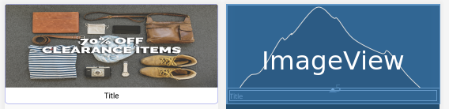

***Step :- 4 activity_main.xml file.***

*<?*xml version="1.0" encoding="utf-8"*?>*<LinearLayout  
 xmlns:android="http://schemas.android.com/apk/res/android"  
 xmlns:card_view="http://schemas.android.com/apk/res-auto"  
 android:id="@+id/layout_item"  
 android:layout_width="match_parent"  
 android:layout_height="wrap_content"  
 android:layout_margin="20dp"  
 android:orientation="vertical">  
  
 *<!-- Load the card view here -->* <include  
 layout="@layout/card_view_design"  
 android:layout_width="match_parent"  
 android:layout_height="wrap_content"/>  
  
 *<!-- Load the card view here -->* <include  
 layout="@layout/card_view_design"  
 android:layout_marginTop="10dp"  
 android:layout_width="match_parent"  
 android:layout_height="wrap_content"/>  
</LinearLayout>

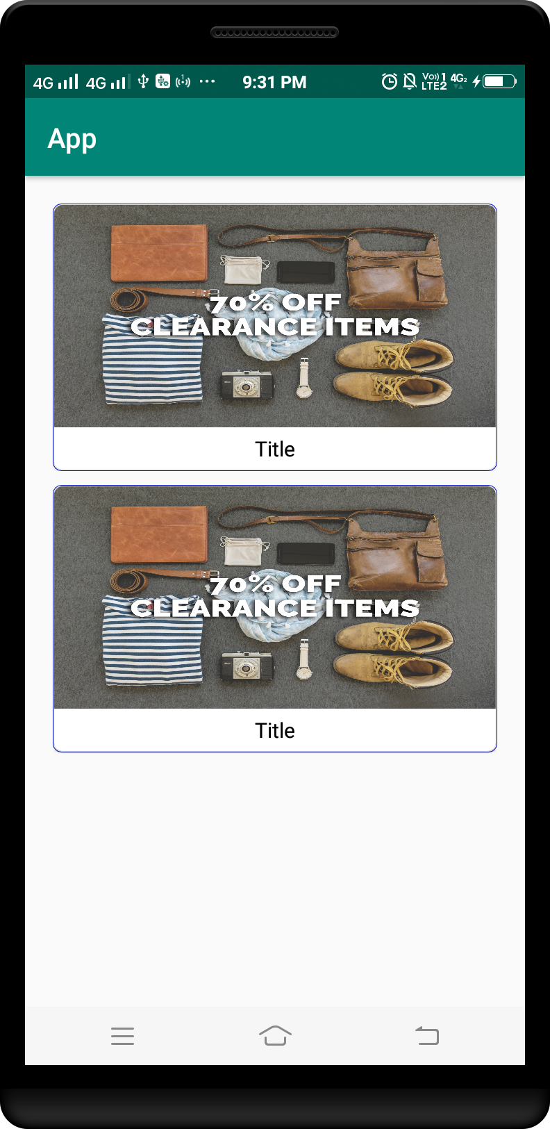

Example 8 :

***Step :- 1 Add Volley Dependency in build.gradle ( Module:app ) file.***

apply plugin: 'com.android.application'  
android {  
 compileSdkVersion 28  
 defaultConfig {  
 applicationId "card.view.com"  
 minSdkVersion 21  
 targetSdkVersion 28  
 versionCode 1  
 versionName "1.0"  
 testInstrumentationRunner "android.support.test.runner.AndroidJUnitRunner"  
 }  
 buildTypes {  
 release {  
 minifyEnabled false  
 proguardFiles getDefaultProguardFile('proguard-android-optimize.txt'), 'proguard-rules.pro'  
 }  
 }  
}  
  
dependencies {  
 implementation fileTree(dir: 'libs', include: ['*.jar'])  
 implementation 'com.android.support:appcompat-v7:28.0.0'  
 implementation 'com.android.support.constraint:constraint-layout:1.1.3'  
 testImplementation 'junit:junit:4.12'  
 androidTestImplementation 'com.android.support.test:runner:1.0.2'  
 androidTestImplementation 'com.android.support.test.espresso:espresso-core:3.0.2'  
  
 implementation 'com.android.support:design:28.0.0'  
 implementation 'com.android.support:cardview-v7:28.0.0'  
}

***item.png***



***Step :- 2 card_view_design.xml file.***

*<?*xml version="1.0" encoding="utf-8"*?>*<LinearLayout  
 xmlns:android="http://schemas.android.com/apk/res/android"  
 xmlns:app="http://schemas.android.com/apk/res-auto"  
 android:orientation="vertical"  
 android:layout_width="match_parent"  
 android:layout_height="wrap_content"  
 android:paddingTop="1dp">  
  
 <android.support.v7.widget.CardView  
 android:id="@+id/card_view"  
 android:layout_gravity="center"  
 android:layout_width="match_parent"  
 android:layout_height="250dp"  
 app:cardCornerRadius="5dp"  
 android:elevation="6dp">  
  
 <RelativeLayout  
 android:layout_width="match_parent"  
 android:layout_height="match_parent">  
  
 <ImageView  
 android:id="@+id/img_background"  
 android:layout_width="match_parent"  
 android:layout_height="match_parent"  
 android:src="@drawable/items"  
 android:scaleType="centerCrop"  
 android:layout_alignParentBottom="true"  
 android:layout_alignParentStart="true"  
 android:transitionName="selectedMovie"/>  
  
 <View  
 android:layout_width="match_parent"  
 android:layout_height="match_parent"  
 android:background="#000000"  
 android:alpha=".4"  
 android:id="@+id/vw_blacklayer" />  
  
 <ImageView  
 android:src="@drawable/items"  
 android:layout_width="80dp"  
 android:layout_height="110dp"  
 android:id="@+id/img_cover_d"  
 android:scaleType="centerCrop"  
 android:layout_marginBottom="12dp"  
 android:layout_alignParentBottom="true"  
 android:layout_alignParentStart="true"  
 android:layout_marginStart="13dp" />  
  
 <TextView  
 android:id="@+id/txt_movie_details"  
 android:layout_width="wrap_content"  
 android:layout_height="wrap_content"  
 android:textAppearance="?android:attr/textAppearanceLarge"  
 android:text="Batman Vs Superman"  
 android:singleLine="true"  
 android:layout_marginTop="6dp"  
 android:paddingStart="10dp"  
 android:textSize="20sp"  
 android:textColor="#ffffff"  
 android:layout_alignTop="@+id/img_cover_d"  
 android:layout_toEndOf="@id/img_cover_d" />  
  
 <TextView  
 android:layout_width="wrap_content"  
 android:layout_height="wrap_content"  
 android:textAppearance="?android:attr/textAppearanceSmall"  
 android:text="It&apos;s been nearly two years since Superman&apos;s (Henry Cavill) colossal battle with Zod (Michael Shannon) devastated the city of Metropolis."  
 android:id="@+id/txt_plot_d"  
 android:paddingLeft="10dp"  
 android:paddingRight="10dp"  
 android:lines="3"  
 android:textSize="12sp"  
 android:ellipsize="end"  
 android:textColor="#ffffff"  
 android:layout_below="@+id/txt_movie_details"  
 android:layout_toRightOf="@+id/img_cover_d"  
 android:layout_toEndOf="@+id/img_cover_d" />  
  
 <TextView  
 android:layout_width="wrap_content"  
 android:layout_height="wrap_content"  
 android:textAppearance="?android:attr/textAppearanceMedium"  
 android:text="Release date: March 25, 2016"  
 android:id="@+id/txt_release_d"  
 android:textColor="#ffffff"  
 android:layout_marginTop="2dp"  
 android:paddingLeft="10dp"  
 android:textSize="14sp"  
 android:layout_below="@+id/txt_plot_d"  
 android:layout_toRightOf="@+id/img_cover_d"  
 android:layout_toEndOf="@+id/img_cover_d" />  
 </RelativeLayout>  
 </android.support.v7.widget.CardView>  
</LinearLayout>

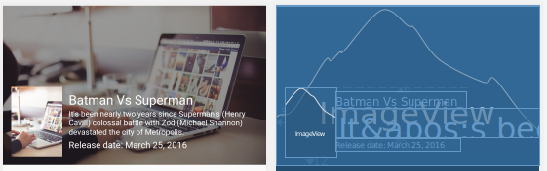

***Step :- 3 activity_main.xml file.***

*<?*xml version="1.0" encoding="utf-8"*?>*<LinearLayout  
 xmlns:android="http://schemas.android.com/apk/res/android"  
 xmlns:card_view="http://schemas.android.com/apk/res-auto"  
 android:id="@+id/layout_item"  
 android:layout_width="match_parent"  
 android:layout_height="wrap_content"  
 android:layout_margin="20dp"  
 android:orientation="vertical">  
  
 *<!-- Load the card view here -->* <include  
 layout="@layout/card_view_design"  
 android:layout_width="match_parent"  
 android:layout_height="wrap_content"/>  
  
 *<!-- Load the card view here -->* <include  
 layout="@layout/card_view_design"  
 android:layout_marginTop="10dp"  
 android:layout_width="match_parent"  
 android:layout_height="wrap_content"/>  
</LinearLayout>

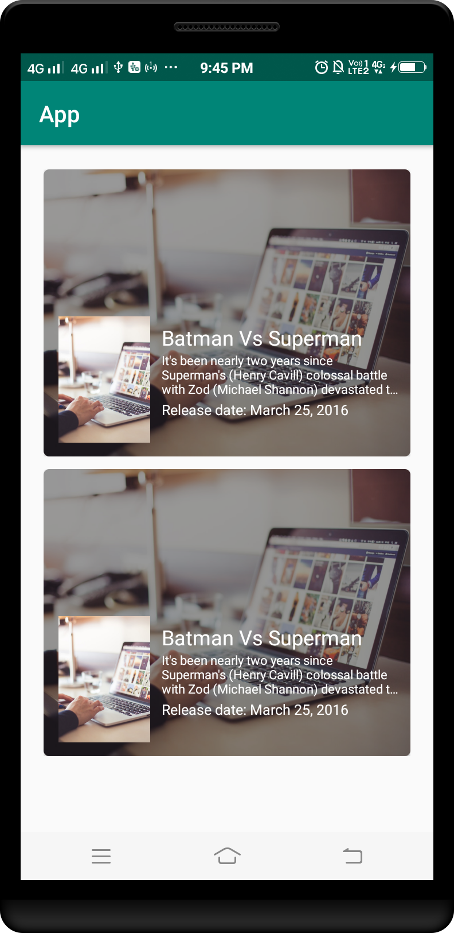

Example 9 :

***Step :- 1 Add Volley Dependency in build.gradle ( Module:app ) file.***

apply plugin: 'com.android.application'  
  
android {  
 compileSdkVersion 28  
 defaultConfig {  
 applicationId "card.view.app"  
 minSdkVersion 21  
 targetSdkVersion 28  
 versionCode 1  
 versionName "1.0"  
 testInstrumentationRunner "android.support.test.runner.AndroidJUnitRunner"  
 }  
 buildTypes {  
 release {  
 minifyEnabled false  
 proguardFiles getDefaultProguardFile('proguard-android-optimize.txt'), 'proguard-rules.pro'  
 }  
 }  
}  
  
dependencies {  
 implementation fileTree(dir: 'libs', include: ['*.jar'])  
 implementation 'com.android.support:appcompat-v7:28.0.0'  
 implementation 'com.android.support.constraint:constraint-layout:1.1.3'  
 testImplementation 'junit:junit:4.12'  
 androidTestImplementation 'com.android.support.test:runner:1.0.2'  
 androidTestImplementation 'com.android.support.test.espresso:espresso-core:3.0.2'  
 implementation 'com.android.support:design:28.0.0'  
 implementation 'com.android.support:cardview-v7:28.0.0'  
 implementation 'com.pkmmte.view:circularimageview:1.1'  
}

***item.png***



***Step :- 2 card_view_design.xml file.***

*<?*xml version="1.0" encoding="utf-8"*?>*<LinearLayout  
 xmlns:android="http://schemas.android.com/apk/res/android"  
 xmlns:app="http://schemas.android.com/apk/res-auto"  
 android:orientation="vertical"  
 android:layout_width="match_parent"  
 android:layout_height="wrap_content"  
 android:paddingTop="1dp">  
  
 <android.support.v7.widget.CardView  
 android:id="@+id/card_view"  
 android:layout_gravity="center"  
 android:layout_width="match_parent"  
 android:layout_height="250dp"  
 app:cardCornerRadius="5dp"  
 android:elevation="6dp">  
  
 <RelativeLayout  
 android:layout_width="match_parent"  
 android:layout_height="match_parent">  
  
 <ImageView  
 android:layout_width="match_parent"  
 android:layout_height="160dp"  
 android:scaleType="centerCrop"  
 android:id="@+id/bg_image"  
 android:src="@drawable/item"/>  
  
 <View  
 android:layout_width="match_parent"  
 android:layout_height="95dp"  
 android:layout_marginTop="155dp"  
 android:background="#F0A830"  
 android:id="@+id/view" />  
  
 <View  
 android:layout_width="10dp"  
 android:layout_height="1dp"  
 android:alpha="0.4"  
 android:background="#000000"  
 android:id="@+id/line"  
 android:layout_marginTop="10dp"  
 android:layout_marginRight="30dp"  
 android:layout_alignLeft="@+id/textView"  
 android:layout_alignStart="@+id/textView"  
 android:layout_below="@+id/textView"  
 android:layout_alignParentRight="true"  
 android:layout_alignParentEnd="true" />  
  
 <com.pkmmte.view.CircularImageView  
 android:layout_width="80dp"  
 android:layout_height="80dp"  
 android:id="@+id/avatar"  
 android:src="@drawable/items"  
 app:border="true"  
 android:scaleType="centerCrop"  
 app:border_color="#F0A830"  
 app:border_width="6dp"  
 android:layout_marginLeft="22dp"  
 android:layout_marginStart="22dp"  
 android:layout_marginBottom="42dp"  
 android:layout_alignParentBottom="true"  
 android:layout_alignParentLeft="true"  
 android:layout_alignParentStart="true" />  
  
 <TextView  
 android:layout_width="wrap_content"  
 android:layout_height="wrap_content"  
 android:textAppearance="?android:attr/textAppearanceLarge"  
 android:text="Yasir Ameen"  
 android:textColor="#ffffff"  
 android:textSize="18sp"  
 android:id="@+id/textView"  
 android:layout_below="@+id/bg_image"  
 android:layout_toRightOf="@+id/avatar"  
 android:layout_toEndOf="@+id/avatar"  
 android:layout_marginLeft="29dp"  
 android:layout_marginStart="29dp" />  
  
 <TextView  
 android:layout_width="match_parent"  
 android:layout_height="wrap_content"  
 android:textAppearance="?android:attr/textAppearanceSmall"  
 android:text="The photo of Yasir Ameen. He is an Android Application Developer and he work hard for giving thier best to the audience. Join him on facebook"  
 android:textSize="10sp"  
 android:lines="3"  
 android:ellipsize="end"  
 android:layout_marginTop="4dp"  
 android:paddingBottom="8dp"  
 android:paddingRight="15dp"  
 android:textColor="#ffffff"  
 android:id="@+id/textView2"  
 android:layout_alignLeft="@+id/line"  
 android:layout_alignStart="@+id/line"  
 android:layout_alignParentBottom="true"  
 android:layout_below="@+id/line" />  
 </RelativeLayout>  
 </android.support.v7.widget.CardView>  
</LinearLayout>

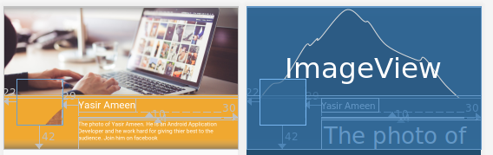

***Step :- 3 activity_main.xml file.***

*<?*xml version="1.0" encoding="utf-8"*?>*<LinearLayout  
 xmlns:android="http://schemas.android.com/apk/res/android"  
 xmlns:card_view="http://schemas.android.com/apk/res-auto"  
 android:id="@+id/layout_item"  
 android:layout_width="match_parent"  
 android:layout_height="wrap_content"  
 android:layout_margin="20dp"  
 android:orientation="vertical">  
  
 *<!-- Load the card view here -->* <include  
 layout="@layout/card_view_design"  
 android:layout_width="match_parent"  
 android:layout_height="wrap_content"/>  
  
 *<!-- Load the card view here -->* <include  
 layout="@layout/card_view_design"  
 android:layout_marginTop="10dp"  
 android:layout_width="match_parent"  
 android:layout_height="wrap_content"/>  
</LinearLayout>

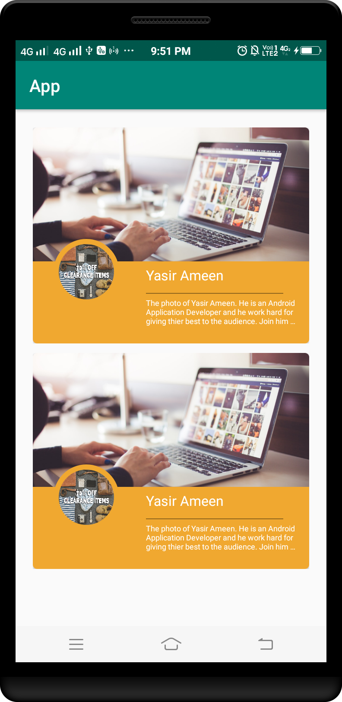

Example 10 :

***Step :- 1 Add Volley Dependency in build.gradle ( Module:app ) file.***

apply plugin: 'com.android.application'  
  
android {  
 compileSdkVersion 28  
 defaultConfig {  
 applicationId "card.view.app"  
 minSdkVersion 21  
 targetSdkVersion 28  
 versionCode 1  
 versionName "1.0"  
 testInstrumentationRunner "android.support.test.runner.AndroidJUnitRunner"  
 }  
 buildTypes {  
 release {  
 minifyEnabled false  
 proguardFiles getDefaultProguardFile('proguard-android-optimize.txt'), 'proguard-rules.pro'  
 }  
 }  
}  
  
dependencies {  
 implementation fileTree(dir: 'libs', include: ['*.jar'])  
 implementation 'com.android.support:appcompat-v7:28.0.0'  
 implementation 'com.android.support.constraint:constraint-layout:1.1.3'  
 testImplementation 'junit:junit:4.12'  
 androidTestImplementation 'com.android.support.test:runner:1.0.2'  
 androidTestImplementation 'com.android.support.test.espresso:espresso-core:3.0.2'  
 implementation 'com.android.support:design:28.0.0'  
 implementation 'com.android.support:cardview-v7:28.0.0'  
 implementation 'com.pkmmte.view:circularimageview:1.1'  
}

***item.png***



***Step :- 2 card_view_design.xml file.***

*<?*xml version="1.0" encoding="utf-8"*?>*<LinearLayout xmlns:android="http://schemas.android.com/apk/res/android"  
 xmlns:card_view="http://schemas.android.com/apk/res-auto"  
 android:layout_width="match_parent"  
 android:layout_height="wrap_content"  
 android:orientation="vertical">  
  
 <android.support.v7.widget.CardView  
 android:layout_width="match_parent"  
 android:layout_height="wrap_content"  
 android:layout_marginBottom="0dp"  
 android:layout_marginLeft="5dp"  
 android:layout_marginRight="5dp"  
 android:layout_marginTop="9dp"  
 card_view:cardCornerRadius="3dp"  
 card_view:cardElevation="0.01dp">  
  
 <RelativeLayout  
 android:id="@+id/top_layout"  
 android:layout_width="match_parent"  
 android:layout_height="160dp">  
  
 <ImageView  
 android:id="@+id/imageView"  
 android:layout_width="match_parent"  
 android:layout_height="150dp"  
 android:layout_above="@+id/textView"  
 android:layout_centerHorizontal="true"  
 android:src="@drawable/item"  
 android:scaleType="fitXY" />  
  
 <TextView  
 android:id="@+id/textView"  
 android:layout_width="fill_parent"  
 android:layout_height="40dp"  
 android:layout_alignParentBottom="true"  
 android:layout_alignParentLeft="true"  
 android:layout_alignParentStart="true"  
 android:layout_gravity="bottom"  
 android:background="#ff444444"  
 android:gravity="center"  
 android:paddingLeft="5dp"  
 android:paddingRight="2dp"  
 android:text="Test"  
 android:textColor="#fff"  
 android:textSize="10dp" />  
  
 </RelativeLayout>  
 </android.support.v7.widget.CardView>  
</LinearLayout>

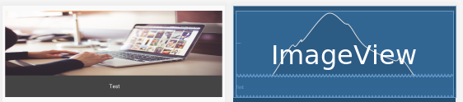

***Step :- 3 activity_main.xml file.***

*<?*xml version="1.0" encoding="utf-8"*?>*<LinearLayout  
 xmlns:android="http://schemas.android.com/apk/res/android"  
 xmlns:card_view="http://schemas.android.com/apk/res-auto"  
 android:id="@+id/layout_item"  
 android:layout_width="match_parent"  
 android:layout_height="wrap_content"  
 android:layout_margin="20dp"  
 android:orientation="vertical">  
  
 *<!-- Load the card view here -->* <include  
 layout="@layout/card_view_design"  
 android:layout_width="match_parent"  
 android:layout_height="wrap_content"/>  
  
 *<!-- Load the card view here -->* <include  
 layout="@layout/card_view_design"  
 android:layout_marginTop="10dp"  
 android:layout_width="match_parent"  
 android:layout_height="wrap_content"/>  
</LinearLayout>

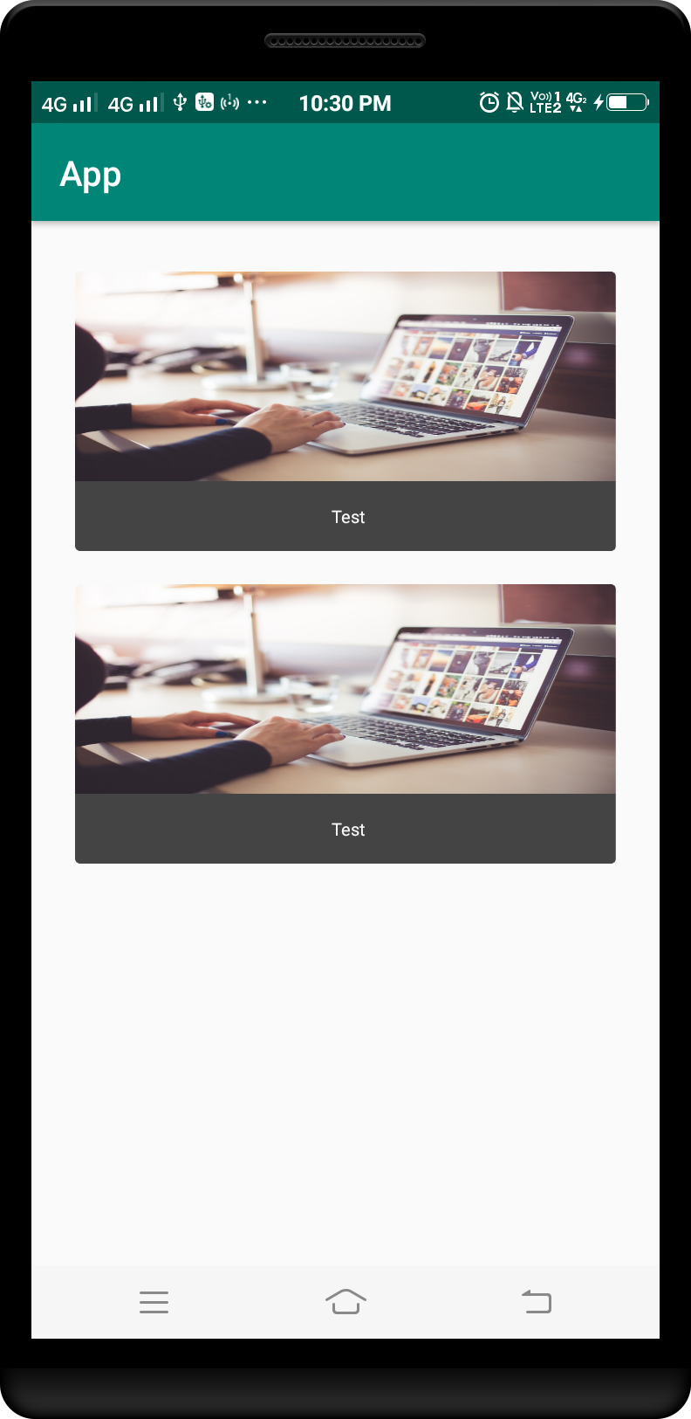

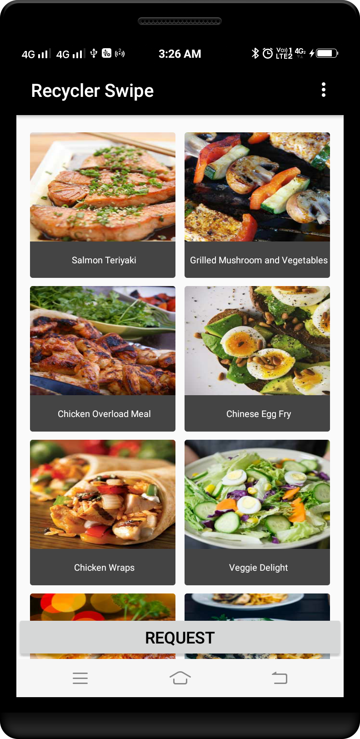

Example 11 :

***Step :- 1 Add Volley Dependency in build.gradle ( Module:app ) file.***

apply plugin: 'com.android.application'  
  
android {  
 compileSdkVersion 28  
 defaultConfig {  
 applicationId "card.view.app"  
 minSdkVersion 21  
 targetSdkVersion 28  
 versionCode 1  
 versionName "1.0"  
 testInstrumentationRunner "android.support.test.runner.AndroidJUnitRunner"  
 }  
 buildTypes {  
 release {  
 minifyEnabled false  
 proguardFiles getDefaultProguardFile('proguard-android-optimize.txt'), 'proguard-rules.pro'  
 }  
 }  
}  
  
dependencies {  
 implementation fileTree(dir: 'libs', include: ['*.jar'])  
 implementation 'com.android.support:appcompat-v7:28.0.0'  
 implementation 'com.android.support.constraint:constraint-layout:1.1.3'  
 testImplementation 'junit:junit:4.12'  
 androidTestImplementation 'com.android.support.test:runner:1.0.2'  
 androidTestImplementation 'com.android.support.test.espresso:espresso-core:3.0.2'  
 implementation 'com.android.support:design:28.0.0'  
 implementation 'com.android.support:cardview-v7:28.0.0'  
 implementation 'com.pkmmte.view:circularimageview:1.1'  
}

***item.png***



***Step :- 2 card_view_design.xml file.***

*<?*xml version="1.0" encoding="utf-8"*?>*<android.support.v7.widget.CardView  
 xmlns:android="http://schemas.android.com/apk/res/android"  
 style="@style/CardView.Light"  
 android:layout_width="match_parent"  
 android:layout_height="wrap_content"  
 android:layout_marginTop="8dp"  
 android:layout_marginStart="8dp"  
 android:layout_marginEnd="8dp">  
  
 <RelativeLayout  
 android:layout_width="match_parent"  
 android:layout_height="match_parent">  
  
 <ImageView  
 android:id="@+id/thumbnail"  
 android:layout_width="match_parent"  
 android:layout_height="200dp"  
 android:scaleType="fitXY"  
 android:src="@drawable/item"/>  
  
 <TextView  
 android:id="@+id/title"  
 style="@style/TextAppearance.AppCompat.Headline"  
 android:layout_width="match_parent"  
 android:layout_height="wrap_content"  
 android:layout_alignBottom="@+id/thumbnail"  
 android:layout_alignParentStart="true"  
 android:layout_marginLeft="8dp"  
 android:layout_marginBottom="8dp"  
 android:padding="8dp"  
 android:text="Title Placeholder"  
 android:textColor="#FFFFFF"/>  
  
 <TextView  
 android:id="@+id/newsTitle"  
 style="@style/TextAppearance.AppCompat.Subhead"  
 android:layout_width="match_parent"  
 android:layout_height="wrap_content"  
 android:layout_below="@+id/thumbnail"  
 android:layout_alignParentStart="true"  
 android:layout_marginStart="8dp"  
 android:textStyle="bold"  
 android:padding="8dp"  
 android:text="Food"/>  
  
 <TextView  
 android:id="@+id/newsInfo"  
 style="@style/TextAppearance.AppCompat.Subhead"  
 android:layout_width="match_parent"  
 android:layout_height="wrap_content"  
 android:layout_below="@+id/newsTitle"  
 android:layout_alignParentStart="true"  
 android:layout_marginStart="8dp"  
 android:layout_marginBottom="8dp"  
 android:padding="8dp"  
 android:text="Indonesia Masters – Saina Nehwal sails into semifinals PV Sindhu, Kidambi Srikanth lose in quarters!"/>  
 </RelativeLayout>  
</android.support.v7.widget.CardView>

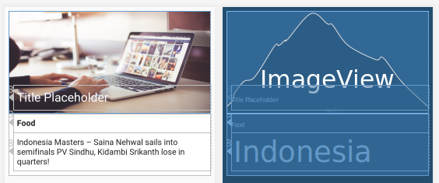

***Step :- 3 activity_main.xml file.***

*<?*xml version="1.0" encoding="utf-8"*?>*<LinearLayout  
 xmlns:android="http://schemas.android.com/apk/res/android"  
 xmlns:card_view="http://schemas.android.com/apk/res-auto"  
 android:id="@+id/layout_item"  
 android:layout_width="match_parent"  
 android:layout_height="wrap_content"  
 android:layout_margin="20dp"  
 android:orientation="vertical">  
  
 *<!-- Load the card view here -->* <include  
 layout="@layout/card_view_design"  
 android:layout_width="match_parent"  
 android:layout_height="wrap_content"/>  
  
 *<!-- Load the card view here -->* <include  
 layout="@layout/card_view_design"  
 android:layout_marginTop="10dp"  
 android:layout_width="match_parent"  
 android:layout_height="wrap_content"/>  
</LinearLayout>

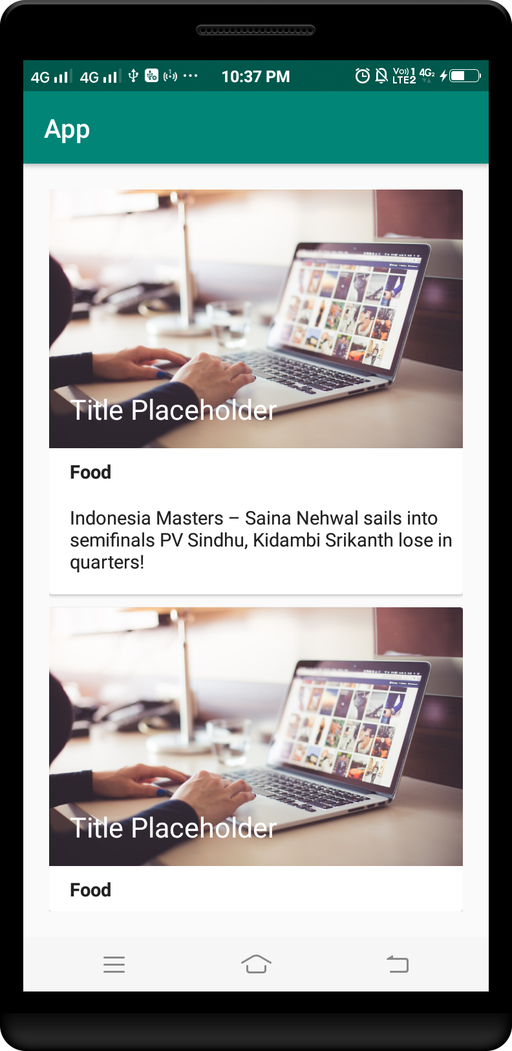

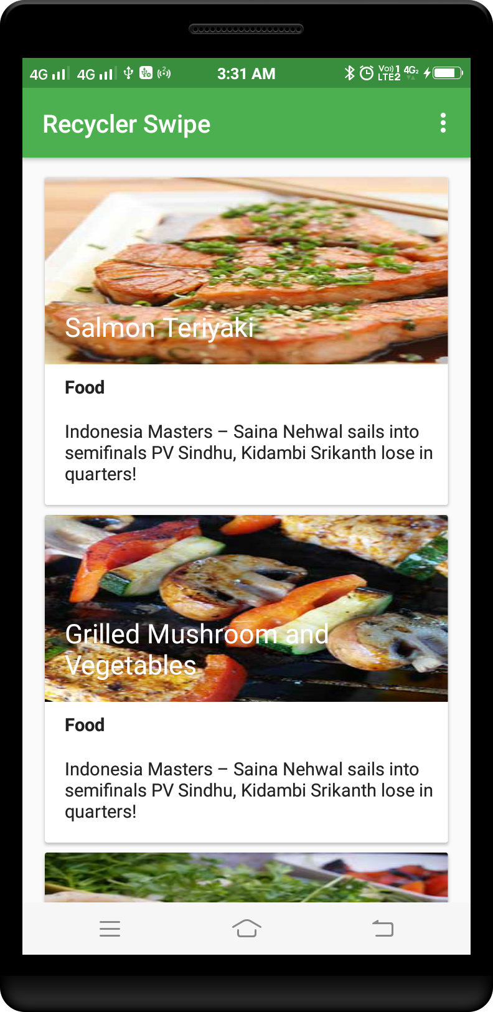

Example 12 :

***Step :- 1 Add Volley Dependency in build.gradle ( Module:app ) file.***

apply plugin: 'com.android.application'  
  
android {  
 compileSdkVersion 28  
 defaultConfig {  
 applicationId "card.view.app"  
 minSdkVersion 21  
 targetSdkVersion 28  
 versionCode 1  
 versionName "1.0"  
 testInstrumentationRunner "android.support.test.runner.AndroidJUnitRunner"  
 }  
 buildTypes {  
 release {  
 minifyEnabled false  
 proguardFiles getDefaultProguardFile('proguard-android-optimize.txt'), 'proguard-rules.pro'  
 }  
 }  
}  
  
dependencies {  
 implementation fileTree(dir: 'libs', include: ['*.jar'])  
 implementation 'com.android.support:appcompat-v7:28.0.0'  
 implementation 'com.android.support.constraint:constraint-layout:1.1.3'  
 testImplementation 'junit:junit:4.12'  
 androidTestImplementation 'com.android.support.test:runner:1.0.2'  
 androidTestImplementation 'com.android.support.test.espresso:espresso-core:3.0.2'  
 implementation 'com.android.support:design:28.0.0'  
 implementation 'com.android.support:cardview-v7:28.0.0'  
 implementation 'com.pkmmte.view:circularimageview:1.1'  
}

***Step :- 2 card_view_design.xml file.***

*<?*xml version="1.0" encoding="utf-8"*?>*<android.support.v7.widget.CardView  
 xmlns:android="http://schemas.android.com/apk/res/android"  
 xmlns:app="http://schemas.android.com/apk/res-auto"  
 xmlns:tools="http://schemas.android.com/tools"  
 android:layout_marginTop="16dp"  
 android:layout_width="match_parent"  
 android:layout_height="wrap_content"  
 app:cardCornerRadius="8dp">  
  
 <LinearLayout  
 android:layout_width="match_parent"  
 android:layout_height="wrap_content"  
 android:orientation="vertical"  
 android:padding="14dp">  
  
 <LinearLayout  
 android:layout_width="match_parent"  
 android:layout_height="wrap_content"  
 android:orientation="horizontal">  
  
 <LinearLayout  
 android:layout_width="wrap_content"  
 android:layout_height="wrap_content"  
 android:orientation="vertical">  
  
 <TextView  
 android:id="@+id/textView"  
 android:layout_width="wrap_content"  
 android:layout_height="wrap_content"  
 android:fontFamily="@font/roboto_bold"  
 android:text="Food Menu1"  
 android:textColor="#fdb501"  
 android:textSize="24dp" />  
  
 <LinearLayout  
 android:layout_marginTop="4dp"  
 android:layout_width="wrap_content"  
 android:layout_height="wrap_content"  
 android:orientation="horizontal">  
  
 <ImageView  
 android:layout_width="wrap_content"  
 android:layout_height="wrap_content"  
 android:src="@drawable/rate" />  
  
 <ImageView  
 android:layout_width="wrap_content"  
 android:layout_height="wrap_content"  
 android:src="@drawable/rate"  
 android:layout_marginLeft="2dp" />  
  
 <ImageView  
 android:layout_width="wrap_content"  
 android:layout_height="wrap_content"  
 android:src="@drawable/rate"  
 android:layout_marginLeft="2dp" />  
  
 <ImageView  
 android:layout_width="wrap_content"  
 android:layout_height="wrap_content"  
 android:src="@drawable/rate"  
 android:layout_marginLeft="2dp" />  
  
 <ImageView  
 android:layout_width="wrap_content"  
 android:layout_height="wrap_content"  
 android:src="@drawable/rate"  
 android:layout_marginLeft="2dp" />  
 </LinearLayout>  
  
 <LinearLayout  
 android:orientation="horizontal"  
 android:layout_width="wrap_content"  
 android:layout_marginTop="16dp"  
 android:layout_height="wrap_content">  
  
 <LinearLayout  
 android:layout_width="wrap_content"  
 android:orientation="vertical"  
 android:layout_height="wrap_content">  
  
 <TextView  
 android:layout_gravity="center"  
 android:layout_width="wrap_content"  
 android:textSize="20dp"  
 android:textColor="#6A90B5"  
 android:fontFamily="@font/roboto_bold"  
 android:layout_height="wrap_content"  
 android:text="20" />  
  
 <TextView  
 android:layout_gravity="center"  
 android:layout_width="wrap_content"  
 android:textSize="14dp"  
 android:textColor="#DF6A90B5"  
 android:fontFamily="@font/roboto_regular"  
 android:layout_height="wrap_content"  
 android:text="Minute" />  
 </LinearLayout>  
  
 <ImageView  
 android:layout_marginLeft="16dp"  
 android:layout_width="wrap_content"  
 android:src="@drawable/split"  
 android:layout_height="match_parent" />  
  
 <LinearLayout  
 android:layout_width="wrap_content"  
 android:orientation="vertical"  
 android:layout_marginLeft="16dp"  
 android:layout_height="wrap_content">  
  
 <TextView  
 android:layout_gravity="center"  
 android:layout_width="wrap_content"  
 android:textSize="20dp"  
 android:textColor="#6A90B5"  
 android:fontFamily="@font/roboto_bold"  
 android:layout_height="wrap_content"  
 android:text="15" />  
  
 <TextView  
 android:layout_gravity="center"  
 android:layout_width="wrap_content"  
 android:textSize="14dp"  
 android:textColor="#EE6A90B5"  
 android:fontFamily="@font/roboto_regular"  
 android:layout_height="wrap_content"  
 android:text="Nutritions" />  
 </LinearLayout>  
 </LinearLayout>  
  
 </LinearLayout>  
  
 <RelativeLayout  
 android:layout_width="match_parent"  
 android:layout_height="wrap_content">  
  
 <ImageView  
 android:id="@+id/imageView"  
 android:layout_height="110dp"  
 android:layout_width="match_parent"  
 android:layout_alignParentEnd="true"  
 android:src="@drawable/food1" />  
 </RelativeLayout>  
  
 </LinearLayout>  
  
 <LinearLayout  
 android:layout_marginTop="10dp"  
 android:layout_width="match_parent"  
 android:orientation="horizontal"  
 android:layout_height="wrap_content">  
  
 <LinearLayout  
 android:layout_width="wrap_content"  
 android:orientation="horizontal"  
 android:layout_weight="1"  
 android:layout_height="wrap_content">  
  
  
 <ImageView  
 android:layout_gravity="center"  
 android:layout_width="wrap_content"  
 android:layout_height="wrap_content"  
 android:src="@drawable/like" />  
  
 <TextView  
 android:layout_width="wrap_content"  
 android:text="320 Likes"  
 android:layout_marginLeft="5dp"  
 android:fontFamily="@font/roboto_regular"  
 android:textColor="#F06A90B5"  
 android:layout_height="wrap_content" />  
  
  
 </LinearLayout>  
  
 <LinearLayout  
 android:layout_width="wrap_content"  
 android:orientation="horizontal"  
 android:layout_weight="1"  
 android:layout_height="wrap_content">  
  
  
 <ImageView  
 android:layout_gravity="center"  
 android:layout_width="wrap_content"  
 android:layout_height="wrap_content"  
 android:src="@drawable/comment" />  
  
 <TextView  
 android:layout_width="wrap_content"  
 android:text="14 Comments"  
 android:layout_marginLeft="5dp"  
 android:fontFamily="@font/roboto_regular"  
 android:textColor="#F06A90B5"  
 android:layout_height="wrap_content" />  
 </LinearLayout>  
  
 <LinearLayout  
 android:layout_width="wrap_content"  
 android:orientation="horizontal"  
 android:layout_weight="1"  
 android:layout_height="wrap_content">  
  
 <ImageView  
 android:layout_gravity="center"  
 android:layout_width="wrap_content"  
 android:layout_height="wrap_content"  
 android:src="@drawable/share" />  
  
 <TextView  
 android:layout_width="wrap_content"  
 android:text="Share"  
 android:layout_marginLeft="5dp"  
 android:fontFamily="@font/roboto_regular"  
 android:textColor="#F06A90B5"  
 android:layout_height="wrap_content" />  
 </LinearLayout>  
 </LinearLayout>  
 </LinearLayout>  
</android.support.v7.widget.CardView>

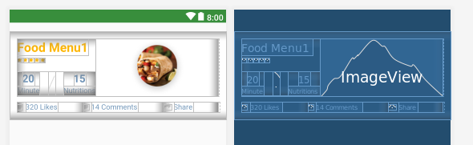

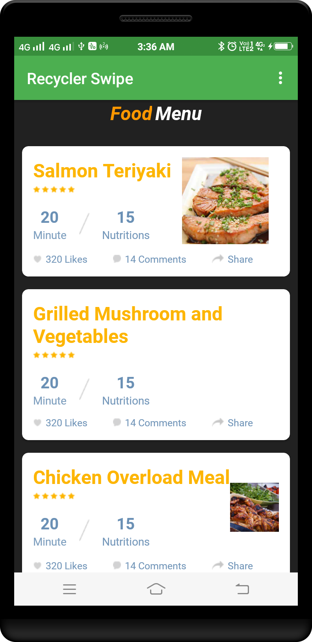

Example 13 :

***Step :- 1 Add Volley Dependency in build.gradle ( Module:app ) file.***

apply plugin: 'com.android.application'  
  
android {  
 compileSdkVersion 28  
 defaultConfig {  
 applicationId "card.view.app"  
 minSdkVersion 21  
 targetSdkVersion 28  
 versionCode 1  
 versionName "1.0"  
 testInstrumentationRunner "android.support.test.runner.AndroidJUnitRunner"  
 }  
 buildTypes {  
 release {  
 minifyEnabled false  
 proguardFiles getDefaultProguardFile('proguard-android-optimize.txt'), 'proguard-rules.pro'  
 }  
 }  
}  
  
dependencies {  
 implementation fileTree(dir: 'libs', include: ['*.jar'])  
 implementation 'com.android.support:appcompat-v7:28.0.0'  
 implementation 'com.android.support.constraint:constraint-layout:1.1.3'  
 testImplementation 'junit:junit:4.12'  
 androidTestImplementation 'com.android.support.test:runner:1.0.2'  
 androidTestImplementation 'com.android.support.test.espresso:espresso-core:3.0.2'  
 implementation 'com.android.support:design:28.0.0'  
 implementation 'com.android.support:cardview-v7:28.0.0'  
 implementation 'com.pkmmte.view:circularimageview:1.1'  
}

***item.png***



***ic_favorite_border_black_24dp.xml***

<vector xmlns:android="http://schemas.android.com/apk/res/android"  
 android:width="24dp"  
 android:height="24dp"  
 android:viewportWidth="24.0"  
 android:viewportHeight="24.0">  
 <path  
 android:fillColor="#FF000000"  
 android:pathData="M16.5,3c-1.74,0 -3.41,0.81 -4.5,2.09C10.91,3.81 9.24,3 7.5,3 4.42,3 2,5.42 2,8.5c0,3.78 3.4,6.86 8.55,11.54L12,21.35l1.45,-1.32C18.6,15.36 22,12.28 22,8.5 22,5.42 19.58,3 16.5,3zM12.1,18.55l-0.1,0.1 -0.1,-0.1C7.14,14.24 4,11.39 4,8.5 4,6.5 5.5,5 7.5,5c1.54,0 3.04,0.99 3.57,2.36h1.87C13.46,5.99 14.96,5 16.5,5c2,0 3.5,1.5 3.5,3.5 0,2.89 -3.14,5.74 -7.9,10.05z"/>  
</vector>

***ic_location_on_black_24dp.xml***

<vector xmlns:android="http://schemas.android.com/apk/res/android"  
 android:width="24dp"  
 android:height="24dp"  
 android:viewportWidth="24.0"  
 android:viewportHeight="24.0">  
 <path  
 android:fillColor="#FF000000"  
 android:pathData="M12,2C8.13,2 5,5.13 5,9c0,5.25 7,13 7,13s7,-7.75 7,-13c0,-3.87 -3.13,-7 -7,-7zM12,11.5c-1.38,0 -2.5,-1.12 -2.5,-2.5s1.12,-2.5 2.5,-2.5 2.5,1.12 2.5,2.5 -1.12,2.5 -2.5,2.5z"/>  
</vector>

***Step :- 2 card_view_design.xml file.***

*<?*xml version="1.0" encoding="utf-8"*?>*<android.support.v7.widget.CardView  
 xmlns:android="http://schemas.android.com/apk/res/android"  
 xmlns:app="http://schemas.android.com/apk/res-auto"  
 android:id="@+id/cardView"  
 android:layout_width="match_parent"  
 android:layout_height="wrap_content"  
 android:layout_marginTop="-10dp"  
 android:layoutDirection="ltr"  
 app:cardBackgroundColor="#FFFFFF"  
 app:cardCornerRadius="10dp"  
 app:cardElevation="10dp"  
 app:cardUseCompatPadding="true"  
 app:contentPadding="0dp">  
  
 <LinearLayout  
 android:layout_width="match_parent"  
 android:layout_height="wrap_content"  
 android:baselineAligned="false"  
 android:orientation="vertical">  
  
 *<!--Photo-->* <RelativeLayout  
 android:layout_width="match_parent"  
 android:layout_height="230dp">  
  
 <ImageView  
 android:id="@+id/photoACImgV"  
 android:layout_width="match_parent"  
 android:layout_height="230dp"  
 android:layout_gravity="center"  
 android:background="#00000000"  
 android:scaleType="centerCrop"  
 app:srcCompat="@drawable/item" />  
  
 <TextView  
 android:id="@+id/newFlagTv"  
 android:layout_width="80dp"  
 android:layout_height="wrap_content"  
 android:layout_alignParentBottom="true"  
 android:layout_alignParentEnd="true"  
 android:layout_margin="8dp"  
 android:background="@drawable/card_button_background"  
 android:gravity="center"  
 android:paddingBottom="4dp"  
 android:paddingEnd="12dp"  
 android:paddingStart="12dp"  
 android:paddingTop="4dp"  
 android:text="New"  
 android:textColor="#FFFFFF"  
 android:textSize="13sp"  
 android:visibility="visible" />  
 </RelativeLayout>  
  
 *<!--Content-->* <RelativeLayout  
 android:layout_width="match_parent"  
 android:layout_height="wrap_content"  
 android:padding="8dp">  
  
 <TextView  
 android:id="@+id/titleTv"  
 android:layout_width="match_parent"  
 android:layout_height="wrap_content"  
 android:gravity="start|center_vertical"  
 android:text="Title"  
 android:textColor="#444444"  
 android:textSize="20sp" />  
  
 <TextView  
 android:layout_below="@id/titleTv"  
 android:id="@+id/descriptionTv"  
 android:layout_width="match_parent"  
 android:layout_height="wrap_content"  
 android:gravity="start|center_vertical"  
 android:text="Description"  
 android:textColor="#444444"  
 android:textSize="14sp" />  
 </RelativeLayout>  
  
 *<!--divider-->* <ImageView  
 android:layout_width="match_parent"  
 android:layout_height="1dp"  
 android:layout_marginEnd="8dp"  
 android:layout_marginStart="8dp"  
 android:background="#EAEAEA" />  
  
 *<!--control btns-->* <RelativeLayout  
 android:layout_width="match_parent"  
 android:layout_height="wrap_content"  
 android:paddingBottom="4dp"  
 android:paddingEnd="8dp"  
 android:paddingStart="8dp"  
 android:paddingTop="4dp">  
  
 <ImageButton  
 android:id="@+id/likeBtn"  
 android:layout_width="wrap_content"  
 android:layout_height="wrap_content"  
 android:background="@android:color/transparent"  
 android:padding="8dp"  
 app:srcCompat="@drawable/ic_favorite_border_black_24dp" />  
  
 <ImageButton  
 android:id="@+id/locationImgBtn"  
 android:layout_width="wrap_content"  
 android:layout_height="wrap_content"  
 android:layout_alignEnd="@+id/likeBtn"  
 android:layout_centerVertical="true"  
 android:layout_marginEnd="-45dp"  
 android:background="@android:color/transparent"  
 android:padding="8dp"  
 app:srcCompat="@drawable/ic_location_on_black_24dp" />  
  
 <TextView  
 android:id="@+id/priceTv"  
 android:layout_width="wrap_content"  
 android:layout_height="wrap_content"  
 android:layout_alignParentEnd="true"  
 android:layout_centerVertical="true"  
 android:gravity="end|center_vertical"  
 android:text="000"  
 android:textColor="#444444"  
 android:textSize="20sp" />  
  
 <TextView  
 android:id="@+id/priceUnitTv"  
 android:layout_width="wrap_content"  
 android:layout_height="wrap_content"  
 android:layout_centerVertical="true"  
 android:layout_toStartOf="@+id/priceTv"  
 android:gravity="center"  
 android:text=" $ "  
 android:textColor="#444444"  
 android:textSize="20sp" />  
 </RelativeLayout>  
 </LinearLayout>  
</android.support.v7.widget.CardView>

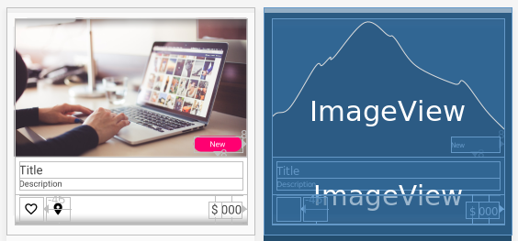

***Step :- 3 activity_main.xml file.***

*<?*xml version="1.0" encoding="utf-8"*?>*<LinearLayout  
 xmlns:android="http://schemas.android.com/apk/res/android"  
 xmlns:card_view="http://schemas.android.com/apk/res-auto"  
 android:id="@+id/layout_item"  
 android:layout_width="match_parent"  
 android:layout_height="wrap_content"  
 android:layout_margin="20dp"  
 android:orientation="vertical">  
  
 *<!-- Load the card view here -->* <include  
 layout="@layout/card_view_design"  
 android:layout_width="match_parent"  
 android:layout_height="wrap_content"/>  
  
 *<!-- Load the card view here -->* <include  
 layout="@layout/card_view_design"  
 android:layout_marginTop="10dp"  
 android:layout_width="match_parent"  
 android:layout_height="wrap_content"/>  
</LinearLayout>

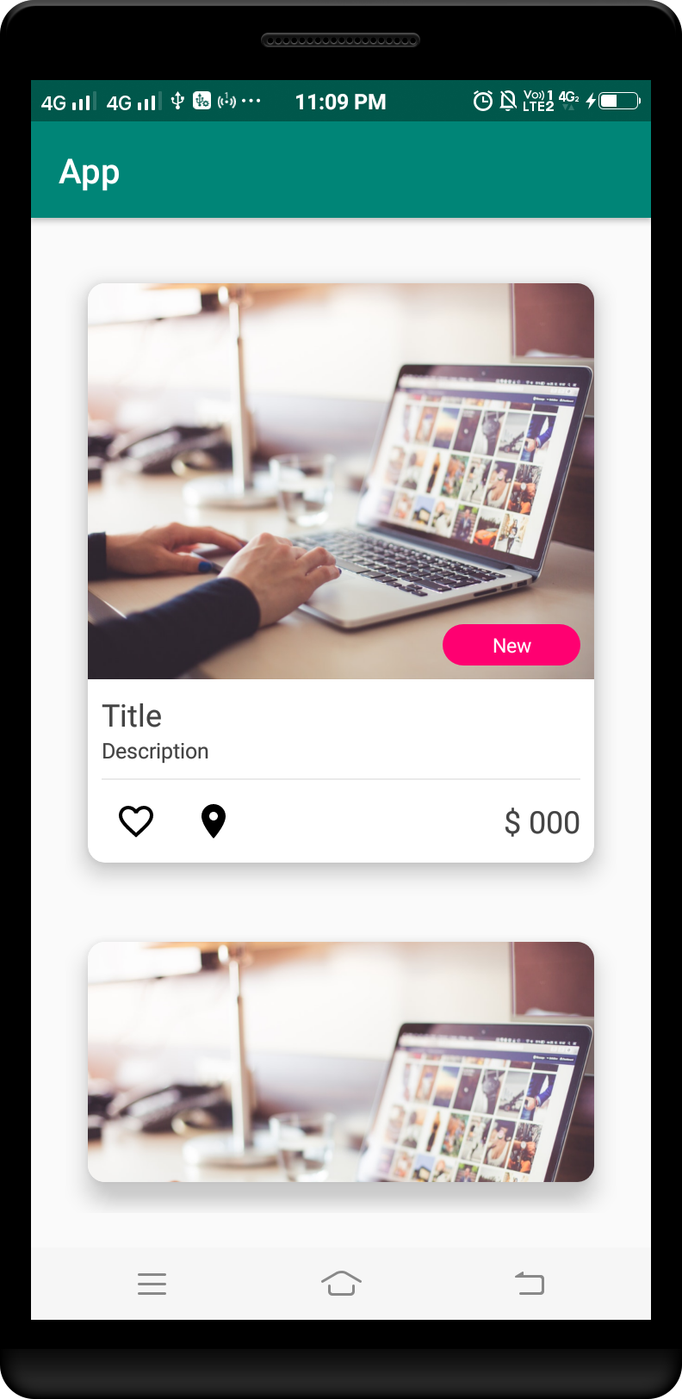

Example 14 :

***Step :- 2 card_view_design.xml file.***

*<?*xml version="1.0" encoding="utf-8"*?>*<RelativeLayout   
 xmlns:android="http://schemas.android.com/apk/res/android"  
 android:layout_width="match_parent"  
 android:layout_height="wrap_content"  
 android:background="@android:color/white"  
 android:clickable="true"  
 android:foreground="?attr/selectableItemBackground"  
 android:padding="16dp">  
  
 <ImageView  
 android:id="@+id/thumbnail"  
 android:layout_width="50dp"  
 android:layout_height="50dp"  
 android:layout_marginRight="10dp"  
 android:scaleType="centerCrop"  
 android:src="@drawable/ic_launcher_background"/>  
  
 <TextView  
 android:id="@+id/name"  
 android:layout_width="wrap_content"  
 android:layout_height="wrap_content"  
 android:layout_toRightOf="@id/thumbnail"  
 android:ellipsize="end"  
 android:fontFamily="sans-serif-medium"  
 android:maxLines="1"  
 android:text="name"  
 android:textColor="#0c0c0c"  
 android:textSize="15dp" />  
  
 <TextView  
 android:id="@+id/chef"  
 android:layout_width="wrap_content"  
 android:layout_height="wrap_content"  
 android:layout_below="@id/name"  
 android:layout_toRightOf="@id/thumbnail"  
 android:maxLines="1"  
 android:text="chef"  
 android:textColor="#0c0c0c"  
 android:textSize="12dp" />  
  
 <TextView  
 android:id="@+id/timestamp"  
 android:layout_width="wrap_content"  
 android:layout_height="wrap_content"  
 android:layout_below="@id/chef"  
 android:layout_toRightOf="@id/thumbnail"  
 android:maxLines="1"  
 android:text="2 min ago"  
 android:textColor="#0c0c0c"  
 android:textSize="11dp" />  
  
 <TextView  
 android:id="@+id/description"  
 android:layout_width="wrap_content"  
 android:layout_height="wrap_content"  
 android:layout_below="@id/thumbnail"  
 android:layout_marginTop="16dp"  
 android:ellipsize="end"  
 android:maxLines="3"  
 android:text="description"  
 android:textColor="#1a1a1a"  
 android:textSize="15dp"/>  
  
 <TextView  
 android:id="@+id/price"  
 android:layout_width="wrap_content"  
 android:layout_height="wrap_content"  
 android:layout_below="@id/description"  
 android:layout_marginTop="10dp"  
 android:textColor="#d91248"  
 android:textSize="13dp"  
 android:text="price"  
 android:textStyle="bold"/>  
  
</RelativeLayout>

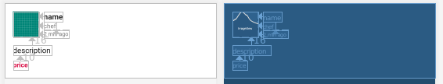

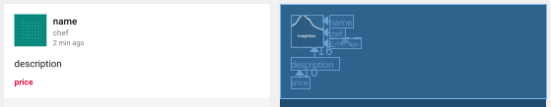

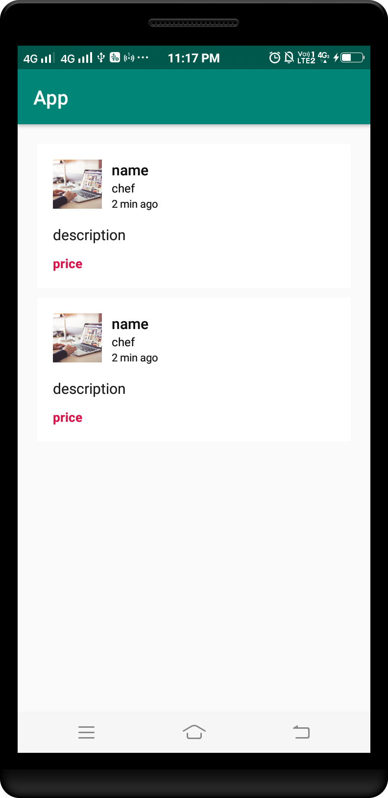

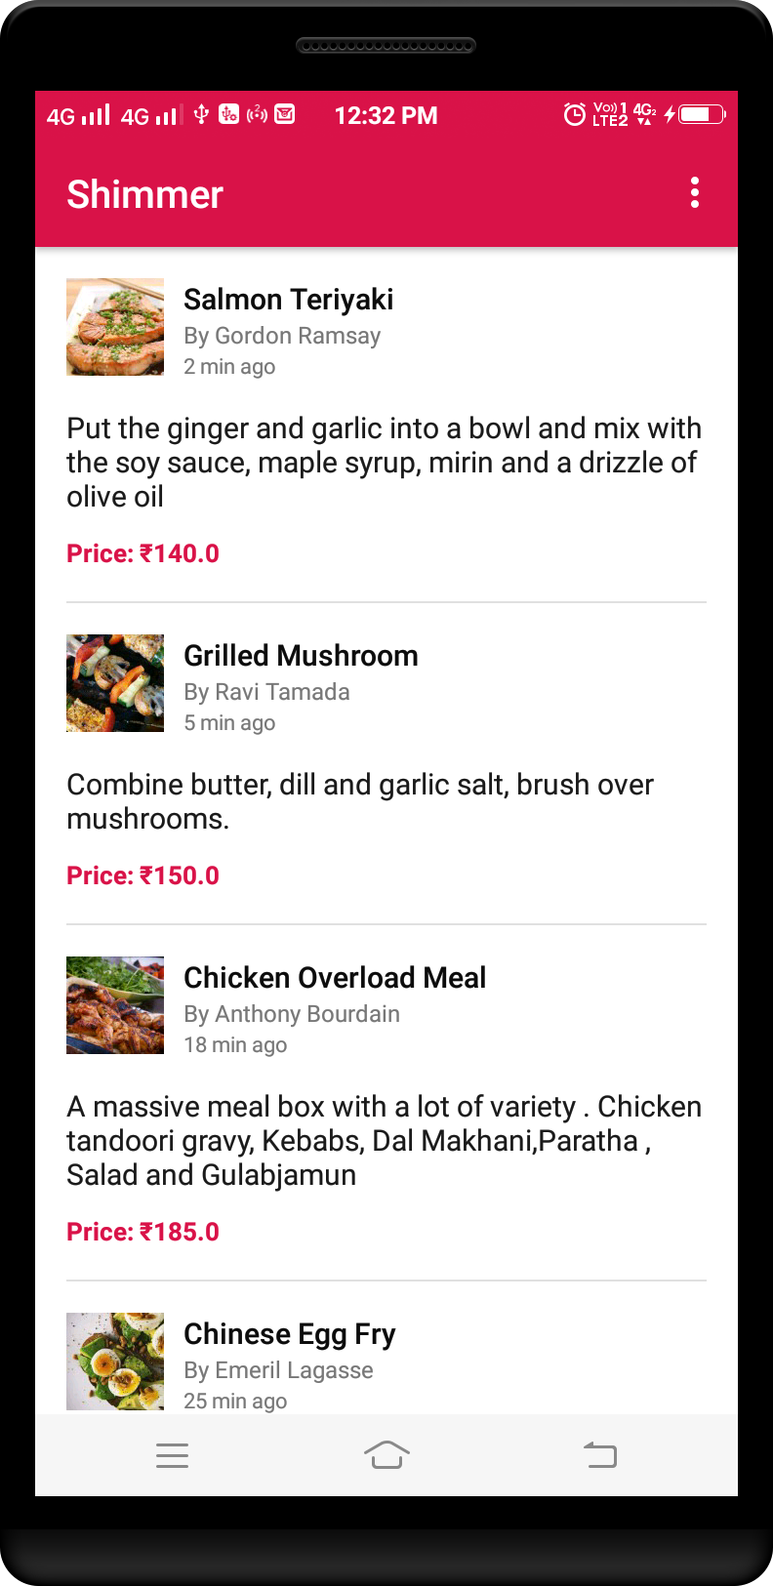

Example 15 :

***ic_keyboard_arrow_right_black_24dp.xml***

<vector xmlns:android="http://schemas.android.com/apk/res/android"  
 android:width="24dp"  
 android:height="24dp"  
 android:viewportWidth="24.0"  
 android:viewportHeight="24.0">  
 <path  
 android:fillColor="#FF000000"  
 android:pathData="M8.59,16.34l4.58,-4.59 -4.58,-4.59L10,5.75l6,6 -6,6z"/>  
</vector>

***Step :- 2 card_view_design.xml file.***

*<?*xml version="1.0" encoding="utf-8"*?>*<android.support.v7.widget.CardView  
 xmlns:android="http://schemas.android.com/apk/res/android"  
 xmlns:tools="http://schemas.android.com/tools"  
 android:layout_width="match_parent"  
 android:layout_height="wrap_content"  
 android:layout_marginTop="5dp"  
 android:layout_marginBottom="5dp"  
 android:backgroundTint="#B6B6B6">  
  
 <LinearLayout  
 android:layout_width="match_parent"  
 android:layout_height="wrap_content"  
 android:orientation="horizontal"  
 android:padding="8dp">  
  
 <TextView  
 android:layout_width="0dp"  
 android:layout_height="wrap_content"  
 android:layout_weight="1"  
 android:gravity="center"  
 android:singleLine="true"  
 android:textSize="10sp"  
 android:text="Master Bedroom"  
 tools:ignore="HardcodedText" />  
  
 <TextView  
 android:layout_width="0dp"  
 android:layout_height="wrap_content"  
 android:layout_weight="1"  
 android:gravity="center"  
 android:singleLine="true"  
 android:textSize="10sp"  
 android:text="Shail Automation Device"  
 tools:ignore="HardcodedText" />  
  
 <TextView  
 android:layout_width="0dp"  
 android:layout_height="wrap_content"  
 android:layout_weight="1"  
 android:gravity="center"  
 android:singleLine="true"  
 android:textSize="10sp"  
 android:text="Fan"  
 tools:ignore="HardcodedText" />  
  
 <ImageView  
 android:layout_width="15dp"  
 android:layout_height="15dp"  
 android:src="@drawable/ic_keyboard_arrow_right_black_24dp"/>  
 </LinearLayout>  
</android.support.v7.widget.CardView>



***Step :- 3 activity_main.xml file.***

*<?*xml version="1.0" encoding="utf-8"*?>*<LinearLayout  
 xmlns:android="http://schemas.android.com/apk/res/android"  
 xmlns:card_view="http://schemas.android.com/apk/res-auto"  
 android:id="@+id/layout_item"  
 android:layout_width="match_parent"  
 android:layout_height="match_parent"  
 android:layout_margin="20dp"  
 android:orientation="vertical">  
  
 *<!-- Load the card view here -->* <include  
 layout="@layout/card_view_design"  
 android:layout_width="match_parent"  
 android:layout_height="wrap_content"/>  
  
 *<!-- Load the card view here -->* <include  
 layout="@layout/card_view_design"  
 android:layout_marginTop="10dp"  
 android:layout_width="match_parent"  
 android:layout_height="wrap_content"/>  
</LinearLayout>

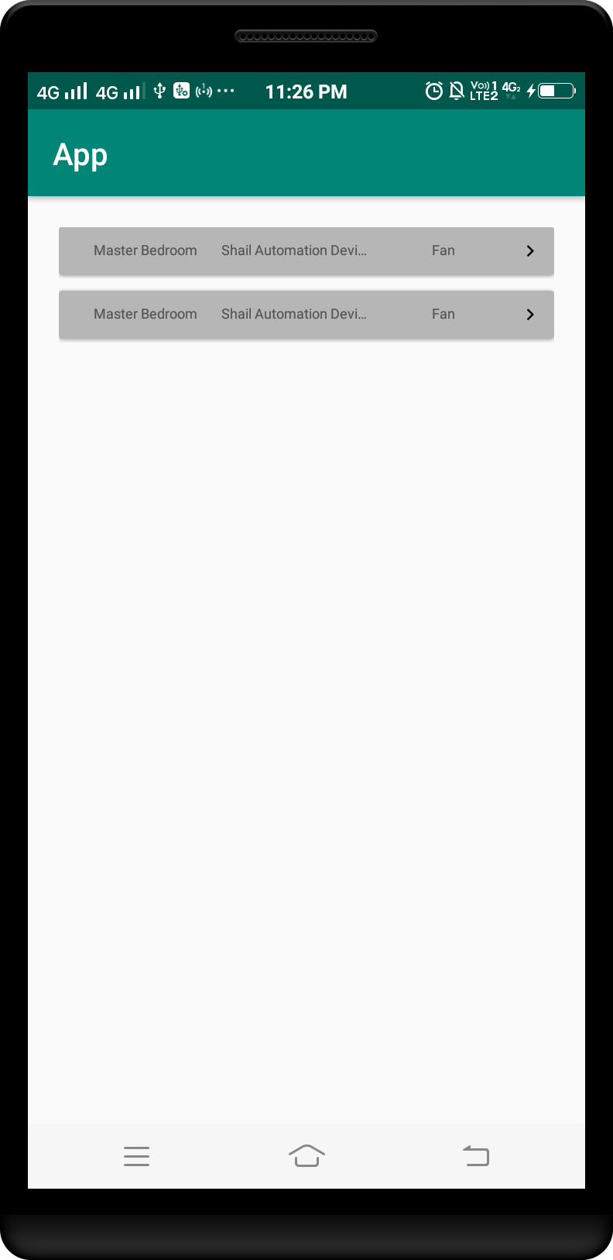

Example 16 :

***Step :- 2 card_view_design.xml file.***

*<?*xml version="1.0" encoding="utf-8"*?>*<android.support.v7.widget.CardView  
 xmlns:android="http://schemas.android.com/apk/res/android"  
 android:layout_height="wrap_content"  
 android:layout_width="match_parent"  
 xmlns:app="http://schemas.android.com/apk/res-auto"  
 app:cardCornerRadius="5dp"  
 app:cardElevation="0dp">  
  
 <ImageView  
 android:id="@+id/advertisment_image_view"  
 android:layout_width="match_parent"  
 android:layout_height="200dp"  
 android:scaleType="fitXY"  
 android:src="@drawable/item"/>  
</android.support.v7.widget.CardView>



***Step :- 3 activity_main.xml file.***

*<?*xml version="1.0" encoding="utf-8"*?>*<LinearLayout  
 xmlns:android="http://schemas.android.com/apk/res/android"  
 xmlns:card_view="http://schemas.android.com/apk/res-auto"  
 android:id="@+id/layout_item"  
 android:layout_width="match_parent"  
 android:layout_height="match_parent"  
 android:layout_margin="20dp"  
 android:orientation="vertical">  
  
 *<!-- Load the card view here -->* <include  
 layout="@layout/card_view_design"  
 android:layout_width="match_parent"  
 android:layout_height="wrap_content"/>  
  
 *<!-- Load the card view here -->* <include  
 layout="@layout/card_view_design"  
 android:layout_marginTop="10dp"  
 android:layout_width="match_parent"  
 android:layout_height="wrap_content"/>  
</LinearLayout>

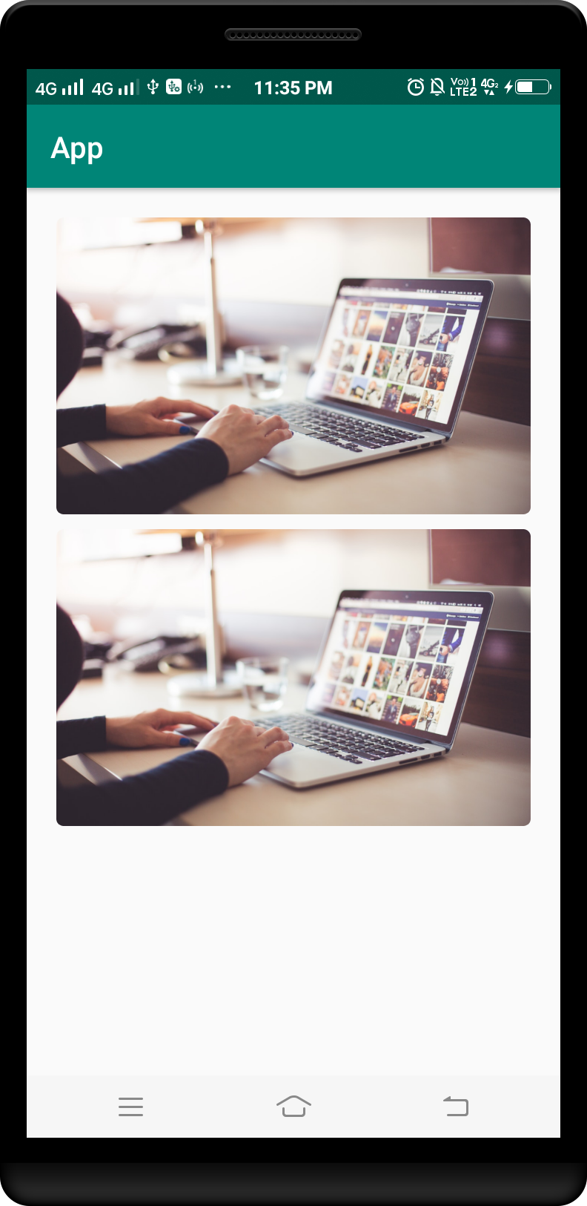

Example 17 :

***Step :- 2 card_view_design.xml file.***

*<?*xml version="1.0" encoding="utf-8"*?>*<android.support.v7.widget.CardView  
 xmlns:android="http://schemas.android.com/apk/res/android"  
 xmlns:app="http://schemas.android.com/apk/res-auto"  
 android:layout_width="150dp"  
 android:layout_height="200dp"  
 app:cardCornerRadius="3dp"  
 app:cardElevation="0dp"  
 app:cardMaxElevation="50dp">  
  
 <ImageView  
 android:id="@+id/imageView"  
 android:layout_width="match_parent"  
 android:scaleType="fitXY"  
 android:src="@drawable/item"  
 android:layout_height="200dp"/>  
</android.support.v7.widget.CardView>



***Step :- 3 activity_main.xml file.***

*<?*xml version="1.0" encoding="utf-8"*?>*<LinearLayout  
 xmlns:android="http://schemas.android.com/apk/res/android"  
 xmlns:card_view="http://schemas.android.com/apk/res-auto"  
 android:id="@+id/layout_item"  
 android:layout_width="match_parent"  
 android:layout_height="match_parent"  
 android:layout_margin="20dp"  
 android:orientation="horizontal">  
  
 *<!-- Load the card view here -->* <include  
 layout="@layout/card_view_design"  
 android:layout_width="match_parent"  
 android:layout_height="wrap_content"  
 android:layout_weight="1"/>  
  
 *<!-- Load the card view here -->* <include  
 layout="@layout/card_view_design"  
 android:layout_width="match_parent"  
 android:layout_height="wrap_content"  
 android:layout_marginStart="5dp"  
 android:layout_weight="1"/>  
</LinearLayout>

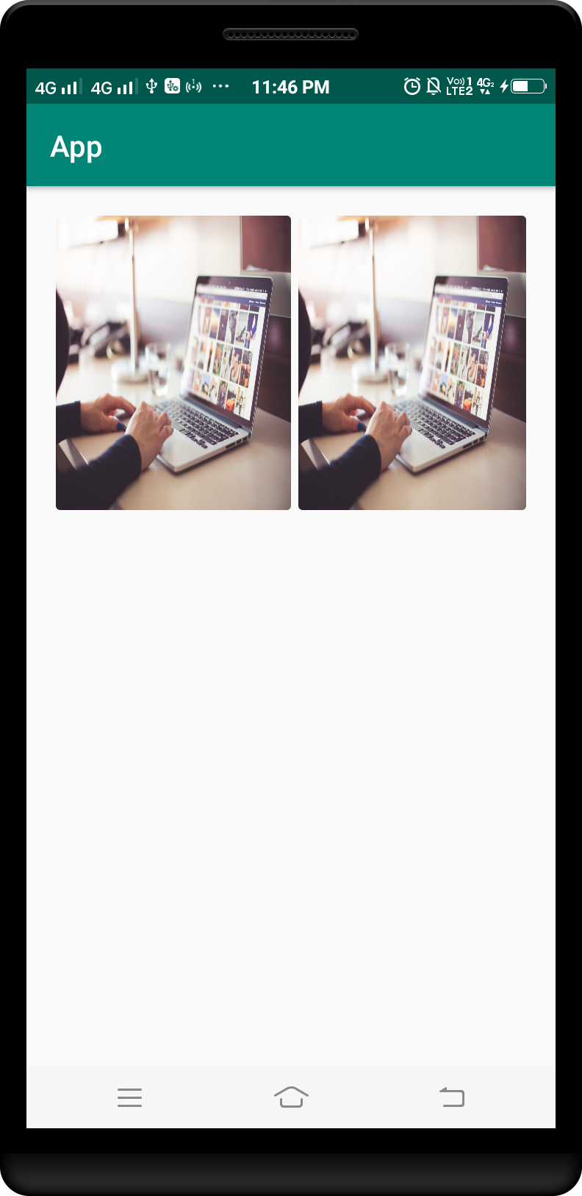



*<?***xml version="1.0" encoding="utf-8"***?>*<**LinearLayout   
 xmlns:android="http://schemas.android.com/apk/res/android"  
 xmlns:app="http://schemas.android.com/apk/res-auto"  
 android:layout_width="200dp"  
 android:layout_height="wrap_content"  
 android:background="@android:color/transparent"  
 android:orientation="vertical"**>  
  
 <**android.support.v7.widget.CardView  
 android:layout_width="200dp"  
 android:layout_height="wrap_content"  
 app:cardBackgroundColor="#3f4d50"  
 app:cardCornerRadius="10dp"  
 app:cardElevation="0dp"**>  
  
 <**LinearLayout  
 android:layout_width="match_parent"  
 android:layout_height="wrap_content"  
 android:layout_margin="5dp"  
 android:orientation="vertical"**>  
  
 <**ImageView  
 android:layout_width="match_parent"  
 android:layout_height="130dp"  
 android:background="#3f4d50"  
 android:contentDescription="Shoply"  
 android:src="@drawable/logo_small_no_background"** />  
  
 <**TextView  
 android:layout_width="match_parent"  
 android:layout_height="wrap_content"  
 android:gravity="center"  
 android:text="Shoply"  
 android:textColor="#f39225"** />  
  
 <**TextView  
 android:layout_width="match_parent"  
 android:layout_height="wrap_content"  
 android:layout_margin="5dp"  
 android:gravity="center"  
 android:text="Copywrite 2018"  
 android:textColor="#ffffff"** />  
  
 </**LinearLayout**>  
 </**android.support.v7.widget.CardView**>  
</**LinearLayout**>

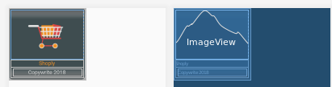



*<?***xml version="1.0" encoding="utf-8"***?>*<**android.support.v7.widget.CardView   
 xmlns:android="http://schemas.android.com/apk/res/android"  
 xmlns:app="http://schemas.android.com/apk/res-auto"  
 android:layout_width="70dp"  
 android:layout_height="70dp"  
 android:layout_margin="5dp"  
 app:cardBackgroundColor="#FFFFFF"  
 app:cardCornerRadius="5dp"**>  
  
 <**ImageView  
 android:layout_width="match_parent"  
 android:layout_height="match_parent"  
 android:layout_margin="5dp"  
 android:src="@drawable/brand1"** />  
</**android.support.v7.widget.CardView**>

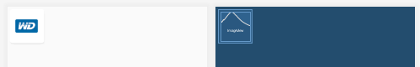

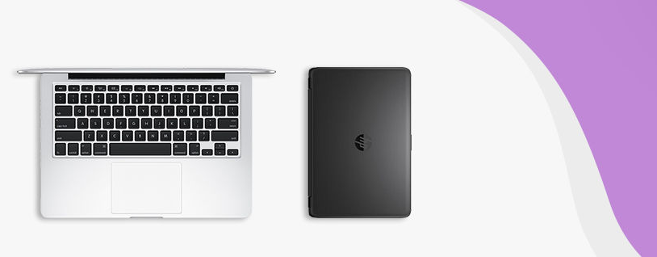

*<?***xml version="1.0" encoding="utf-8"***?>*<**android.support.v7.widget.CardView  
 xmlns:android="http://schemas.android.com/apk/res/android"  
 xmlns:app="http://schemas.android.com/apk/res-auto"  
 android:layout_width="match_parent"  
 android:layout_height="wrap_content"  
 android:layout_margin="5dp"  
 app:cardCornerRadius="10dp"  
 app:cardElevation="3dp"**>  
  
 <**RelativeLayout  
 android:layout_width="match_parent"  
 android:layout_height="150dp"  
 android:layout_margin="5dp"**>  
  
 <**ImageView  
 android:layout_width="match_parent"  
 android:layout_height="150dp"  
 android:scaleType="fitXY"  
 android:src="@drawable/cover1"** />  
  
 <**TextView  
 android:layout_width="match_parent"  
 android:layout_height="30dp"  
 android:layout_alignParentBottom="true"  
 android:background="#649f9f9f"  
 android:gravity="center|start"  
 android:paddingEnd="5dp"  
 android:paddingStart="5dp"  
 android:text="Computers &amp; Laptops"  
 android:textColor="#3f4d50"  
 android:textSize="18sp"  
 android:textStyle="bold"** />  
 </**RelativeLayout**>  
</**android.support.v7.widget.CardView**>

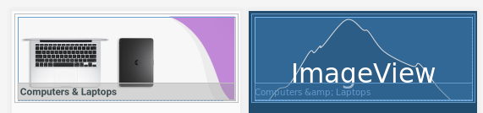

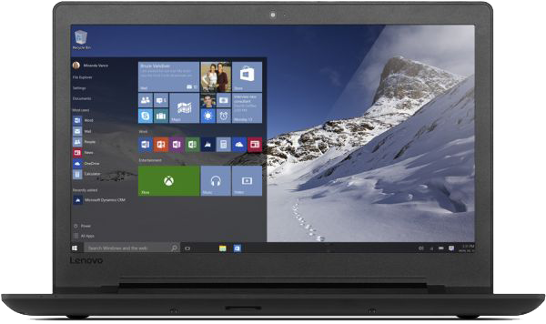

*<?***xml version="1.0" encoding="utf-8"***?>*<**android.support.v7.widget.CardView  
 xmlns:android="http://schemas.android.com/apk/res/android"  
 xmlns:app="http://schemas.android.com/apk/res-auto"  
 android:layout_width="100dp"  
 android:layout_height="wrap_content"  
 android:layout_margin="5dp"  
 app:cardBackgroundColor="#ffffff"  
 app:cardCornerRadius="5dp"**>  
  
 <**LinearLayout  
 android:layout_width="match_parent"  
 android:layout_height="wrap_content"  
 android:layout_margin="5dp"  
 android:orientation="vertical"**>  
  
 <**ImageView  
 android:layout_width="90dp"  
 android:layout_height="90dp"  
 android:background="#e6e6e5"  
 android:src="@drawable/img1"** />  
  
 <**TextView  
 android:layout_width="match_parent"  
 android:layout_height="wrap_content"  
 android:text="Lenovo Ideapad 310 laptop"  
 android:textColor="#000000"  
 android:textSize="12sp"** />  
  
 <**TextView  
 android:layout_width="match_parent"  
 android:layout_height="wrap_content"  
 android:text="7,999 EGP"  
 android:textColor="#2f383a"  
 android:textSize="12sp"** />  
  
 </**LinearLayout**>  
</**android.support.v7.widget.CardView**>

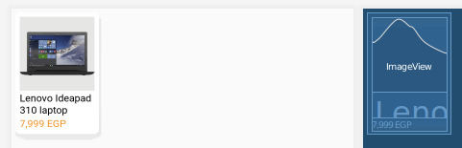

card_background.xml

*<?***xml version="1.0" encoding="utf-8"***?>*<**selector  
 xmlns:android="http://schemas.android.com/apk/res/android"**>  
  
 <**item android:state_focused="true"**>  
  
 <**shape android:shape="rectangle"**>  
  
 <**padding  
 android:left="4dp"  
 android:top="4dp"  
 android:right="4dp"  
 android:bottom="4dp"**/>  
  
 <**gradient android:startColor="#1c88b7" android:endColor="#2972ba" android:angle="270"**/>  
  
 <**corners android:topLeftRadius="4dp" android:topRightRadius="4dp"**/>  
 </**shape**>  
  
 </**item**>  
  
 <**item android:state_focused="false"**>  
  
 <**shape android:shape="rectangle"**>  
  
 <**padding  
 android:left="4dp"  
 android:top="4dp"  
 android:right="4dp"  
 android:bottom="4dp"**/>  
  
 <**gradient android:startColor="#b71c83" android:endColor="#29ba41" android:angle="270"**/>  
  
 <**corners android:topLeftRadius="4dp" android:topRightRadius="4dp"**/>  
 </**shape**>  
 </**item**>  
</**selector**>

activity_main.xml

*<?***xml version="1.0" encoding="utf-8"***?>*<**LinearLayout  
 xmlns:android="http://schemas.android.com/apk/res/android"  
 android:layout_width="match_parent"  
 android:layout_height="wrap_content"  
 android:orientation="vertical"  
 android:tag="cards main container"**>  
  
 <**android.support.v7.widget.CardView  
 android:id="@+id/card_view"  
 xmlns:card_view="http://schemas.android.com/apk/res-auto"  
 android:layout_width="match_parent"  
 android:layout_height="wrap_content"  
 card_view:cardBackgroundColor="#FFFFFF"  
 card_view:cardCornerRadius="10dp"  
 card_view:cardElevation="5dp"  
 card_view:cardUseCompatPadding="true"**>  
  
 <**LinearLayout  
 android:layout_width="match_parent"  
 android:layout_height="wrap_content"  
 android:orientation="vertical"**>  
  
 <**TextView  
 android:layout_width="match_parent"  
 android:layout_height="match_parent"  
 android:id="@+id/tv"  
 android:height="40dp"  
 android:background="@drawable/card_background"  
 android:gravity="center_vertical"  
 android:paddingLeft="10dp"  
 android:text="Awesome design"  
 android:textColor="#fff"  
 android:textStyle="bold"  
 android:textSize="18sp"** />  
  
 <**LinearLayout  
 android:layout_width="wrap_content"  
 android:layout_height="wrap_content"  
 android:orientation="horizontal"**>  
  
 <**CheckBox  
 android:layout_width="wrap_content"  
 android:layout_height="wrap_content"  
 android:layout_marginTop="5dp"  
 android:id="@+id/cb"  
 android:text="Checkbox"**/>  
  
 <**TextView  
 android:layout_width="wrap_content"  
 android:layout_height="wrap_content"  
 android:id="@+id/animal"  
 android:layout_marginLeft="20dp"  
 android:textSize="20sp"  
 android:layout_marginTop="5dp"  
 android:text="animal"**/>  
 </**LinearLayout**>  
 </**LinearLayout**>  
 </**android.support.v7.widget.CardView**>  
</**LinearLayout**>

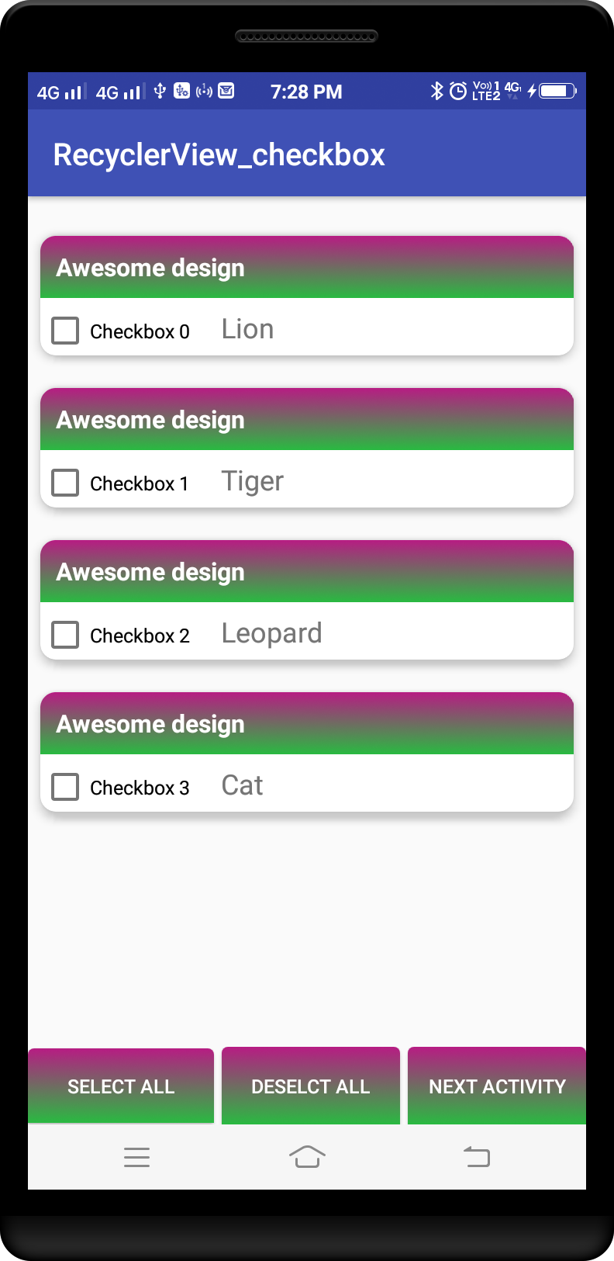

# Using of ConstraintLayout to build out CardView with Material Design

[Material design guidelines](https://material.io/guidelines/components/cards.html?source=post_page---------------------------" \l "cards-content-blocks) mention that cards can be constructed using blocks of content which include:

* An optional header
* A primary title
* Rich media
* Supporting text
* Actions

These blocks can be organized to promote different types of content. Let’s consider some possible [combinations of content blocks](https://material.io/guidelines/components/cards.html?source=post_page---------------------------" \l "cards-content-blocks) to build cards and how they can be implemented using ConstraintLayout.

# **1 Media 16:9 and supporting text**

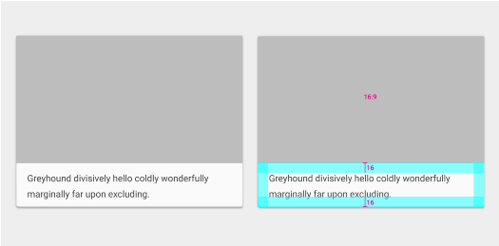

Taken from Material design guidelines

# **2 Avatar, media 16:9, supporting text and action buttons**

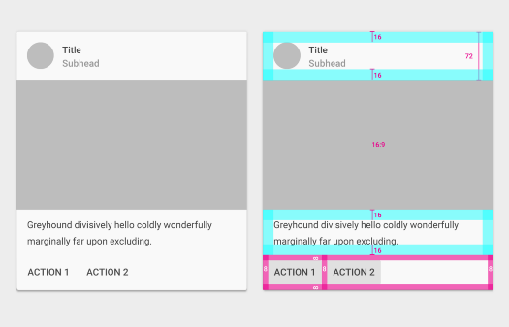

Taken from Material design guidelines

# **3 Avatar, media 16:9 and action buttons**

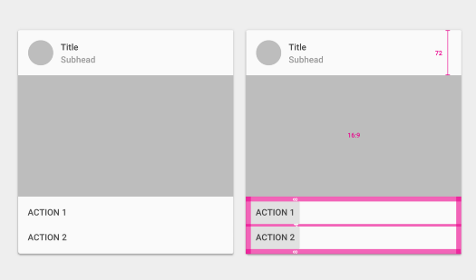

Taken from Material design guidelines

# **4 Media 16:9, p**rimary text, subtext,** actions and expandable supporting text**

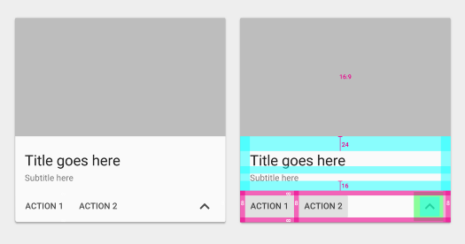

Taken from Material design guidelines

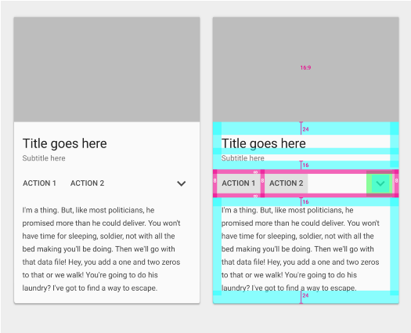

Taken from Material design guidelines

# **5 P**rimary text, subtext,** supporting text and actions**

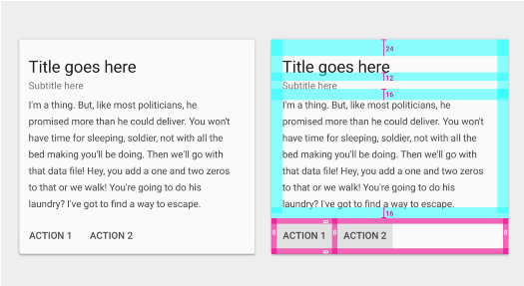

Taken from Material design guidelines

# **6 Media 16:9 and actions**

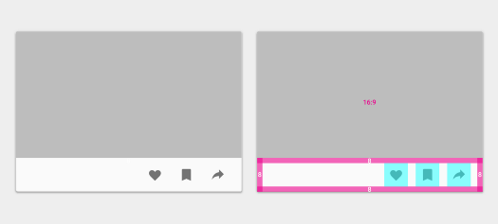

Taken from Material design guidelines

# **7 Media 1:1, primary text, subtext and actions**

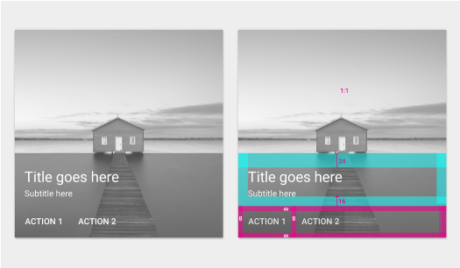

Taken from Material design guidelines

# **8 Media 1x, primary text, subtext and actions**

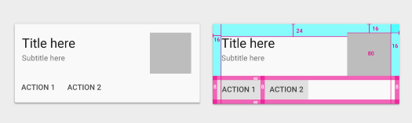

Taken from Material design guidelines

# **9 Media 1.5x, primary text, subtext and actions**

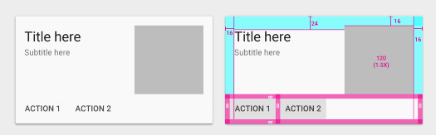

Taken from Material design guidelines

# **10 Media 2x, primary text, subtext and actions**

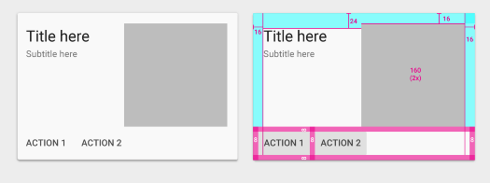

Taken from Material design guidelines

# **11 Media 3x and actions**

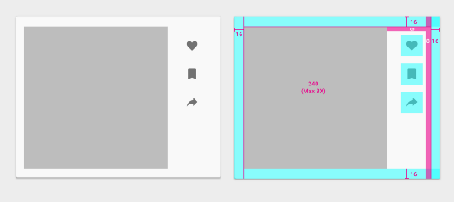

Taken from Material design guidelines

You can find source code for all the examples chek in lab work folder

<https://docs.microsoft.com/en-us/xamarin/android/user-interface/controls/card-view>

# [Android Elevation Example](https://www.viralandroid.com/2015/09/android-elevation-example.html)

### **XML Layout File**

*res/layout/activity_main.xml*

<**LinearLayout xmlns:android="http://schemas.android.com/apk/res/android"  
 xmlns:tools="http://schemas.android.com/tools"  
 android:layout_width="match_parent"  
 android:layout_height="match_parent"  
 android:orientation="vertical"  
 android:paddingBottom="@dimen/activity_vertical_margin"  
 android:paddingLeft="@dimen/activity_horizontal_margin"  
 android:paddingRight="@dimen/activity_horizontal_margin"  
 android:paddingTop="@dimen/activity_vertical_margin"  
 tools:context=".MainActivity"**>  
  
 <**TextView  
 android:layout_width="match_parent"  
 android:layout_height="100dp"  
 android:background="#fff"  
 android:elevation="4dp"  
 android:gravity="center"  
 android:text="Elevation = 4dp"** />  
  
 <**TextView  
 android:layout_width="match_parent"  
 android:layout_height="100dp"  
 android:layout_marginTop="16dp"  
 android:background="#fff"  
 android:elevation="6dp"  
 android:gravity="center"  
 android:text="Elevation = 6dp"** />  
  
 <**TextView  
 android:layout_width="match_parent"  
 android:layout_height="100dp"  
 android:layout_marginTop="16dp"  
 android:background="#fff"  
 android:elevation="10dp"  
 android:gravity="center"  
 android:text="Elevation 10dp"** />  
  
 <**TextView  
 android:layout_width="match_parent"  
 android:layout_height="100dp"  
 android:layout_marginTop="16dp"  
 android:background="#fff"  
 android:elevation="16dp"  
 android:gravity="center"  
 android:text="Elevation = 16dp"** />  
  
</**LinearLayout**>

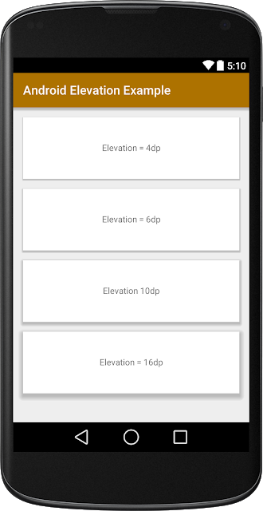

*<?***xml version="1.0" encoding="utf-8"***?>*<**RelativeLayout   
 xmlns:android="http://schemas.android.com/apk/res/android"  
 xmlns:app="http://schemas.android.com/apk/res-auto"  
 android:layout_width="match_parent"  
 android:layout_height="wrap_content"  
 android:background="#66639E"**>  
  
 <**TextView  
 android:id="@+id/username"  
 android:layout_width="wrap_content"  
 android:layout_height="wrap_content"  
 android:layout_alignTop="@+id/profile_image_view"  
 android:layout_toRightOf="@+id/profile_image_view"  
 android:layout_toEndOf="@+id/profile_image_view"  
 android:layout_marginTop="10dp"  
 android:textSize="18sp"  
 android:textColor="#6BCEF7"  
 android:text="Rohit Yadav"**/>  
  
 <**TextView  
 android:id="@+id/message"  
 android:layout_width="wrap_content"  
 android:layout_height="wrap_content"  
 android:layout_alignLeft="@+id/username"  
 android:layout_alignStart="@+id/username"  
 android:layout_below="@+id/username"  
 android:layout_marginTop="10dp"  
 android:textColor="#FFFFFF"  
 android:text="Android Developer at Reoft Technology"**/>  
  
 <**TextView  
 android:id="@+id/time"  
 android:layout_width="wrap_content"  
 android:layout_height="wrap_content"  
 android:layout_alignParentRight="true"  
 android:layout_alignParentEnd="true"  
 android:layout_margin="5dp"  
 android:textColor="#958CC8"  
 android:layout_alignParentTop="true"  
 android:text="20 july 2019"**/>  
  
 <**ImageView  
 android:id="@+id/profile_image_view"  
 android:layout_width="80dp"  
 android:layout_height="80dp"  
 android:layout_alignParentStart="true"  
 android:layout_alignParentTop="true"  
 android:layout_alignParentLeft="true"  
 android:adjustViewBounds="true"  
 android:src="@drawable/ic_img_chat_one"**/>  
</**RelativeLayout**>

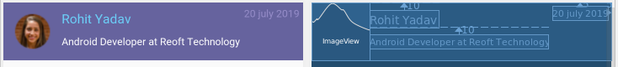

*<?***xml version="1.0" encoding="utf-8"***?>*<**RelativeLayout  
 xmlns:android="http://schemas.android.com/apk/res/android"  
 android:layout_width="match_parent"  
 android:layout_height="wrap_content"  
 android:layout_margin="10dp"  
 android:background="#CCC8C8"  
 android:padding="10dp"**>  
  
 <**ImageView  
 android:id="@+id/company_logo"  
 android:layout_width="80dp"  
 android:layout_height="80dp"  
 android:padding="5dp"  
 android:layout_centerHorizontal="true"  
 android:src="@drawable/c1"**/>  
  
 <**RelativeLayout  
 android:layout_below="@+id/company_logo"  
 android:id="@+id/content_relative_layout"  
 android:layout_width="match_parent"  
 android:layout_height="wrap_content"**>  
  
 <**TextView  
 android:id="@+id/company_name_text_view"  
 android:layout_width="wrap_content"  
 android:layout_height="wrap_content"  
 android:layout_centerHorizontal="true"  
 android:textStyle="bold"  
 android:textSize="18dp"  
 android:text="Apple"**/>  
  
 <**TextView  
 android:id="@+id/company_price_text_view"  
 android:layout_below="@+id/company_name_text_view"  
 android:layout_width="wrap_content"  
 android:layout_height="wrap_content"  
 android:layout_centerHorizontal="true"  
 android:layout_marginTop="5dp"  
 android:text="USD 1000K$"**/>  
 </**RelativeLayout**>  
</**RelativeLayout**>

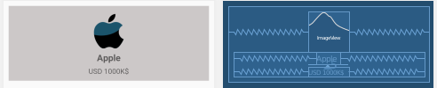

*<?***xml version="1.0" encoding="utf-8"***?>*<**android.support.v7.widget.CardView  
 xmlns:card_view="http://schemas.android.com/apk/res-auto"  
 xmlns:android="http://schemas.android.com/apk/res/android"  
 android:layout_width="100dp"  
 android:layout_height="wrap_content"  
 card_view:cardBackgroundColor="#B1B3B3"  
 card_view:cardUseCompatPadding="true"  
 card_view:cardCornerRadius="8dp"  
 android:layout_marginBottom="16dp"**>  
  
 <**RelativeLayout  
 android:layout_width="match_parent"  
 android:layout_height="match_parent"**>  
  
 <**ImageView  
 android:id="@+id/country_photo"  
 android:layout_width="wrap_content"  
 android:layout_height="wrap_content"  
 android:src="@drawable/c1"  
 android:scaleType="fitXY"** />  
  
 <**TextView  
 android:id="@+id/country_name"  
 android:layout_width="match_parent"  
 android:layout_height="wrap_content"  
 android:textSize="13sp"  
 android:text="Country Name"  
 android:textColor="#FFFFFF"  
 android:gravity="center"  
 android:layout_below="@+id/country_photo"  
 android:paddingBottom="8dp"  
 android:paddingTop="8dp"  
 android:background="#000000"**/>  
 </**RelativeLayout**>  
</**android.support.v7.widget.CardView**>



*<?***xml version="1.0" encoding="utf-8"***?>*<**android.support.v7.widget.CardView  
 xmlns:card_view="http://schemas.android.com/apk/res-auto"  
 xmlns:android="http://schemas.android.com/apk/res/android"  
 android:layout_width="100dp"  
 android:layout_height="wrap_content"  
 card_view:cardBackgroundColor="#FFFFFF"  
 card_view:cardUseCompatPadding="true"  
 card_view:cardCornerRadius="4dp"  
 card_view:cardElevation="4dp"**>  
  
 <**RelativeLayout  
 android:layout_width="wrap_content"  
 android:layout_height="wrap_content"**>  
  
 <**ImageView  
 android:id="@+id/image_view"  
 android:layout_width="wrap_content"  
 android:layout_height="wrap_content"  
 android:layout_alignParentTop="true"  
 android:layout_centerHorizontal="true"  
 android:scaleType="fitXY"  
 android:src="@drawable/c1"**/>  
  
 <**TextView  
 android:id="@+id/title_text_view"  
 android:layout_width="match_parent"  
 android:layout_height="wrap_content"  
 android:gravity="center"  
 android:layout_below="@+id/image_view"  
 android:layout_alignLeft="@+id/image_view"  
 android:layout_alignStart="@+id/image_view"  
 android:text="Title"  
 android:inputType="text"  
 android:textColor="#000"  
 android:layout_marginTop="8dp"  
 android:textSize="12dp"**/>  
  
 <**TextView  
 android:id="@+id/music_author"  
 android:layout_width="match_parent"  
 android:layout_height="wrap_content"  
 android:gravity="center"  
 android:layout_below="@+id/title_text_view"  
 android:layout_alignLeft="@+id/title_text_view"  
 android:layout_alignStart="@+id/title_text_view"  
 android:layout_marginTop="5dp"  
 android:layout_marginBottom="5dp"  
 android:text="Sub Title"  
 android:textSize="12sp"**/>  
 </**RelativeLayout**>  
</**android.support.v7.widget.CardView**>



*<?***xml version="1.0" encoding="utf-8"***?>*<**LinearLayout  
 xmlns:android="http://schemas.android.com/apk/res/android"  
 xmlns:card_view="http://schemas.android.com/apk/res-auto"  
 android:layout_width="match_parent"  
 android:layout_height="wrap_content"  
 android:layout_margin="4dp"  
 android:orientation="vertical"**>  
  
 <**android.support.v7.widget.CardView  
 android:layout_width="match_parent"  
 android:layout_height="match_parent"  
 android:layout_margin="5dp"  
 card_view:cardCornerRadius="4dp"  
 card_view:cardElevation="3dp"**>  
  
 <**RelativeLayout  
 android:background="?android:attr/selectableItemBackground"  
 android:clickable="true"  
 android:focusable="true"  
 android:layout_width="match_parent"  
 android:layout_height="match_parent"**>  
  
 <**ImageView  
 android:id="@+id/food_image_view"  
 android:layout_width="match_parent"  
 android:layout_height="160dp"  
 android:layout_alignParentTop="true"  
 android:layout_centerHorizontal="true"  
 android:src="@drawable/placeholder"** />  
  
 <**TextView  
 android:id="@+id/food_name"  
 android:layout_width="wrap_content"  
 android:layout_height="wrap_content"  
 android:layout_alignParentLeft="true"  
 android:layout_alignParentStart="true"  
 android:layout_below="@+id/food_image_view"  
 android:layout_marginLeft="12dp"  
 android:layout_marginStart="12dp"  
 android:text="Peppy Paneer"  
 android:textSize="14sp"  
 android:textStyle="bold"**/>  
  
 <**TextView  
 android:id="@+id/food_price"  
 android:layout_width="wrap_content"  
 android:layout_height="wrap_content"  
 android:layout_alignLeft="@+id/food_name"  
 android:layout_alignStart="@+id/food_name"  
 android:layout_below="@+id/food_name"  
 android:layout_marginBottom="10dp"  
 android:layout_marginTop="4dp"  
 android:text="Price : \u20B9 150"  
 android:textSize="12sp"** />  
  
 <**ImageView  
 android:id="@+id/menuDots"  
 android:layout_width="wrap_content"  
 android:layout_height="wrap_content"  
 android:layout_alignParentEnd="true"  
 android:layout_alignParentRight="true"  
 android:layout_alignTop="@+id/food_price"  
 android:src="@drawable/ic_more_vert_black_24dp"** />  
 </**RelativeLayout**>  
 </**android.support.v7.widget.CardView**>  
</**LinearLayout**>

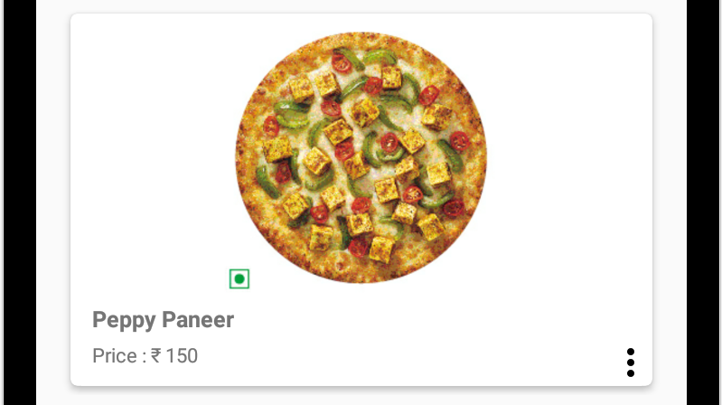

*<?***xml version="1.0" encoding="utf-8"***?>*<**LinearLayout  
 xmlns:android="http://schemas.android.com/apk/res/android"  
 xmlns:card_view="http://schemas.android.com/apk/res-auto"  
 android:layout_width="match_parent"  
 android:layout_height="wrap_content"  
 android:layout_margin="4dp"  
 android:orientation="vertical"**>  
  
 <**android.support.v7.widget.CardView  
 android:layout_width="match_parent"  
 android:layout_height="match_parent"  
 android:layout_margin="5dp"  
 card_view:cardCornerRadius="4dp"  
 card_view:cardElevation="3dp"**>  
  
 <**RelativeLayout  
 android:clickable="true"  
 android:focusable="true"  
 android:layout_width="match_parent"  
 android:layout_height="match_parent"**>  
  
 <**ImageView  
 android:id="@+id/food_image_view"  
 android:layout_width="match_parent"  
 android:layout_height="160dp"  
 android:layout_alignParentTop="true"  
 android:layout_centerHorizontal="true"  
 android:src="@drawable/placeholder"** />  
  
 <**TextView  
 android:id="@+id/food_name"  
 android:layout_width="wrap_content"  
 android:layout_height="wrap_content"  
 android:layout_alignParentLeft="true"  
 android:layout_alignParentStart="true"  
 android:layout_below="@+id/food_image_view"  
 android:layout_marginLeft="12dp"  
 android:layout_marginStart="12dp"  
 android:text="Peppy Paneer"  
 android:textSize="14sp"  
 android:textStyle="bold"**/>  
  
 <**TextView  
 android:id="@+id/food_price"  
 android:layout_width="wrap_content"  
 android:layout_height="wrap_content"  
 android:layout_alignLeft="@+id/food_name"  
 android:layout_alignStart="@+id/food_name"  
 android:layout_below="@+id/food_name"  
 android:layout_marginBottom="10dp"  
 android:layout_marginTop="4dp"  
 android:text="Price : \u20B9 150"  
 android:textSize="12sp"** />  
  
 <**ImageView  
 android:id="@+id/menuDots"  
 android:layout_width="wrap_content"  
 android:layout_height="wrap_content"  
 android:layout_alignParentEnd="true"  
 android:layout_alignParentRight="true"  
 android:layout_marginBottom="5dp"  
 android:layout_marginRight="5dp"  
 android:layout_marginEnd="5dp"  
 android:layout_alignTop="@+id/food_price"  
 android:src="@drawable/ic_more_vert_black_24dp"  
 android:background="?android:attr/selectableItemBackground"**/>  
 </**RelativeLayout**>  
 </**android.support.v7.widget.CardView**>  
</**LinearLayout**>

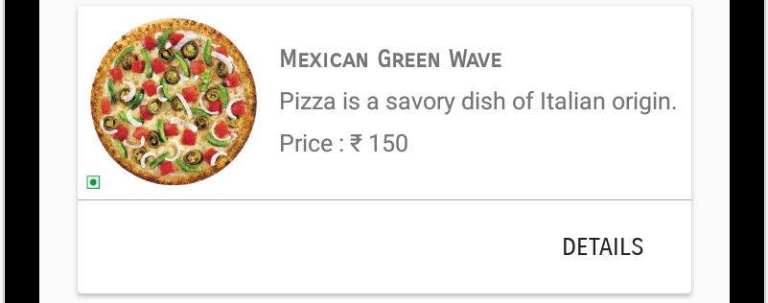

*<?***xml version="1.0" encoding="utf-8"***?>*<**android.support.v7.widget.CardView  
 xmlns:android="http://schemas.android.com/apk/res/android"  
 xmlns:card_view="http://schemas.android.com/apk/res-auto"  
 android:id="@+id/food_card_view"  
 android:layout_width="match_parent"  
 android:layout_height="150dp"  
 android:layout_marginTop="10dp"  
 android:layout_marginLeft="10dp"  
 android:layout_marginRight="10dp"  
 android:clickable="true"  
 android:focusable="true"  
 android:elevation="60dp"  
 android:foreground="?android:attr/selectableItemBackground"**>  
  
 <**RelativeLayout  
 android:layout_width="match_parent"  
 android:layout_height="match_parent"**>  
  
 <**ImageView  
 android:id="@+id/food_image_view"  
 android:layout_width="100dp"  
 android:layout_height="100dp"  
 android:scaleType="fitXY"  
 android:src="@drawable/mexican_green_wave"**/>  
  
 <**TextView  
 android:id="@+id/food_name_text_view"  
 android:layout_width="wrap_content"  
 android:layout_height="wrap_content"  
 android:layout_toEndOf="@id/food_image_view"  
 android:layout_toRightOf="@id/food_image_view"  
 android:layout_marginLeft="5dp"  
 android:layout_marginStart="5dp"  
 android:layout_marginTop="20dp"  
 android:text="Mexican Green Wave"  
 android:textStyle="bold"  
 android:fontFamily="sans-serif-smallcaps"**/>  
  
 <**TextView  
 android:id="@+id/food_description_text_view"  
 android:layout_width="wrap_content"  
 android:layout_height="wrap_content"  
 android:layout_marginStart="5dp"  
 android:layout_marginLeft="5dp"  
 android:layout_marginTop="5dp"  
 android:layout_toRightOf="@id/food_image_view"  
 android:layout_toEndOf="@id/food_image_view"  
 android:layout_below="@id/food_name_text_view"  
 android:text="Pizza is a savory dish of Italian origin."**/>  
  
 <**TextView  
 android:id="@+id/food_price_text_view"  
 android:layout_width="wrap_content"  
 android:layout_height="wrap_content"  
 android:layout_marginStart="5dp"  
 android:layout_marginLeft="5dp"  
 android:layout_marginTop="5dp"  
 android:layout_toEndOf="@id/food_image_view"  
 android:layout_toRightOf="@id/food_image_view"  
 android:layout_below="@id/food_description_text_view"  
 android:text="Price : \u20B9 150"**/>  
  
 <**View  
 android:id="@+id/horizontal_line"  
 android:layout_width="match_parent"  
 android:layout_height="0.5dp"  
 android:layout_marginTop="1dp"  
 android:layout_below="@id/food_image_view"  
 android:background="@android:color/darker_gray"**/>  
  
 <**Button  
 android:layout_below="@id/horizontal_line"  
 style="@style/Widget.AppCompat.Button.Borderless"  
 android:id="@+id/more_food_detail"  
 android:layout_width="wrap_content"  
 android:layout_height="wrap_content"  
 android:layout_alignParentBottom="true"  
 android:layout_alignParentEnd="true"  
 android:layout_alignParentRight="true"  
 android:layout_marginEnd="2dp"  
 android:layout_marginTop="2dp"  
 android:layout_marginRight="2dp"  
 android:layout_marginBottom="2dp"  
 android:text="DETAILS"  
 android:fontFamily="sans-serif-smallcaps"**/>  
 </**RelativeLayout**>  
</**android.support.v7.widget.CardView**>

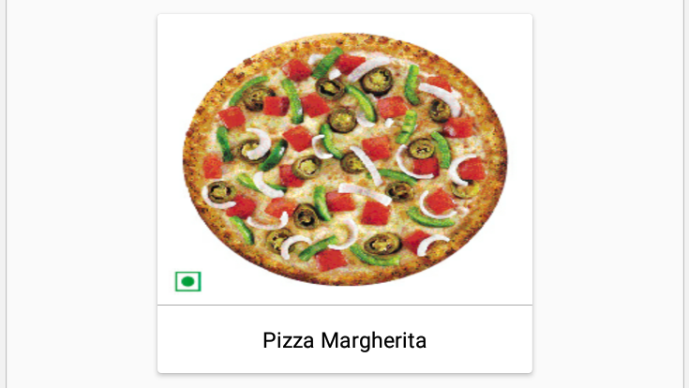

*<?***xml version="1.0" encoding="utf-8"***?>*<**android.support.v7.widget.CardView  
 xmlns:card_view="http://schemas.android.com/apk/res-auto"  
 xmlns:android="http://schemas.android.com/apk/res/android"  
 xmlns:app="http://schemas.android.com/apk/res-auto"  
 android:id="@+id/food_card_view"  
 android:layout_width="200dp"  
 android:layout_height="wrap_content"  
 android:layout_marginTop="10dp"  
 android:layout_marginLeft="10dp"  
 android:layout_marginRight="10dp"  
 android:clickable="true"  
 android:focusable="true"  
 android:elevation="60dp"  
 android:foreground="?android:attr/selectableItemBackground"**>  
  
 <**RelativeLayout  
 android:id="@+id/relative_layout"  
 android:layout_width="wrap_content"  
 android:layout_height="wrap_content"**>  
  
 <**ImageView  
 android:id="@+id/food_image_view"  
 android:layout_width="match_parent"  
 android:layout_height="155dp"  
 android:scaleType="fitXY"  
 android:src="@drawable/mexican_green_wave"**/>  
  
 <**View  
 android:id="@+id/horizontal_line"  
 android:layout_width="match_parent"  
 android:layout_height="0.2dp"  
 android:layout_below="@id/food_image_view"  
 android:background="@android:color/darker_gray"**/>  
  
 <**TextView  
 android:layout_below="@id/horizontal_line"  
 android:id="@+id/food_name_text_view"  
 android:layout_width="match_parent"  
 android:layout_height="wrap_content"  
 android:layout_alignParentLeft="true"  
 android:layout_alignParentStart="true"  
 android:textColor="@android:color/black"  
 android:gravity="center"  
 android:text="Pizza Margherita"  
 android:padding="10dp"  
 android:textSize="13sp"**/>  
 </**RelativeLayout**>  
</**android.support.v7.widget.CardView**>

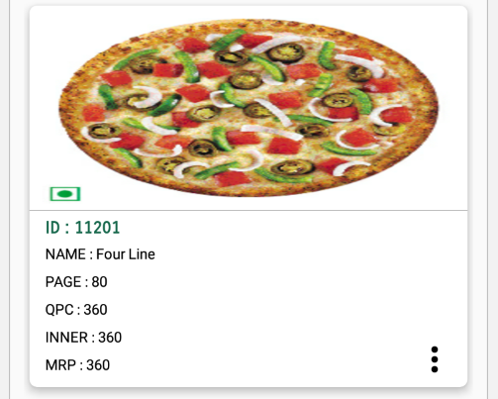

*<?***xml version="1.0" encoding="utf-8"***?>*<**android.support.v7.widget.CardView  
 xmlns:android="http://schemas.android.com/apk/res/android"  
 xmlns:card_view="http://schemas.android.com/apk/res-auto"  
 android:layout_width="wrap_content"  
 android:layout_height="wrap_content"  
 card_view:cardElevation="5dp"  
 card_view:cardCornerRadius="6dp"  
 android:layout_margin="4dp"**>  
  
 <**RelativeLayout  
 android:id="@+id/relative_layout"  
 android:layout_width="wrap_content"  
 android:layout_height="wrap_content"**>  
  
 <**ImageView  
 android:id="@+id/product_image_view"  
 android:layout_width="match_parent"  
 android:layout_height="155dp"  
 android:scaleType="fitXY"  
 android:src="@drawable/mexican_green_wave"**/>  
  
 <**View  
 android:id="@+id/horizontal_line"  
 android:layout_width="match_parent"  
 android:layout_height="0.5dp"  
 android:layout_marginBottom="5dp"  
 android:layout_below="@id/product_image_view"  
 android:background="@android:color/darker_gray"**/>  
  
 <**TextView  
 android:id="@+id/product_id_text_view"  
 android:layout_width="wrap_content"  
 android:layout_height="wrap_content"  
 android:layout_below="@+id/horizontal_line"  
 android:layout_marginLeft="12dp"  
 android:layout_marginStart="12dp"  
 android:layout_alignParentLeft="true"  
 android:layout_alignParentStart="true"  
 android:text="ID : 11201"  
 android:textColor="#14664a"  
 android:textSize="14sp"  
 android:textStyle="bold"  
 android:fontFamily="sans-serif-smallcaps"**/>  
  
 <**TextView  
 android:id="@+id/product_name_text_view"  
 android:layout_width="wrap_content"  
 android:layout_height="wrap_content"  
 android:layout_marginBottom="6dp"  
 android:layout_marginTop="4dp"  
 android:layout_alignLeft="@+id/product_id_text_view"  
 android:layout_alignStart="@+id/product_id_text_view"  
 android:layout_below="@+id/product_id_text_view"  
 android:text="NAME : Four Line"  
 android:textColor="@android:color/black"  
 android:textSize="12sp"** />  
  
 <**TextView  
 android:id="@+id/product_page_text_view"  
 android:layout_width="wrap_content"  
 android:layout_height="wrap_content"  
 android:layout_marginBottom="6dp"  
 android:layout_alignLeft="@+id/product_name_text_view"  
 android:layout_alignStart="@+id/product_name_text_view"  
 android:layout_below="@+id/product_name_text_view"  
 android:textColor="@android:color/black"  
 android:text="PAGE : 80"  
 android:textSize="12sp"** />  
  
 <**TextView  
 android:id="@+id/product_QPC_text_view"  
 android:layout_width="wrap_content"  
 android:layout_height="wrap_content"  
 android:layout_marginBottom="6dp"  
 android:layout_alignLeft="@+id/product_page_text_view"  
 android:layout_alignStart="@+id/product_page_text_view"  
 android:layout_below="@+id/product_page_text_view"  
 android:textColor="@android:color/black"  
 android:text="QPC : 360"  
 android:textSize="12sp"** />  
  
 <**TextView  
 android:id="@+id/product_inner_text_view"  
 android:layout_width="wrap_content"  
 android:layout_height="wrap_content"  
 android:layout_marginBottom="6dp"  
 android:layout_alignLeft="@+id/product_QPC_text_view"  
 android:layout_alignStart="@+id/product_QPC_text_view"  
 android:layout_below="@+id/product_QPC_text_view"  
 android:textColor="@android:color/black"  
 android:text="INNER : 360"  
 android:textSize="12sp"** />  
  
 <**TextView  
 android:id="@+id/product_price_text_view"  
 android:layout_width="wrap_content"  
 android:layout_height="wrap_content"  
 android:layout_marginBottom="10dp"  
 android:layout_alignLeft="@+id/product_inner_text_view"  
 android:layout_alignStart="@+id/product_inner_text_view"  
 android:layout_below="@+id/product_inner_text_view"  
 android:textColor="@android:color/black"  
 android:text="MRP : 360"  
 android:textSize="12sp"** />  
  
 <**ImageView  
 android:id="@+id/addProductButton"  
 android:layout_width="30dp"  
 android:layout_height="30dp"  
 android:layout_marginTop="10dp"  
 android:layout_marginEnd="10dp"  
 android:layout_marginStart="10dp"  
 android:layout_marginLeft="10dp"  
 android:layout_marginRight="10dp"  
 android:layout_alignParentEnd="true"  
 android:layout_alignParentRight="true"  
 android:layout_alignTop="@+id/product_inner_text_view"  
 android:src="@drawable/ic_more_vert_black_24dp"**/>  
 </**RelativeLayout**>  
</**android.support.v7.widget.CardView**>

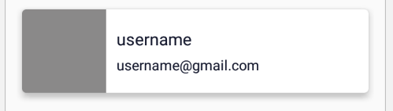

*<?***xml version="1.0" encoding="utf-8"***?>*<**android.support.v7.widget.CardView  
 xmlns:android="http://schemas.android.com/apk/res/android"  
 xmlns:card_view="http://schemas.android.com/apk/res-auto"  
 android:id="@+id/card_view"  
 android:layout_width="match_parent"  
 android:layout_height="wrap_content"  
 android:layout_margin="5dp"  
 card_view:cardCornerRadius="4dp"  
 card_view:cardElevation="5dp"**>  
  
 <**LinearLayout  
 android:orientation="horizontal"  
 android:layout_width="match_parent"  
 android:layout_height="wrap_content"**>  
  
 <**ImageView  
 android:id="@+id/user_profile_image_view"  
 android:layout_width="80dp"  
 android:layout_height="80dp"  
 android:scaleType="fitXY"  
 android:src="#8A8989"**/>  
  
 <**LinearLayout  
 android:layout_width="match_parent"  
 android:layout_height="wrap_content"  
 android:layout_marginStart="10dp"  
 android:layout_marginLeft="10dp"  
 android:layout_gravity="center"  
 android:orientation="vertical"**>  
  
 <**TextView  
 android:id="@+id/user_name_text_view"  
 android:layout_width="wrap_content"  
 android:layout_height="wrap_content"  
 android:text="username"  
 android:textSize="18sp"  
 android:textColor="#15192e"**/>  
  
 <**TextView  
 android:id="@+id/email_address_text_view"  
 android:layout_width="wrap_content"  
 android:layout_height="wrap_content"  
 android:layout_marginTop="5dp"  
 android:text="username@gmail.com"  
 android:textSize="15sp"  
 android:textColor="#15192e"**/>  
 </**LinearLayout**>  
 </**LinearLayout**>  
</**android.support.v7.widget.CardView**>

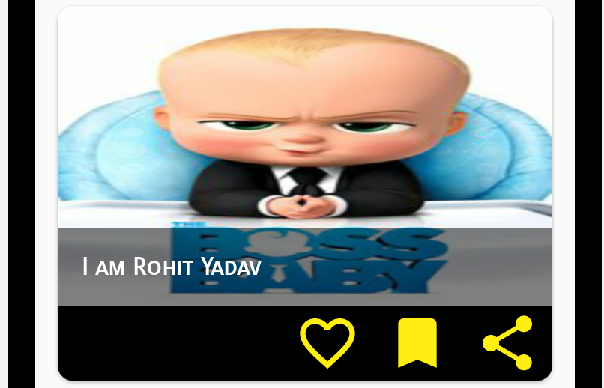

*<?***xml version="1.0" encoding="utf-8"***?>*<**android.support.v7.widget.CardView  
 xmlns:android="http://schemas.android.com/apk/res/android"  
 xmlns:card_view="http://schemas.android.com/apk/res-auto"  
 android:id="@+id/card_view"  
 android:layout_width="match_parent"  
 android:layout_height="wrap_content"  
 android:layout_margin="5dp"  
 card_view:cardCornerRadius="10dp"**>  
  
 <**LinearLayout  
 android:layout_width="match_parent"  
 android:layout_height="250dip"  
 android:orientation="vertical"  
 android:weightSum="4"**>  
  
 <**LinearLayout  
 android:layout_width="match_parent"  
 android:layout_height="0dip"  
 android:layout_weight="3.2"  
 android:orientation="vertical"**>  
  
 <**FrameLayout  
 android:layout_width="match_parent"  
 android:layout_height="match_parent"  
 android:layout_gravity="center_horizontal"**>  
  
 <**ImageView  
 android:id="@+id/image_view"  
 android:layout_width="match_parent"  
 android:layout_height="match_parent"  
 android:layout_gravity="center"  
 android:scaleType="fitXY"  
 android:src="@drawable/test_poster"** />  
  
 <**LinearLayout  
 android:layout_width="match_parent"  
 android:layout_height="wrap_content"  
 android:orientation="vertical"  
 android:layout_gravity="left|bottom"  
 android:background="@android:drawable/screen_background_dark_transparent"**>  
  
 <**TextView  
 android:id="@+id/text_card_name"  
 android:layout_width="match_parent"  
 android:layout_height="wrap_content"  
 android:paddingBottom="16dp"  
 android:paddingLeft="16dp"  
 android:paddingRight="16dp"  
 android:paddingTop="16dp"  
 android:text="I am Rohit Yadav"  
 android:textColor="#ffffff"  
 android:textStyle="bold"  
 android:fontFamily="sans-serif-smallcaps"  
 android:textAppearance="?android:attr/textAppearanceMedium"**/>  
 </**LinearLayout**>  
 </**FrameLayout**>  
 </**LinearLayout**>  
  
 <**LinearLayout  
 android:layout_width="match_parent"  
 android:layout_height="0dip"  
 android:layout_weight="0.8"  
 android:gravity="center|right"  
 android:orientation="horizontal"  
 android:background="#000000"**>  
  
 <**ImageView  
 android:id="@+id/image_action_like"  
 android:layout_width="60dip"  
 android:layout_height="60dip"  
 android:padding="8dp"  
 android:src="@drawable/ic_favorite_border_black_24dp"** />  
  
 <**ImageView  
 android:id="@+id/image_action_flag"  
 android:layout_width="60dip"  
 android:layout_height="60dip"  
 android:padding="8dp"  
 android:src="@drawable/ic_turned_in_black_24dp"** />  
  
 <**ImageView  
 android:id="@+id/image_action_share"  
 android:layout_width="60dip"  
 android:layout_height="60dip"  
 android:padding="8dp"  
 android:src="@drawable/ic_share_black_24dp"** />  
 </**LinearLayout**>  
 </**LinearLayout**>  
</**android.support.v7.widget.CardView**>

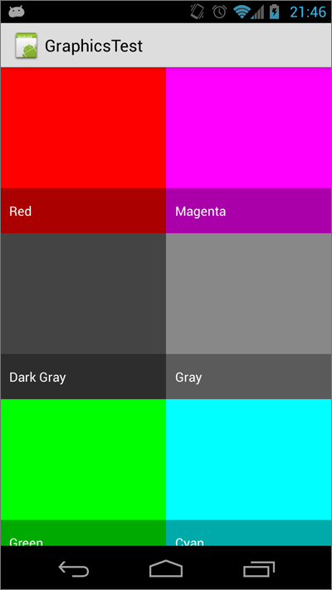

*<?***xml version="1.0" encoding="utf-8"***?>*<**FrameLayout  
 xmlns:android="http://schemas.android.com/apk/res/android"  
 android:layout_width="match_parent"  
 android:layout_height="match_parent"**>  
  
 <**ImageView  
 android:id="@+id/image_view"  
 android:layout_width="match_parent"  
 android:layout_height="match_parent"  
 android:scaleType="centerCrop"**/>  
  
 <**TextView  
 android:id="@+id/text_view"  
 android:layout_width="match_parent"  
 android:layout_height="wrap_content"  
 android:paddingLeft="10dp"  
 android:paddingRight="10dp"  
 android:paddingTop="15dp"  
 android:paddingBottom="15dp"  
 android:layout_gravity="bottom"  
 android:textColor="@android:color/white"  
 android:background="#55000000"**/>  
</**FrameLayout**>

*<?***xml version="1.0" encoding="utf-8"***?>*<**LinearLayout  
 xmlns:android="http://schemas.android.com/apk/res/android"  
 xmlns:tools="http://schemas.android.com/tools"  
 xmlns:app="http://schemas.android.com/apk/res-auto"  
 android:layout_width="match_parent"  
 android:layout_height="match_parent"  
 android:background="@android:color/black"  
 android:padding="20dp"  
 android:layout_gravity="center"  
 android:gravity="center"  
 tools:context=".MainActivity"**>  
  
 <**RelativeLayout  
 android:orientation="vertical"  
 android:layout_width="wrap_content"  
 android:layout_height="wrap_content"**>  
  
 <**android.support.v7.widget.CardView  
 android:layout_width="match_parent"  
 android:layout_height="wrap_content"  
 android:layout_alignParentStart="true"  
 android:layout_alignParentTop="true"  
 android:layout_alignParentLeft="true"  
 app:cardElevation="15dp"**>  
  
 <**RelativeLayout  
 android:layout_width="match_parent"  
 android:layout_height="match_parent"**>  
  
 <**ImageView  
 android:id="@+id/image_view"  
 android:layout_width="150dp"  
 android:layout_height="170dp"  
 android:layout_alignParentStart="true"  
 android:layout_alignParentLeft="true"  
 android:layout_alignParentTop="true"  
 android:alpha="0.9"  
 android:scaleType="fitXY"  
 android:src="@drawable/rice"**/>  
  
 <**TextView  
 android:id="@+id/name_text_view"  
 android:layout_width="wrap_content"  
 android:layout_height="wrap_content"  
 android:layout_alignStart="@+id/price_text_view"  
 android:layout_alignLeft="@+id/price_text_view"  
 android:layout_alignTop="@+id/image_view"  
 android:fontFamily="cursive"  
 android:padding="8dp"  
 android:text="Name"  
 android:textColor="@android:color/black"  
 android:textSize="20sp"  
 android:textStyle="bold"**/>  
  
 <**TextView  
 android:layout_above="@+id/button_relative_layout"  
 android:layout_alignStart="@+id/button_relative_layout"  
 android:layout_alignLeft="@+id/button_relative_layout"  
 android:id="@+id/price_text_view"  
 android:layout_width="wrap_content"  
 android:layout_height="wrap_content"  
 android:layout_marginBottom="22dp"  
 android:text="Price"  
 android:fontFamily="serif"  
 android:padding="5dp"  
 android:textColor="@android:color/black"**/>  
  
 <**RelativeLayout  
 android:id="@+id/button_relative_layout"  
 android:layout_width="match_parent"  
 android:layout_height="40dp"  
 android:layout_alignBottom="@+id/image_view"  
 android:layout_toEndOf="@+id/image_view"  
 android:layout_toRightOf="@+id/image_view"  
 android:layout_alignParentEnd="true"  
 android:layout_alignParentRight="true"**>  
  
 <**Button  
 android:id="@+id/remove_button"  
 android:layout_width="wrap_content"  
 android:layout_height="wrap_content"  
 android:layout_alignParentTop="true"  
 android:layout_alignParentEnd="true"  
 android:layout_alignParentRight="true"  
 android:layout_toEndOf="@+id/move_to_card"  
 android:layout_toRightOf="@+id/move_to_card"  
 android:textColor="#BB0000"  
 android:text="REMOVE"  
 android:background="@android:color/white"**/>  
  
 <**Button  
 android:id="@+id/move_to_card"  
 android:layout_width="wrap_content"  
 android:layout_height="match_parent"  
 android:layout_alignParentTop="true"  
 android:textColor="#0000BB"  
 android:padding="7dp"  
 android:text="MOVE TO CART"  
 android:background="@android:color/white"**/>  
 </**RelativeLayout**>  
 </**RelativeLayout**>  
 </**android.support.v7.widget.CardView**>  
 </**RelativeLayout**>  
</**LinearLayout**>

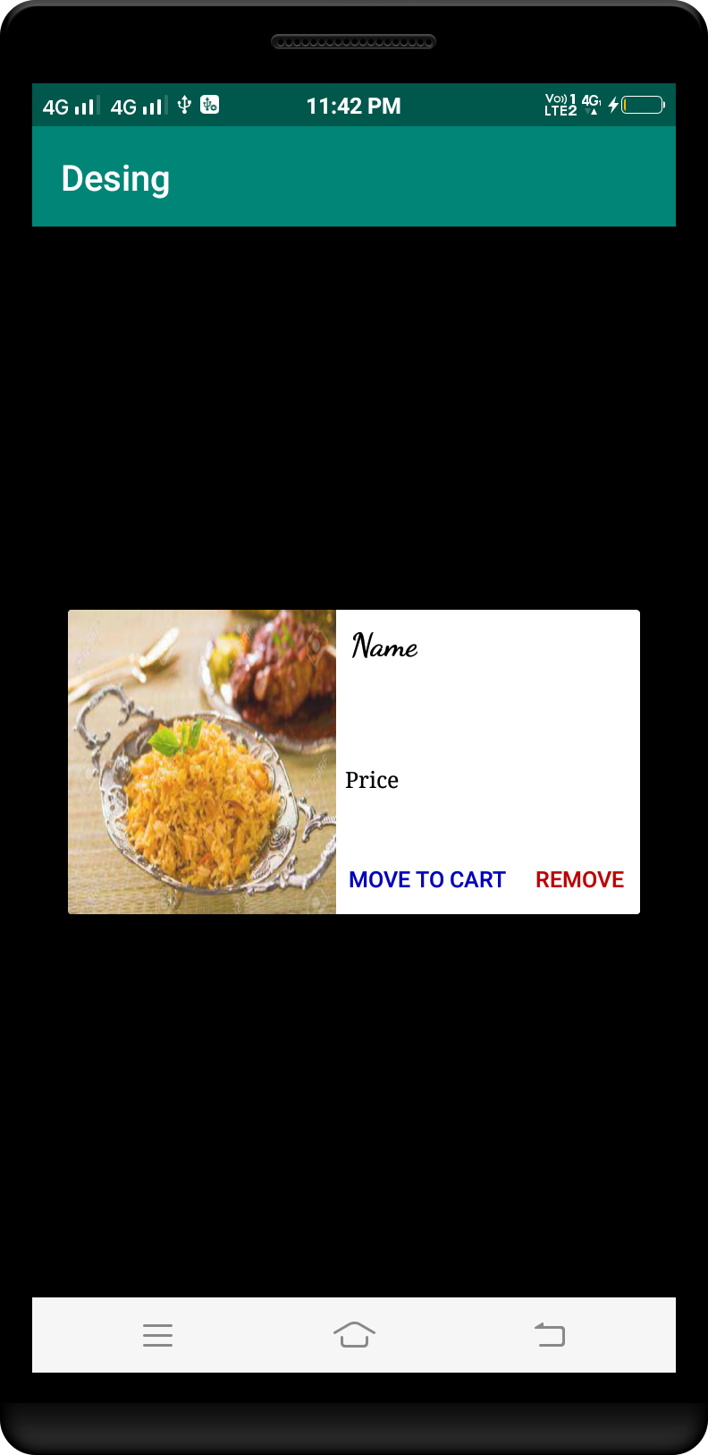

*<?***xml version="1.0" encoding="utf-8"***?>*<**LinearLayout  
 xmlns:android="http://schemas.android.com/apk/res/android"  
 xmlns:tools="http://schemas.android.com/tools"  
 xmlns:card_view="http://schemas.android.com/apk/res-auto"  
 android:layout_width="match_parent"  
 android:layout_height="match_parent"  
 android:background="@android:color/black"  
 android:padding="20dp"  
 android:layout_gravity="center"  
 android:gravity="center"  
 tools:context=".MainActivity"**>  
  
 <**RelativeLayout  
 android:layout_width="wrap_content"  
 android:layout_height="wrap_content"  
 android:layout_margin="2dp"**>  
  
 <**android.support.v7.widget.CardView  
 android:layout_width="match_parent"  
 android:layout_height="250dp"  
 android:layout_alignParentTop="true"  
 android:layout_alignParentStart="true"  
 android:layout_alignParentLeft="true"  
 card_view:cardCornerRadius="5dp"  
 android:clickable="true"  
 android:foreground="@android:color/transparent"**>  
  
 <**RelativeLayout  
 android:layout_width="match_parent"  
 android:layout_height="match_parent"**>  
  
 <**ImageView  
 android:id="@+id/image_view"  
 android:layout_width="match_parent"  
 android:layout_height="match_parent"  
 android:alpha="0.9"  
 android:background="@drawable/image_corner"  
 android:scaleType="fitXY"  
 android:layout_centerVertical="true"  
 android:layout_alignParentEnd="true"  
 android:layout_alignParentRight="true"  
 android:src="@drawable/rice"**/>  
  
 <**RelativeLayout  
 android:layout_width="match_parent"  
 android:layout_height="wrap_content"  
 android:background="#40000000"**>  
  
 <**TextView  
 android:id="@+id/menuItemName"  
 android:layout_width="match_parent"  
 android:layout_height="wrap_content"  
 android:layout_alignParentTop="true"  
 android:layout_centerHorizontal="true"  
 android:layout_marginRight="5dp"  
 android:layout_marginEnd="5dp"  
 android:layout_marginTop="2dp"  
 android:fontFamily="cursive"  
 android:padding="5dp"  
 android:shadowColor="@android:color/black"  
 android:shadowRadius="2"  
 android:text="Text"  
 android:textAlignment="center"  
 android:textColor="@android:color/white"  
 android:textSize="20dp"**/>  
 </**RelativeLayout**>  
  
 <**RelativeLayout  
 android:layout_width="match_parent"  
 android:layout_height="50dp"  
 android:layout_alignParentBottom="true"  
 android:background="#30000000"**>  
  
 <**ImageButton  
 android:id="@+id/add_to_favorite"  
 android:layout_width="30dp"  
 android:layout_height="30dp"  
 android:background="@android:color/transparent"  
 android:scaleType="fitXY"  
 android:layout_centerVertical="true"  
 android:layout_centerHorizontal="true"  
 android:src="@drawable/ic_favorite_border_black_24dp"**/>  
  
  
 <**ImageButton  
 android:id="@+id/add_to_card"  
 android:layout_width="30dp"  
 android:layout_height="30dp"  
 android:background="@android:color/transparent"  
 android:scaleType="fitXY"  
 android:layout_marginLeft="10dp"  
 android:src="@drawable/ic_add_shopping_cart_black_24dp"  
 android:layout_alignTop="@+id/add_to_favorite"  
 android:layout_alignParentStart="true"  
 android:layout_alignParentLeft="true"  
 android:layout_marginStart="10dp"** />  
  
 <**TextView  
 android:id="@+id/price_text_view"  
 android:layout_width="wrap_content"  
 android:layout_height="wrap_content"  
 android:layout_gravity="bottom"  
 android:layout_marginRight="10dp"  
 android:shadowColor="@android:color/black"  
 android:shadowRadius="2"  
 android:text="Price"  
 android:fontFamily="serif"  
 android:textAlignment="center"  
 android:textColor="@android:color/white"  
 android:layout_centerVertical="true"  
 android:layout_alignParentEnd="true"  
 android:layout_alignParentRight="true"** />  
 </**RelativeLayout**>  
 </**RelativeLayout**>  
 </**android.support.v7.widget.CardView**>  
 </**RelativeLayout**>  
</**LinearLayout**>

image_corner.xml

*<?***xml version="1.0" encoding="utf-8"***?>*<**shape xmlns:android="http://schemas.android.com/apk/res/android" android:shape="rectangle"**>  
 <**corners android:radius="5dp"**/>  
</**shape**>

ic_add_shopping_cart_black_24dp.xml

<**vector xmlns:android="http://schemas.android.com/apk/res/android"  
 android:width="24dp"  
 android:height="24dp"  
 android:viewportWidth="24.0"  
 android:viewportHeight="24.0"**>  
 <**path  
 android:fillColor="#FFFFFFFF"  
 android:pathData="M11,9h2L13,6h3L16,4h-3L13,1h-2v3L8,4v2h3v3zM7,18c-1.1,0 -1.99,0.9 -1.99,2S5.9,22 7,22s2,-0.9 2,-2 -0.9,-2 -2,-2zM17,18c-1.1,0 -1.99,0.9 -1.99,2s0.89,2 1.99,2 2,-0.9 2,-2 -0.9,-2 -2,-2zM7.17,14.75l0.03,-0.12 0.9,-1.63h7.45c0.75,0 1.41,-0.41 1.75,-1.03l3.86,-7.01L19.42,4h-0.01l-1.1,2 -2.76,5L8.53,11l-0.13,-0.27L6.16,6l-0.95,-2 -0.94,-2L1,2v2h2l3.6,7.59 -1.35,2.45c-0.16,0.28 -0.25,0.61 -0.25,0.96 0,1.1 0.9,2 2,2h12v-2L7.42,15c-0.13,0 -0.25,-0.11 -0.25,-0.25z"**/>  
</**vector**>

ic_favorite_border_black_24dp.xml

<**vector xmlns:android="http://schemas.android.com/apk/res/android"  
 android:width="24dp"  
 android:height="24dp"  
 android:viewportWidth="24.0"  
 android:viewportHeight="24.0"**>  
 <**path  
 android:fillColor="#FFFFFF"  
 android:pathData="M16.5,3c-1.74,0 -3.41,0.81 -4.5,2.09C10.91,3.81 9.24,3 7.5,3 4.42,3 2,5.42 2,8.5c0,3.78 3.4,6.86 8.55,11.54L12,21.35l1.45,-1.32C18.6,15.36 22,12.28 22,8.5 22,5.42 19.58,3 16.5,3zM12.1,18.55l-0.1,0.1 -0.1,-0.1C7.14,14.24 4,11.39 4,8.5 4,6.5 5.5,5 7.5,5c1.54,0 3.04,0.99 3.57,2.36h1.87C13.46,5.99 14.96,5 16.5,5c2,0 3.5,1.5 3.5,3.5 0,2.89 -3.14,5.74 -7.9,10.05z"**/>  
</**vector**>

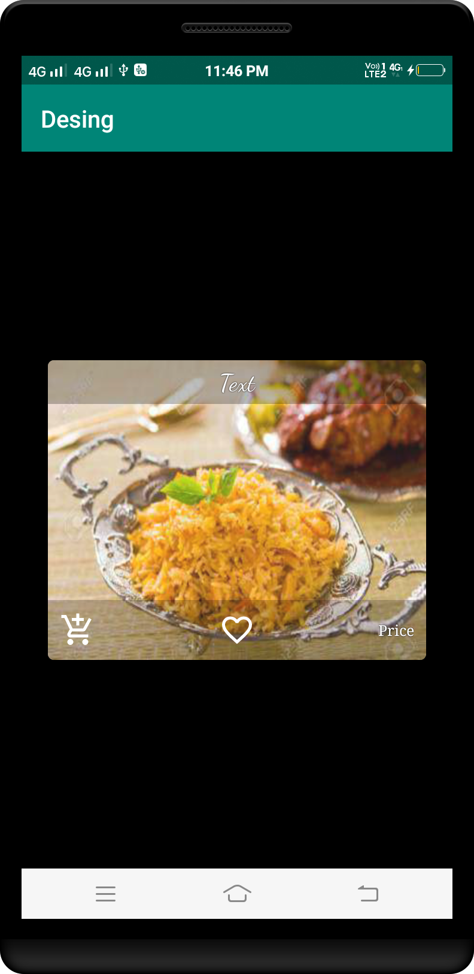

*<?***xml version="1.0" encoding="utf-8"***?>*<**RelativeLayout   
 xmlns:android="http://schemas.android.com/apk/res/android"  
 xmlns:app="http://schemas.android.com/apk/res-auto"  
 android:orientation="vertical"   
 android:layout_width="wrap_content"  
 android:layout_height="wrap_content"**>  
  
 <**android.support.v7.widget.CardView  
 android:layout_width="match_parent"  
 android:layout_height="180dp"  
 android:layout_margin="5dp"  
 app:cardCornerRadius="5dp"  
 android:layout_alignParentTop="true"  
 android:layout_alignParentStart="true"  
 android:layout_alignParentLeft="true"**>  
  
 <**RelativeLayout  
 android:layout_width="match_parent"  
 android:layout_height="match_parent"**>  
  
 <**ImageView  
 android:id="@+id/image_view"  
 android:layout_width="150dp"  
 android:layout_height="170dp"  
 android:layout_alignParentStart="true"  
 android:layout_marginStart="10dp"  
 android:layout_marginTop="3dp"  
 android:alpha="0.9"  
 android:scaleType="centerCrop"  
 android:layout_alignParentLeft="true"  
 android:layout_marginLeft="10dp"** />  
  
 <**TextView  
 android:id="@+id/name_text_view"  
 android:layout_width="wrap_content"  
 android:layout_height="wrap_content"  
 android:layout_alignStart="@+id/price_text_view"  
 android:layout_alignTop="@+id/image_view"  
 android:layout_marginTop="14dp"  
 android:fontFamily="cursive"  
 android:text="Name"  
 android:textAllCaps="false"  
 android:textColor="@android:color/black"  
 android:textSize="22sp"  
 android:textStyle="bold"  
 android:layout_alignLeft="@+id/price_text_view"** />  
  
 <**TextView  
 android:id="@+id/price_text_view"  
 android:layout_width="wrap_content"  
 android:layout_height="wrap_content"  
 android:layout_centerVertical="true"  
 android:layout_marginStart="14dp"  
 android:textColor="@android:color/black"  
 android:layout_toEndOf="@+id/image_view"  
 android:text="Price"  
 android:fontFamily="serif"  
 android:layout_marginLeft="14dp"  
 android:layout_toRightOf="@+id/image_view"** />  
  
 <**ImageButton  
 android:id="@+id/plus"  
 android:layout_width="25dp"  
 android:layout_height="25dp"  
 android:layout_alignTop="@+id/quantity"  
 android:layout_toEndOf="@+id/quantity"  
 android:background="@android:color/white"  
 android:scaleType="fitXY"  
 android:src="@drawable/ic_add_circle_outline_black_24dp"  
 android:layout_toRightOf="@+id/quantity"** />  
  
 <**ImageButton  
 android:id="@+id/minus"  
 android:layout_width="25dp"  
 android:layout_height="25dp"  
 android:layout_alignBottom="@+id/image_view"  
 android:layout_alignStart="@+id/price_text_view"  
 android:layout_marginBottom="14dp"  
 android:background="@android:color/white"  
 android:scaleType="fitXY"  
 android:src="@drawable/ic_remove_circle_outline_black_24dp"  
 android:layout_alignLeft="@+id/price_text_view"** />  
  
 <**Button  
 android:id="@+id/delete_from_cart"  
 style="@style/Widget.AppCompat.Button.Small"  
 android:layout_width="wrap_content"  
 android:layout_height="wrap_content"  
 android:padding="10dp"  
 android:background="@android:color/white"  
 android:textColor="#BB0000"  
 android:text="Remove"  
 android:layout_alignBaseline="@+id/quantity"  
 android:layout_alignBottom="@+id/quantity"  
 android:layout_toEndOf="@+id/plus"  
 android:layout_marginStart="10dp"  
 android:layout_toRightOf="@+id/plus"  
 android:layout_marginLeft="10dp"** />  
  
 <**TextView  
 android:id="@+id/quantity"  
 android:layout_width="25dp"  
 android:layout_height="25dp"  
 android:layout_alignTop="@+id/minus"  
 android:layout_marginLeft="5dp"  
 android:layout_marginRight="5dp"  
 android:layout_toEndOf="@+id/minus"  
 android:gravity="center"  
 android:text="1"  
 android:textAlignment="center"  
 android:layout_toRightOf="@+id/minus"** />  
 </**RelativeLayout**>  
 </**android.support.v7.widget.CardView**>  
</**RelativeLayout**>

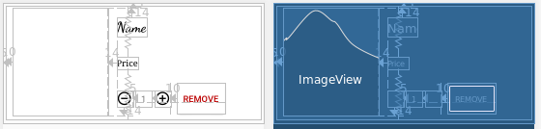

*<?***xml version="1.0" encoding="utf-8"***?>*<**RelativeLayout  
 xmlns:android="http://schemas.android.com/apk/res/android"  
 android:id="@+id/parent_list_map"  
 android:layout_width="match_parent"  
 android:layout_height="wrap_content"  
 android:background="@android:color/white"**>  
  
 <**ImageView  
 android:id="@+id/img_user"  
 android:layout_width="match_parent"  
 android:layout_height="200dp"  
 android:background="#16000000"  
 android:scaleType="centerCrop"  
 android:src="@drawable/rice"**/>  
  
 <**LinearLayout  
 android:layout_width="match_parent"  
 android:layout_height="wrap_content"  
 android:layout_alignBottom="@+id/img_user"  
 android:layout_alignParentLeft="true"  
 android:layout_alignParentStart="true"  
 android:background="#66000000"  
 android:orientation="vertical"  
 android:paddingBottom="10dp"  
 android:paddingLeft="10dp"  
 android:paddingRight="10dp"  
 android:paddingTop="16dp"**>  
  
 <**TextView  
 android:id="@+id/item_txt_title"  
 android:layout_width="match_parent"  
 android:layout_height="wrap_content"  
 android:singleLine="true"  
 android:textColor="@android:color/white"  
 android:textSize="16sp"  
 android:textStyle="bold"  
 android:text="ITEM TEXT TITLE"**/>  
  
 <**TextView  
 android:id="@+id/item_txt_message"  
 android:layout_width="match_parent"  
 android:layout_height="wrap_content"  
 android:layout_marginTop="5dp"  
 android:singleLine="true"  
 android:textColor="@android:color/white"  
 android:textSize="14sp"  
 android:text="ITEM TEXT MESSAGE"**/>  
 </**LinearLayout**>  
</**RelativeLayout**>

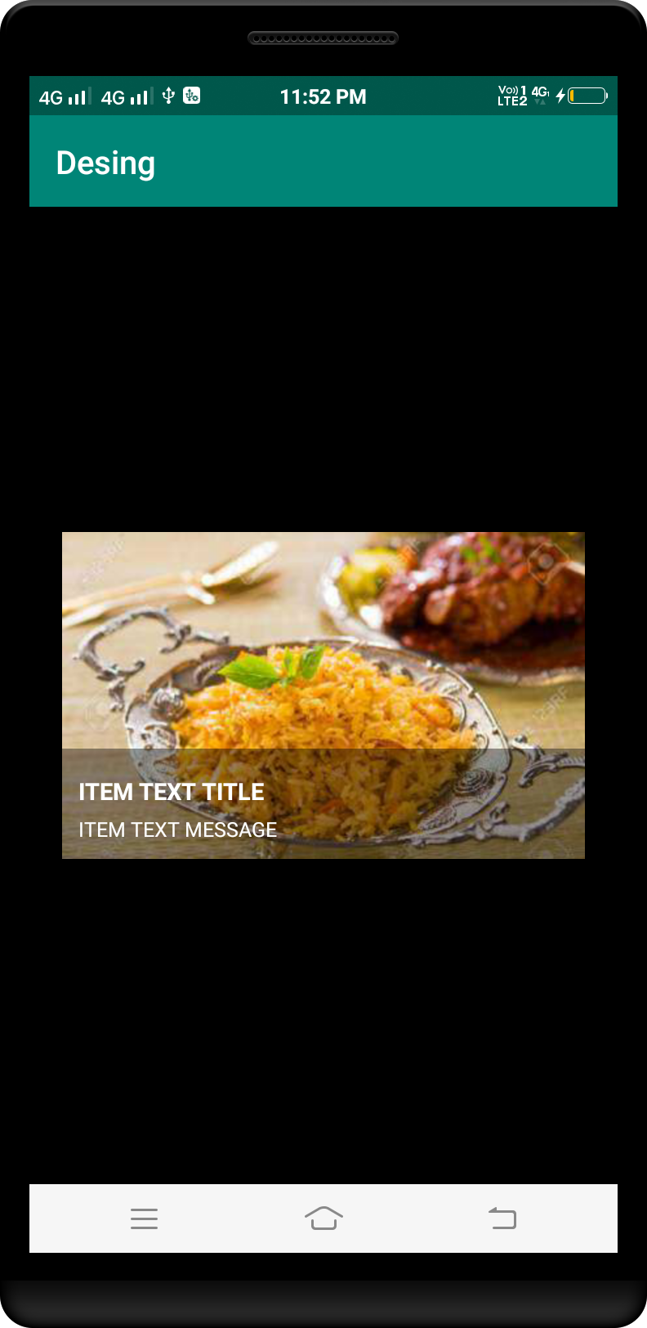

*<?***xml version="1.0" encoding="utf-8"***?>*<**LinearLayout  
 xmlns:android="http://schemas.android.com/apk/res/android"  
 android:layout_width="match_parent"  
 android:layout_height="wrap_content"  
 android:background="#FFFFFF"  
 android:gravity="center_vertical"  
 android:orientation="horizontal"  
 android:padding="12dp"**>  
  
 <**ImageView  
 android:id="@+id/img_user"  
 android:layout_width="60dp"  
 android:layout_height="60dp"  
 android:background="#16000000"** />  
  
 <**LinearLayout  
 android:layout_width="match_parent"  
 android:layout_height="wrap_content"  
 android:gravity="center_vertical"  
 android:orientation="horizontal"**>  
  
 <**LinearLayout  
 android:layout_width="0dp"  
 android:layout_height="wrap_content"  
 android:layout_weight="1"  
 android:gravity="center_vertical"  
 android:orientation="vertical"  
 android:paddingLeft="16dp"  
 android:paddingRight="16dp"**>  
  
 <**TextView  
 android:id="@+id/item_txt_title"  
 android:layout_width="match_parent"  
 android:layout_height="wrap_content"  
 android:text="ITEM TEXT TITLE"  
 android:textColor="#212121"  
 android:textSize="14dp"** />  
  
 <**TextView  
 android:id="@+id/item_txt_message"  
 android:layout_width="match_parent"  
 android:layout_height="wrap_content"  
 android:layout_marginTop="8dp"  
 android:text="ITEM TEXT MESSAGE"  
 android:textColor="#727272"  
 android:textSize="14dp"** />  
 </**LinearLayout**>  
  
 <**CheckBox  
 android:id="@+id/check_list"  
 android:layout_width="wrap_content"  
 android:layout_height="wrap_content"** />  
 </**LinearLayout**>  
</**LinearLayout**>

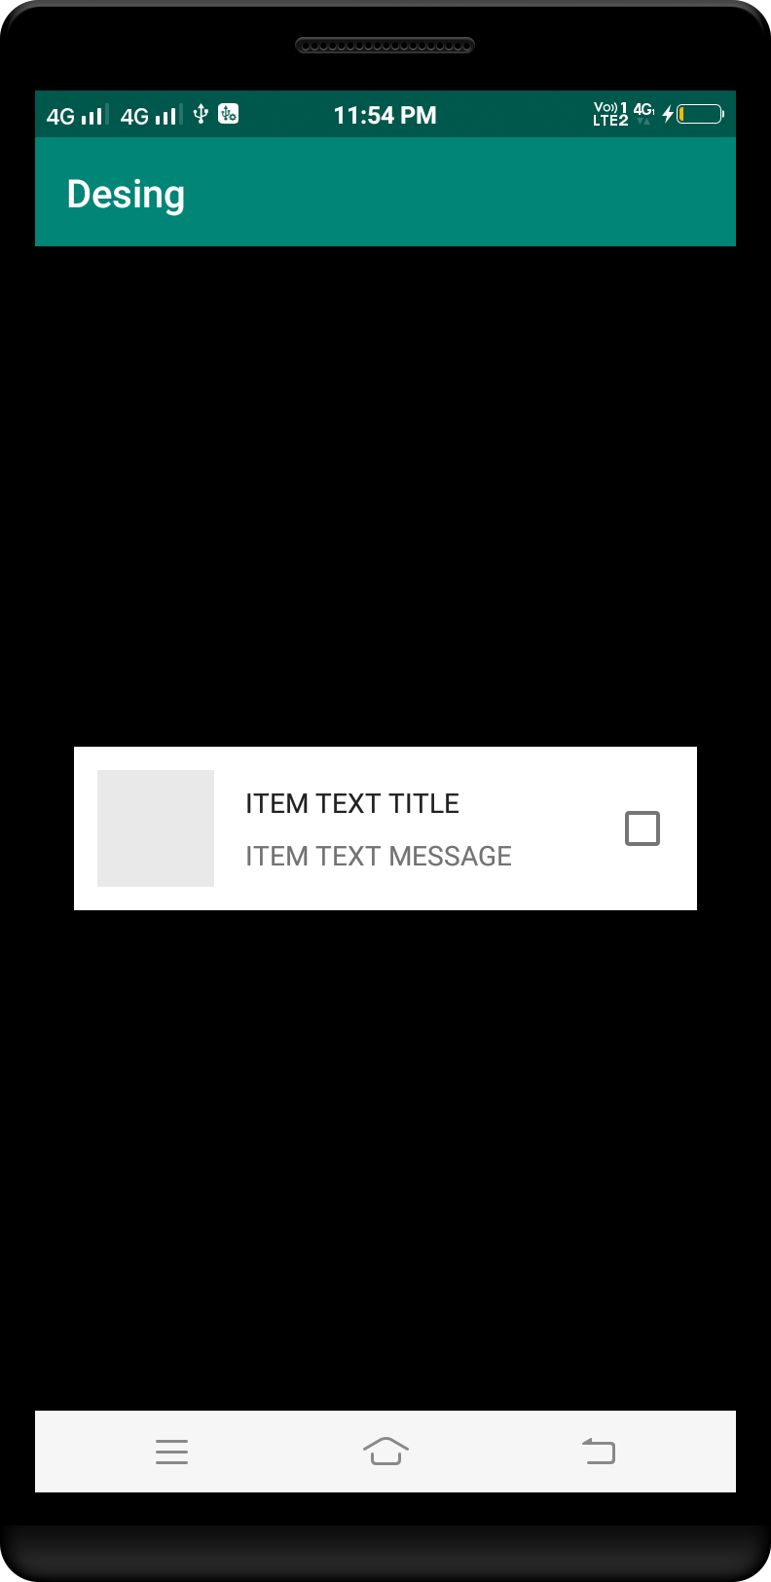

*<?***xml version="1.0" encoding="utf-8"***?>*<**RelativeLayout  
 xmlns:android="http://schemas.android.com/apk/res/android"  
 xmlns:app="http://schemas.android.com/apk/res-auto"  
 android:layout_width="match_parent"  
 android:layout_height="180dp"  
 android:gravity="center"**>  
  
 <**ImageView  
 android:id="@+id/img_user"  
 android:layout_width="match_parent"  
 android:layout_height="match_parent"  
 android:adjustViewBounds="true"  
 android:alpha="0.9"  
 android:background="#16000000"  
 android:scaleType="centerCrop"  
 android:src="@drawable/rice"**/>  
  
 <**LinearLayout  
 android:layout_width="match_parent"  
 android:layout_height="wrap_content"  
 android:layout_alignParentBottom="true"  
 android:background="#80000000"  
 android:gravity="center"  
 android:orientation="vertical"**>  
  
 <**TextView  
 android:id="@+id/item_txt_title"  
 android:layout_width="match_parent"  
 android:layout_height="wrap_content"  
 android:gravity="center"  
 android:maxLines="1"  
 android:padding="5dp"  
 android:text="Title"  
 android:textColor="@android:color/white"  
 android:textSize="14sp"** />  
  
 <**TextView  
 android:id="@+id/item_txt_message"  
 android:layout_width="match_parent"  
 android:layout_height="wrap_content"  
 android:gravity="center"  
 android:maxLines="1"  
 android:padding="5dp"  
 android:text="Message"  
 android:textColor="@android:color/white"  
 android:textSize="12sp"** />  
 </**LinearLayout**>  
</**RelativeLayout**>

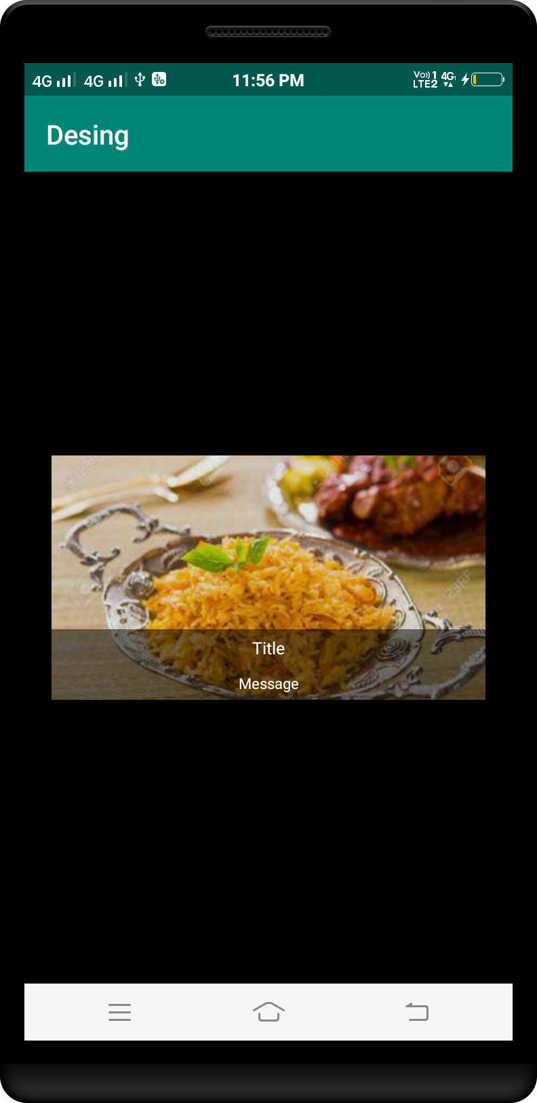

*<?***xml version="1.0" encoding="utf-8"***?>*<**LinearLayout  
 xmlns:android="http://schemas.android.com/apk/res/android"  
 android:layout_width="match_parent"  
 android:layout_height="wrap_content"  
 android:background="#FFFFFF"  
 android:gravity="center_vertical"  
 android:orientation="horizontal"  
 android:padding="12dp"**>  
  
 <**ImageView  
 android:id="@+id/img_user"  
 android:layout_width="60dp"  
 android:layout_height="60dp"  
 android:background="#16000000"** />  
  
 <**LinearLayout  
 android:layout_width="match_parent"  
 android:layout_height="wrap_content"  
 android:gravity="center_vertical"  
 android:orientation="horizontal"**>  
  
 <**LinearLayout  
 android:layout_width="0dp"  
 android:layout_height="wrap_content"  
 android:layout_weight="1"  
 android:gravity="center_vertical"  
 android:orientation="vertical"  
 android:paddingLeft="16dp"  
 android:paddingRight="16dp"**>  
  
 <**TextView  
 android:id="@+id/item_txt_title"  
 android:layout_width="match_parent"  
 android:layout_height="wrap_content"  
 android:text="ITEM TEXT TITLE"  
 android:textColor="#212121"  
 android:textSize="14dp"** />  
  
 <**TextView  
 android:id="@+id/item_txt_message"  
 android:layout_width="match_parent"  
 android:layout_height="wrap_content"  
 android:layout_marginTop="8dp"  
 android:text="ITEM TEXT MESSAGE"  
 android:textColor="#727272"  
 android:textSize="14dp"** />  
 </**LinearLayout**>  
  
 <**RadioButton  
 android:id="@+id/radio_list"  
 android:layout_width="wrap_content"  
 android:layout_height="wrap_content"  
 android:text=""** />  
 </**LinearLayout**>  
</**LinearLayout**>

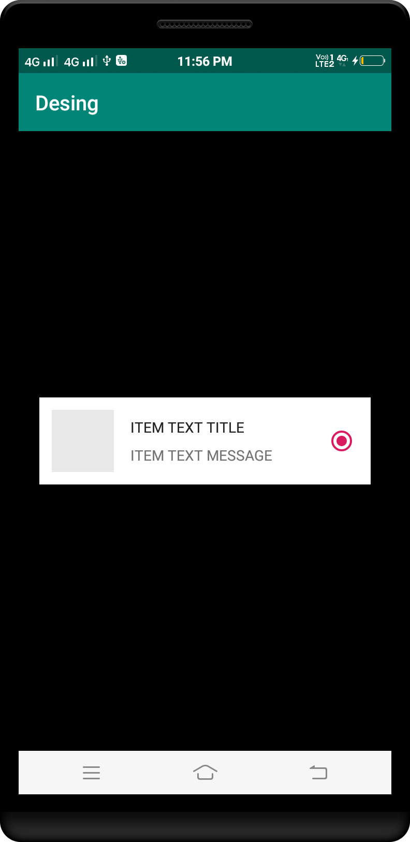

*<?***xml version="1.0" encoding="utf-8"***?>*<**LinearLayout  
 xmlns:android="http://schemas.android.com/apk/res/android"  
 android:layout_width="match_parent"  
 android:layout_height="wrap_content"  
 android:background="#FFFFFF"  
 android:gravity="center_vertical"  
 android:orientation="horizontal"  
 android:padding="12dp"**>  
  
 <**ImageView  
 android:id="@+id/img_user"  
 android:layout_width="60dp"  
 android:layout_height="60dp"  
 android:background="#16000000"**/>  
  
 <**LinearLayout  
 android:layout_width="0dp"  
 android:layout_height="wrap_content"  
 android:layout_marginLeft="16dp"  
 android:layout_weight="1"  
 android:gravity="center_vertical"  
 android:orientation="vertical"**>  
  
 <**TextView  
 android:id="@+id/item_txt_title"  
 android:layout_width="match_parent"  
 android:layout_height="wrap_content"  
 android:text="ITEM TEXT TITLE"  
 android:textColor="#212121"  
 android:textSize="14dp"** />  
  
 <**TextView  
 android:id="@+id/item_txt_message"  
 android:layout_width="match_parent"  
 android:layout_height="wrap_content"  
 android:layout_marginTop="8dp"  
 android:text="ITEM TEXT MESSAGE"  
 android:textColor="#727272"  
 android:textSize="14dp"** />  
 </**LinearLayout**>  
</**LinearLayout**>

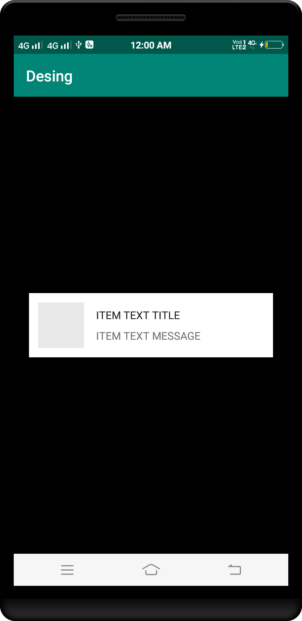

*<?***xml version="1.0" encoding="utf-8"***?>*<**LinearLayout  
 xmlns:android="http://schemas.android.com/apk/res/android"  
 android:layout_width="match_parent"  
 android:layout_height="wrap_content"  
 android:background="#FFFFFF"  
 android:gravity="center_vertical"  
 android:orientation="horizontal"  
 android:padding="12dp"**>  
  
 <**ImageView  
 android:id="@+id/img_user"  
 android:layout_width="60dp"  
 android:layout_height="60dp"  
 android:background="#16000000"**/>  
  
 <**LinearLayout  
 android:layout_width="match_parent"  
 android:layout_height="wrap_content"  
 android:gravity="center_vertical"  
 android:orientation="horizontal"**>  
  
 <**LinearLayout  
 android:layout_width="0dp"  
 android:layout_height="wrap_content"  
 android:layout_weight="1"  
 android:gravity="center_vertical"  
 android:orientation="vertical"  
 android:paddingLeft="16dp"  
 android:paddingRight="16dp"**>  
  
 <**TextView  
 android:id="@+id/item_txt_title"  
 android:layout_width="match_parent"  
 android:layout_height="wrap_content"  
 android:text="ITEM TEXT TITLE"  
 android:textColor="#212121"  
 android:textSize="14dp"** />  
  
 <**TextView  
 android:id="@+id/item_txt_message"  
 android:layout_width="match_parent"  
 android:layout_height="wrap_content"  
 android:layout_marginTop="8dp"  
 android:text="ITEM TEXT MESSAGE"  
 android:textColor="#727272"  
 android:textSize="14dp"** />  
 </**LinearLayout**>  
  
 <**android.support.v7.widget.SwitchCompat  
 android:id="@+id/switch_list"  
 android:layout_width="wrap_content"  
 android:layout_height="wrap_content"** />  
 </**LinearLayout**>  
</**LinearLayout**>

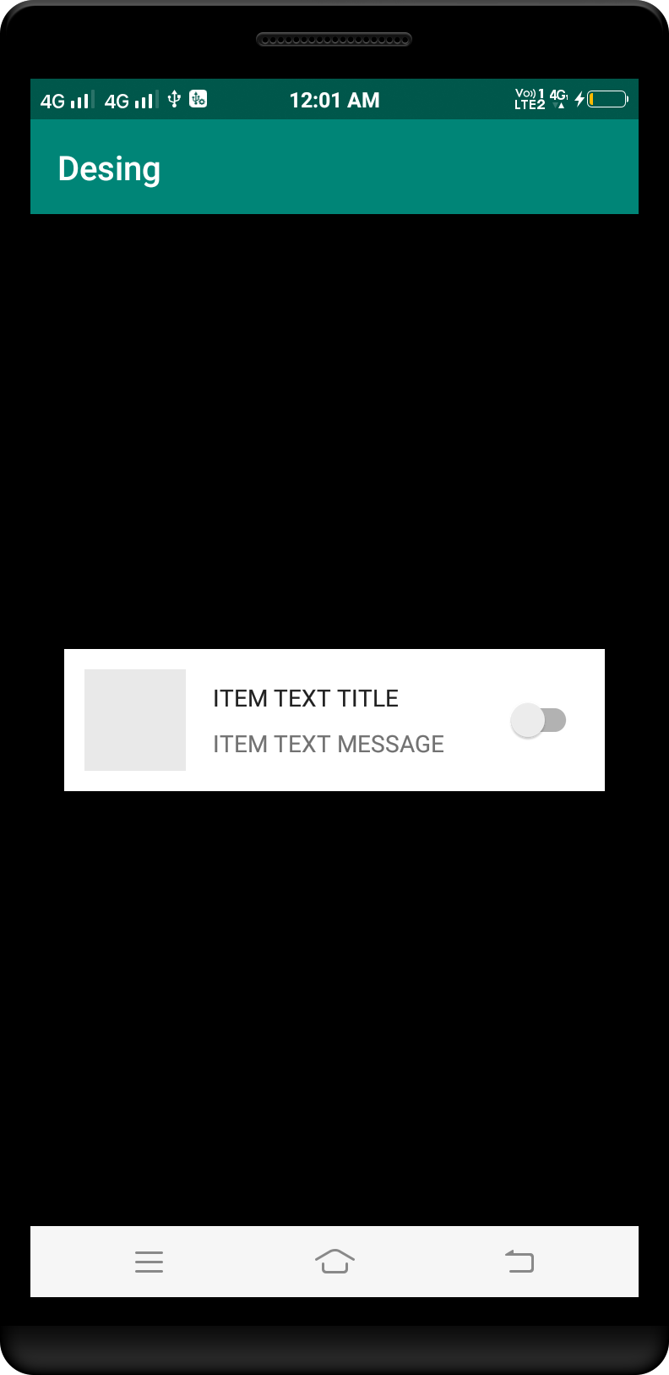

*<?***xml version="1.0" encoding="utf-8"***?>*<**RelativeLayout  
 xmlns:android="http://schemas.android.com/apk/res/android"  
 android:layout_width="wrap_content"  
 android:layout_height="wrap_content"  
 android:background="@android:color/white"**>  
  
 <**ImageView  
 android:id="@+id/posterThumbnail"  
 android:layout_width="match_parent"  
 android:layout_height="180dp"  
 android:scaleType="fitXY"  
 android:src="@drawable/rice"**/>  
  
 <**TextView  
 android:id="@+id/movieTitle"  
 android:layout_width="wrap_content"  
 android:layout_height="wrap_content"  
 android:layout_below="@id/posterThumbnail"  
 android:layout_margin="16dp"  
 android:textAppearance="?attr/textAppearanceListItem"  
 android:text="Movie Title"**/>  
</**RelativeLayout**>

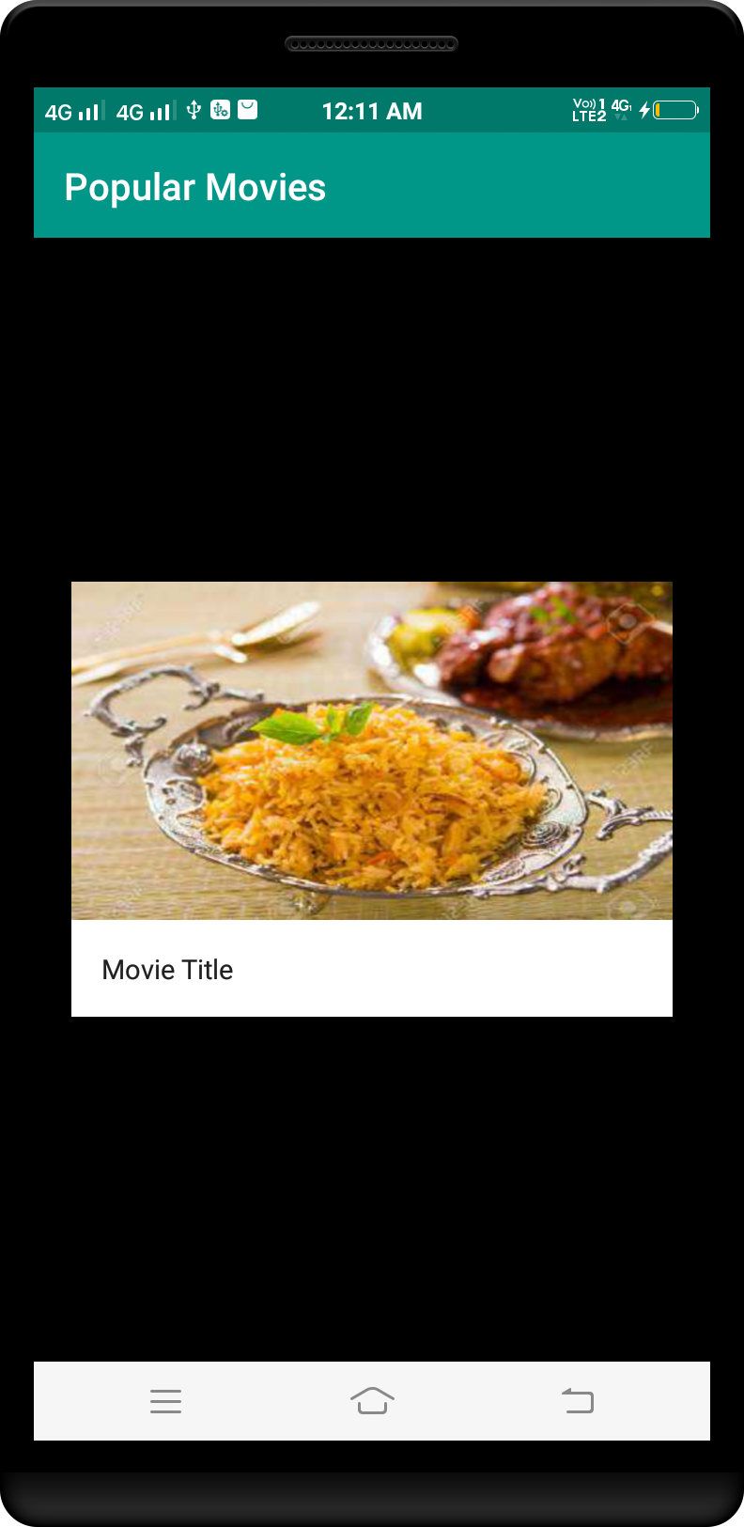

*<?***xml version="1.0" encoding="utf-8"***?>*<**LinearLayout  
 xmlns:android="http://schemas.android.com/apk/res/android"  
 xmlns:tools="http://schemas.android.com/tools"  
 android:layout_width="wrap_content"  
 android:layout_height="wrap_content"  
 android:orientation="vertical"  
 android:padding="16dp"  
 tools:ignore="UseCompoundDrawables"**>  
  
  
 <**RelativeLayout  
 android:layout_width="match_parent"  
 android:layout_height="wrap_content"**>  
  
 <**ImageView  
 android:id="@+id/video_preview_image"  
 android:layout_width="match_parent"  
 android:layout_height="wrap_content"  
 android:src="@drawable/rice"**/>  
  
 <**ImageView  
 android:id="@+id/play_icon"  
 android:layout_width="64dp"  
 android:layout_height="64dp"  
 android:layout_centerInParent="true"  
 android:src="@drawable/ic_play"** />  
 </**RelativeLayout**>  
  
 <**TextView  
 android:id="@+id/caption"  
 android:layout_width="match_parent"  
 android:layout_height="wrap_content"  
 android:gravity="center_horizontal"  
 android:textAppearance="@style/TextAppearance.AppCompat.Body2"  
 tools:text="Entitled to an opinion"** />  
  
 <**TextView  
 android:id="@+id/source"  
 android:layout_width="match_parent"  
 android:layout_height="wrap_content"  
 android:gravity="center_horizontal"  
 android:textAppearance="@style/TextAppearance.AppCompat.Body1"  
 android:visibility="gone"  
 tools:text="Youtube"** />  
</**LinearLayout**>

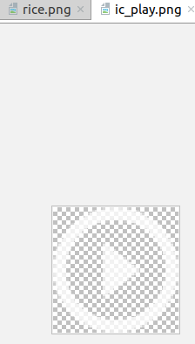

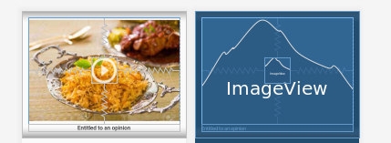

*<?***xml version="1.0" encoding="utf-8"***?>*<**android.support.v7.widget.CardView  
 xmlns:android="http://schemas.android.com/apk/res/android"  
 xmlns:app="http://schemas.android.com/apk/res-auto"  
 android:layout_width="match_parent"  
 android:layout_height="wrap_content"  
 android:layout_marginLeft="8dp"  
 android:layout_marginRight="8dp"  
 android:layout_marginTop="4dp"  
 android:orientation="vertical"  
 android:layout_marginBottom="4dp"**>  
  
 <**LinearLayout  
 android:orientation="horizontal"  
 android:layout_width="match_parent"  
 android:layout_height="wrap_content"  
 android:layout_margin="5dp"  
 android:id="@+id/linearLayout"**>  
  
 <**FrameLayout  
 android:layout_width="120dp"  
 android:layout_height="160dp"**>  
  
 <**ImageView  
 android:layout_width="120dp"  
 android:layout_height="160dp"  
 android:id="@+id/imageViewMoviePoster"  
 android:scaleType="fitXY"  
 android:src="@drawable/placeholder"**/>  
  
 <**ProgressBar  
 style="?android:attr/progressBarStyle"  
 android:layout_width="wrap_content"  
 android:layout_height="wrap_content"  
 android:id="@+id/progressBarMoviePoster"  
 android:layout_gravity="center"**/>  
  
 </**FrameLayout**>  
  
 <**LinearLayout  
 android:layout_width="match_parent"  
 android:layout_height="match_parent"  
 android:orientation="vertical"  
 android:padding="16dp"**>  
  
 <**TextView  
 android:id="@+id/textViewTitle"  
 android:layout_width="match_parent"  
 android:layout_height="wrap_content"  
 android:text="Movie Title"  
 android:textSize="18sp"  
 android:textStyle="normal|bold"** />  
  
 <**TextView  
 android:text="Year"  
 android:layout_width="match_parent"  
 android:layout_height="wrap_content"  
 android:id="@+id/textViewYear"** />  
  
 <**TextView  
 android:id="@+id/textViewTagline"  
 android:layout_width="match_parent"  
 android:layout_height="wrap_content"  
 android:text="Tagline"** />  
  
 <**TextView  
 android:id="@+id/textViewCast"  
 android:layout_width="match_parent"  
 android:layout_height="wrap_content"  
 android:text="Casts"** />  
 </**LinearLayout**>  
 </**LinearLayout**>  
  
</**android.support.v7.widget.CardView**>

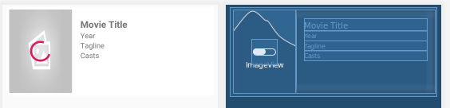

**package** com.mdc.cardview;  
  
**import** androidx.appcompat.app.AppCompatActivity;  
**import** androidx.cardview.widget.CardView;  
  
**import** android.os.Bundle;  
**import** android.view.animation.Animation;  
**import** android.view.animation.AnimationUtils;  
  
**public class** MainActivity **extends** AppCompatActivity {  
  
 CardView **VisitBtn**;  
 @Override  
 **protected void** onCreate(Bundle savedInstanceState) {  
 **super**.onCreate(savedInstanceState);  
 setContentView(R.layout.***activity_main***);  
  
 **final** Animation myAnim = AnimationUtils.*loadAnimation*(**this**, R.anim.***bounce***);  
 **VisitBtn**=(CardView)findViewById(R.id.***FreeBtn***);  
 **VisitBtn**.startAnimation(myAnim);  
 }  
}

In anim folder

bounce.xml.

*<?***xml version="1.0" encoding="utf-8"***?>*<**set xmlns:android="http://schemas.android.com/apk/res/android"** >  
  
 <**scale  
 android:duration="2000"  
 android:fromXScale="0.3"  
 android:toXScale="1.0"  
 android:fromYScale="0.3"  
 android:toYScale="1.0"  
 android:pivotX="50%"  
 android:pivotY="50%"** />  
</**set**>

Activity.xml

*<?***xml version="1.0" encoding="utf-8"***?>*<**androidx.cardview.widget.CardView  
 android:id="@+id/FreeBtn"  
 xmlns:android="http://schemas.android.com/apk/res/android"  
 xmlns:app="http://schemas.android.com/apk/res-auto"  
 xmlns:tools="http://schemas.android.com/tools"  
 android:layout_width="match_parent"  
 android:layout_height="80dp"  
 android:layout_margin="10dp"  
 app:cardBackgroundColor="#FFFFFF"  
 app:cardCornerRadius="16dp"**>  
  
 <**LinearLayout  
 android:layout_width="match_parent"  
 android:layout_height="match_parent"  
 android:gravity="center"  
 android:orientation="horizontal"**>  
  
 <**View  
 android:layout_width="10dp"  
 android:layout_height="match_parent"  
 android:background="@color/colorPrimary"**/>  
  
 <**TextView  
 android:layout_width="match_parent"  
 android:layout_height="match_parent"  
 android:padding="10dp"  
 android:layout_weight="1"  
 android:textStyle="bold"  
 android:gravity="center_vertical"  
 android:textColor="#000000"  
 android:textAppearance="?android:textAppearanceLarge"  
 android:text="Online Free"**/>  
  
 <**ImageView  
 android:layout_width="wrap_content"  
 android:layout_height="wrap_content"  
 android:tint="@color/colorPrimary"  
 android:src="@drawable/ic_chevron_right_black_24dp"**/>  
  
 </**LinearLayout**>  
</**androidx.cardview.widget.CardView**>

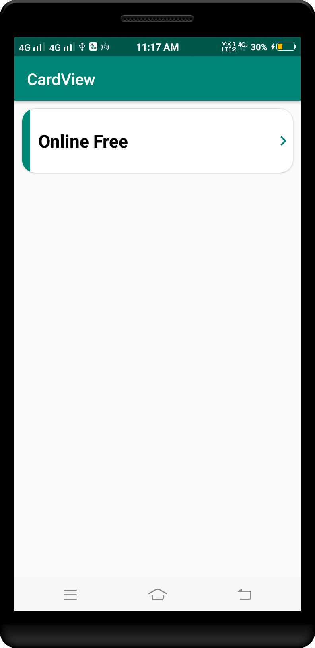

Other

*<?***xml version="1.0" encoding="utf-8"***?>*<**ScrollView xmlns:android="http://schemas.android.com/apk/res/android"  
 xmlns:app="http://schemas.android.com/apk/res-auto"  
 xmlns:tools="http://schemas.android.com/tools"  
 android:layout_width="match_parent"  
 android:layout_height="match_parent"  
 tools:context=".MainActivity"**>  
  
 <**LinearLayout  
 android:layout_width="match_parent"  
 android:layout_height="match_parent"  
 android:orientation="vertical"**>  
  
 <**RelativeLayout  
 android:layout_width="match_parent"  
 android:layout_height="wrap_content"  
 android:layout_marginLeft="20dp"  
 android:layout_marginTop="32dp"  
 android:layout_marginRight="20dp"**>  
  
 <**ImageView  
 android:layout_width="62dp"  
 android:layout_height="62dp"  
 android:layout_alignParentRight="true"  
 android:src="@drawable/angular"** />  
  
 <**TextView  
 android:id="@+id/testdashboard"  
 android:layout_width="wrap_content"  
 android:layout_height="wrap_content"  
 android:text="My DashBoard"  
 android:textColor="#2B1A1A"  
 android:textSize="22dp"** />  
  
 <**TextView  
 android:layout_width="wrap_content"  
 android:layout_height="wrap_content"  
 android:layout_below="@id/testdashboard"  
 android:layout_marginTop="6dp"  
 android:text="20 Items"  
 android:textColor="#2B1A1A"  
 android:textSize="14dp"** />  
  
  
 </**RelativeLayout**>  
  
 <**GridLayout  
 android:layout_width="match_parent"  
 android:layout_height="wrap_content"  
 android:alignmentMode="alignMargins"  
 android:columnCount="2"  
 android:columnOrderPreserved="false"  
 android:rowCount="3"**>  
  
  
 <**androidx.cardview.widget.CardView  
 android:id="@+id/card1"  
 android:layout_width="wrap_content"  
 android:layout_height="wrap_content"  
 android:layout_rowWeight="1"  
 android:layout_columnWeight="1"  
 android:layout_margin="12dp"  
 app:cardCornerRadius="12dp"  
 app:cardElevation="6dp"**>  
  
 <**LinearLayout  
 android:layout_width="match_parent"  
 android:layout_height="match_parent"  
 android:gravity="center"  
 android:orientation="vertical"  
 android:padding="16dp"**>  
  
 <**ImageView  
 android:layout_width="80dp"  
 android:layout_height="80dp"  
 android:src="@drawable/angular"** />  
  
 <**TextView  
 android:layout_width="wrap_content"  
 android:layout_height="wrap_content"  
 android:layout_marginTop="12dp"  
 android:text="Angular"  
 android:textColor="#6f6f6f"  
 android:textSize="18dp"** />  
  
 </**LinearLayout**>  
  
  
 </**androidx.cardview.widget.CardView**>  
  
 <**androidx.cardview.widget.CardView  
 android:layout_width="wrap_content"  
 android:layout_height="wrap_content"  
 android:layout_rowWeight="1"  
 android:layout_columnWeight="1"  
 android:layout_margin="12dp"  
 app:cardCornerRadius="12dp"  
 app:cardElevation="6dp"**>  
  
 <**LinearLayout  
 android:layout_width="match_parent"  
 android:layout_height="match_parent"  
 android:gravity="center"  
 android:orientation="vertical"  
 android:padding="16dp"**>  
  
 <**ImageView  
 android:layout_width="80dp"  
 android:layout_height="80dp"  
 android:src="@drawable/angular"** />  
  
 <**TextView  
 android:layout_width="wrap_content"  
 android:layout_height="wrap_content"  
 android:layout_marginTop="12dp"  
 android:text="Angular"  
 android:textColor="#6f6f6f"  
 android:textSize="18dp"** />  
  
 </**LinearLayout**>  
  
 </**androidx.cardview.widget.CardView**>  
  
  
 <**androidx.cardview.widget.CardView  
 android:layout_width="wrap_content"  
 android:layout_height="wrap_content"  
 android:layout_rowWeight="1"  
 android:layout_columnWeight="1"  
 android:layout_margin="12dp"  
 app:cardCornerRadius="12dp"  
 app:cardElevation="6dp"**>  
  
 <**LinearLayout  
 android:layout_width="match_parent"  
 android:layout_height="match_parent"  
 android:gravity="center"  
 android:orientation="vertical"  
 android:padding="16dp"**>  
  
 <**ImageView  
 android:layout_width="80dp"  
 android:layout_height="80dp"  
 android:src="@drawable/angular"** />  
  
 <**TextView  
 android:layout_width="wrap_content"  
 android:layout_height="wrap_content"  
 android:layout_marginTop="12dp"  
 android:text="Angular"  
 android:textColor="#6f6f6f"  
 android:textSize="18dp"** />  
  
 </**LinearLayout**>  
  
  
 </**androidx.cardview.widget.CardView**>  
  
 <**androidx.cardview.widget.CardView  
 android:layout_width="wrap_content"  
 android:layout_height="wrap_content"  
 android:layout_rowWeight="1"  
 android:layout_columnWeight="1"  
 android:layout_margin="12dp"  
 app:cardCornerRadius="12dp"  
 app:cardElevation="6dp"**>  
  
 <**LinearLayout  
 android:layout_width="match_parent"  
 android:layout_height="match_parent"  
 android:gravity="center"  
 android:orientation="vertical"  
 android:padding="16dp"**>  
  
 <**ImageView  
 android:layout_width="80dp"  
 android:layout_height="80dp"  
 android:src="@drawable/angular"** />  
  
 <**TextView  
 android:layout_width="wrap_content"  
 android:layout_height="wrap_content"  
 android:layout_marginTop="12dp"  
 android:text="Angular"  
 android:textColor="#6f6f6f"  
 android:textSize="18dp"** />  
  
 </**LinearLayout**>  
  
  
 </**androidx.cardview.widget.CardView**>  
  
 <**androidx.cardview.widget.CardView  
 android:layout_width="wrap_content"  
 android:layout_height="wrap_content"  
 android:layout_rowWeight="1"  
 android:layout_columnWeight="1"  
 android:layout_margin="12dp"  
 app:cardCornerRadius="12dp"  
 app:cardElevation="6dp"**>  
  
 <**LinearLayout  
 android:layout_width="match_parent"  
 android:layout_height="match_parent"  
 android:gravity="center"  
 android:orientation="vertical"  
 android:padding="16dp"**>  
  
 <**ImageView  
 android:layout_width="80dp"  
 android:layout_height="80dp"  
 android:src="@drawable/angular"** />  
  
 <**TextView  
 android:layout_width="wrap_content"  
 android:layout_height="wrap_content"  
 android:layout_marginTop="12dp"  
 android:text="Angular"  
 android:textColor="#6f6f6f"  
 android:textSize="18dp"** />  
  
 </**LinearLayout**>  
  
  
 </**androidx.cardview.widget.CardView**>  
  
  
 <**androidx.cardview.widget.CardView  
 android:layout_width="wrap_content"  
 android:layout_height="wrap_content"  
 android:layout_rowWeight="1"  
 android:layout_columnWeight="1"  
 android:layout_margin="12dp"  
 app:cardCornerRadius="12dp"  
 app:cardElevation="6dp"**>  
  
 <**LinearLayout  
 android:layout_width="match_parent"  
 android:layout_height="match_parent"  
 android:gravity="center"  
 android:orientation="vertical"  
 android:padding="16dp"**>  
  
 <**ImageView  
 android:layout_width="80dp"  
 android:layout_height="80dp"  
 android:src="@drawable/angular"** />  
  
 <**TextView  
 android:layout_width="wrap_content"  
 android:layout_height="wrap_content"  
 android:layout_marginTop="12dp"  
 android:text="Angular"  
 android:textColor="#6f6f6f"  
 android:textSize="18dp"** />  
  
 </**LinearLayout**>  
  
  
 </**androidx.cardview.widget.CardView**>  
  
  
 <**androidx.cardview.widget.CardView  
 android:layout_width="wrap_content"  
 android:layout_height="wrap_content"  
 android:layout_rowWeight="1"  
 android:layout_columnWeight="1"  
 android:layout_margin="12dp"  
 app:cardCornerRadius="12dp"  
 app:cardElevation="6dp"**>  
  
 <**LinearLayout  
 android:layout_width="match_parent"  
 android:layout_height="match_parent"  
 android:gravity="center"  
 android:orientation="vertical"  
 android:padding="16dp"**>  
  
 <**ImageView  
 android:layout_width="80dp"  
 android:layout_height="80dp"  
 android:src="@drawable/angular"** />  
  
 <**TextView  
 android:layout_width="wrap_content"  
 android:layout_height="wrap_content"  
 android:layout_marginTop="12dp"  
 android:text="Angular"  
 android:textColor="#6f6f6f"  
 android:textSize="18dp"** />  
  
 </**LinearLayout**>  
  
  
 </**androidx.cardview.widget.CardView**>  
  
  
 <**androidx.cardview.widget.CardView  
 android:layout_width="wrap_content"  
 android:layout_height="wrap_content"  
 android:layout_rowWeight="1"  
 android:layout_columnWeight="1"  
 android:layout_margin="12dp"  
 app:cardCornerRadius="12dp"  
 app:cardElevation="6dp"**>  
  
 <**LinearLayout  
 android:layout_width="match_parent"  
 android:layout_height="match_parent"  
 android:gravity="center"  
 android:orientation="vertical"  
 android:padding="16dp"**>  
  
 <**ImageView  
 android:layout_width="80dp"  
 android:layout_height="80dp"  
 android:src="@drawable/angular"** />  
  
 <**TextView  
 android:layout_width="wrap_content"  
 android:layout_height="wrap_content"  
 android:layout_marginTop="12dp"  
 android:text="Angular"  
 android:textColor="#6f6f6f"  
 android:textSize="18dp"** />  
  
 </**LinearLayout**>  
  
  
 </**androidx.cardview.widget.CardView**>  
  
  
 <**androidx.cardview.widget.CardView  
 android:layout_width="wrap_content"  
 android:layout_height="wrap_content"  
 android:layout_rowWeight="1"  
 android:layout_columnWeight="1"  
 android:layout_margin="12dp"  
 app:cardCornerRadius="12dp"  
 app:cardElevation="6dp"**>  
  
 <**LinearLayout  
 android:layout_width="match_parent"  
 android:layout_height="match_parent"  
 android:gravity="center"  
 android:orientation="vertical"  
 android:padding="16dp"**>  
  
 <**ImageView  
 android:layout_width="80dp"  
 android:layout_height="80dp"  
 android:src="@drawable/angular"** />  
  
 <**TextView  
 android:layout_width="wrap_content"  
 android:layout_height="wrap_content"  
 android:layout_marginTop="12dp"  
 android:text="Angular"  
 android:textColor="#6f6f6f"  
 android:textSize="18dp"** />  
  
 </**LinearLayout**>  
  
  
 </**androidx.cardview.widget.CardView**>  
  
  
 <**androidx.cardview.widget.CardView  
 android:layout_width="wrap_content"  
 android:layout_height="wrap_content"  
 android:layout_rowWeight="1"  
 android:layout_columnWeight="1"  
 android:layout_margin="12dp"  
 app:cardCornerRadius="12dp"  
 app:cardElevation="6dp"**>  
  
 <**LinearLayout  
 android:layout_width="match_parent"  
 android:layout_height="match_parent"  
 android:gravity="center"  
 android:orientation="vertical"  
 android:padding="16dp"**>  
  
 <**ImageView  
 android:layout_width="80dp"  
 android:layout_height="80dp"  
 android:src="@drawable/angular"** />  
  
 <**TextView  
 android:layout_width="wrap_content"  
 android:layout_height="wrap_content"  
 android:layout_marginTop="12dp"  
 android:text="Angular"  
 android:textColor="#6f6f6f"  
 android:textSize="18dp"** />  
  
 </**LinearLayout**>  
  
  
 </**androidx.cardview.widget.CardView**>  
  
  
 <**androidx.cardview.widget.CardView  
 android:layout_width="wrap_content"  
 android:layout_height="wrap_content"  
 android:layout_rowWeight="1"  
 android:layout_columnWeight="1"  
 android:layout_margin="12dp"  
 app:cardCornerRadius="12dp"  
 app:cardElevation="6dp"**>  
  
 <**LinearLayout  
 android:layout_width="match_parent"  
 android:layout_height="match_parent"  
 android:gravity="center"  
 android:orientation="vertical"  
 android:padding="16dp"**>  
  
 <**ImageView  
 android:layout_width="80dp"  
 android:layout_height="80dp"  
 android:src="@drawable/angular"** />  
  
 <**TextView  
 android:layout_width="wrap_content"  
 android:layout_height="wrap_content"  
 android:layout_marginTop="12dp"  
 android:text="Angular"  
 android:textColor="#6f6f6f"  
 android:textSize="18dp"** />  
  
 </**LinearLayout**>  
  
  
 </**androidx.cardview.widget.CardView**>  
  
  
 <**androidx.cardview.widget.CardView  
 android:layout_width="wrap_content"  
 android:layout_height="wrap_content"  
 android:layout_rowWeight="1"  
 android:layout_columnWeight="1"  
 android:layout_margin="12dp"  
 app:cardCornerRadius="12dp"  
 app:cardElevation="6dp"**>  
  
 <**LinearLayout  
 android:layout_width="match_parent"  
 android:layout_height="match_parent"  
 android:gravity="center"  
 android:orientation="vertical"  
 android:padding="16dp"**>  
  
 <**ImageView  
 android:layout_width="80dp"  
 android:layout_height="80dp"  
 android:src="@drawable/angular"** />  
  
 <**TextView  
 android:layout_width="wrap_content"  
 android:layout_height="wrap_content"  
 android:layout_marginTop="12dp"  
 android:text="Angular"  
 android:textColor="#6f6f6f"  
 android:textSize="18dp"** />  
  
 </**LinearLayout**>  
  
  
 </**androidx.cardview.widget.CardView**>  
  
  
 <**androidx.cardview.widget.CardView  
 android:layout_width="wrap_content"  
 android:layout_height="wrap_content"  
 android:layout_rowWeight="1"  
 android:layout_columnWeight="1"  
 android:layout_margin="12dp"  
 app:cardCornerRadius="12dp"  
 app:cardElevation="6dp"**>  
  
 <**LinearLayout  
 android:layout_width="match_parent"  
 android:layout_height="match_parent"  
 android:gravity="center"  
 android:orientation="vertical"  
 android:padding="16dp"**>  
  
 <**ImageView  
 android:layout_width="80dp"  
 android:layout_height="80dp"  
 android:src="@drawable/angular"** />  
  
 <**TextView  
 android:layout_width="wrap_content"  
 android:layout_height="wrap_content"  
 android:layout_marginTop="12dp"  
 android:text="Angular"  
 android:textColor="#6f6f6f"  
 android:textSize="18dp"** />  
  
 </**LinearLayout**>  
  
  
 </**androidx.cardview.widget.CardView**>  
  
  
 <**androidx.cardview.widget.CardView  
 android:layout_width="wrap_content"  
 android:layout_height="wrap_content"  
 android:layout_rowWeight="1"  
 android:layout_columnWeight="1"  
 android:layout_margin="12dp"  
 app:cardCornerRadius="12dp"  
 app:cardElevation="6dp"**>  
  
 <**LinearLayout  
 android:layout_width="match_parent"  
 android:layout_height="match_parent"  
 android:gravity="center"  
 android:orientation="vertical"  
 android:padding="16dp"**>  
  
 <**ImageView  
 android:layout_width="80dp"  
 android:layout_height="80dp"  
 android:src="@drawable/angular"** />  
  
 <**TextView  
 android:layout_width="wrap_content"  
 android:layout_height="wrap_content"  
 android:layout_marginTop="12dp"  
 android:text="Angular"  
 android:textColor="#6f6f6f"  
 android:textSize="18dp"** />  
  
 </**LinearLayout**>  
  
  
 </**androidx.cardview.widget.CardView**>  
  
  
 </**GridLayout**>  
  
  
 </**LinearLayout**>  
  
</**ScrollView**>

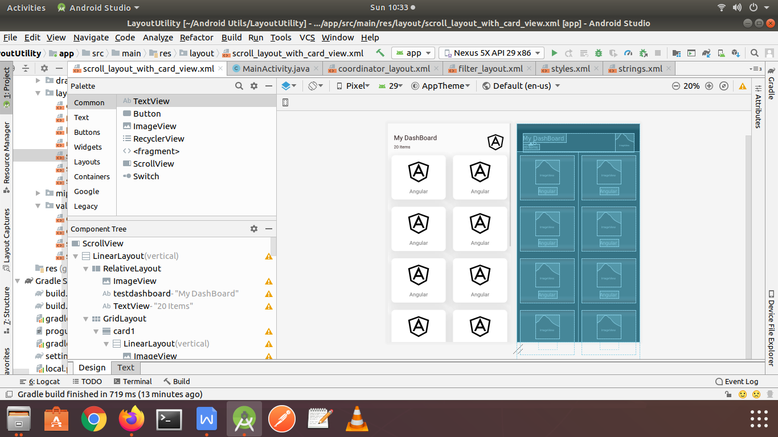

Example :

custom_progress_dialog.xml

*<?***xml version="1.0" encoding="utf-8"***?>*<**rotate xmlns:android="http://schemas.android.com/apk/res/android"  
 android:fromDegrees="0"  
 android:pivotX="50%"  
 android:pivotY="50%"  
 android:toDegrees="1440"**>  
 <**shape  
 android:innerRadiusRatio="3"  
 android:shape="ring"  
 android:thicknessRatio="15"  
 android:useLevel="false"**>  
  
 <**size  
 android:width="56dip"  
 android:height="56dip"** />  
  
 <**gradient  
 android:angle="0"  
 android:endColor="#e073ec"  
 android:startColor="@android:color/transparent"  
 android:type="sweep"  
 android:useLevel="false"** />  
 </**shape**>  
</**rotate**>

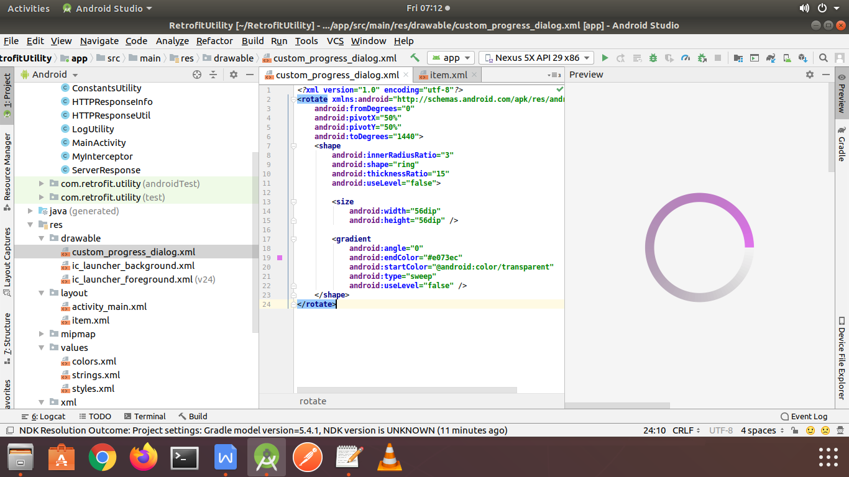

styles.xml

<**resources**>  
  
 *<!-- Base application theme. -->* <**style name="AppTheme" parent="Theme.AppCompat.Light.DarkActionBar"**>  
 *<!-- Customize your theme here. -->* <**item name="colorPrimary"**>@color/colorPrimary</**item**>  
 <**item name="colorPrimaryDark"**>@color/colorPrimaryDark</**item**>  
 <**item name="colorAccent"**>@color/colorAccent</**item**>  
 </**style**>  
  
 <**style name="CircularProgress" parent="Theme.AppCompat.Light"**>  
 <**item name="colorAccent"**>@color/white</**item**>  
 </**style**>  
</**resources**>

item.xml

*<?***xml version="1.0" encoding="utf-8"***?>*<**FrameLayout  
 xmlns:android="http://schemas.android.com/apk/res/android"  
 xmlns:app="http://schemas.android.com/apk/res-auto"  
 xmlns:tools="http://schemas.android.com/tools"  
 android:layout_width="match_parent"  
 android:layout_height="wrap_content"  
 android:orientation="vertical"**>  
  
 <**androidx.cardview.widget.CardView  
 android:layout_width="wrap_content"  
 android:layout_height="wrap_content"  
 android:layout_margin="@dimen/_8sdp"  
 app:cardBackgroundColor="#AAADC4"  
 app:cardCornerRadius="3dp"  
 app:cardPreventCornerOverlap="false"**>  
  
 <**ProgressBar  
 android:id="@+id/movie_progress"  
 style="@style/Widget.AppCompat.ProgressBar"  
 android:layout_width="@dimen/_16sdp"  
 android:layout_height="@dimen/_16sdp"  
 android:layout_gravity="center"  
 android:theme="@style/CircularProgress"**/>  
  
 <**ImageView  
 android:id="@+id/movie_poster"  
 android:layout_width="@dimen/_72sdp"  
 android:layout_height="@dimen/_96sdp"  
 android:fitsSystemWindows="true"  
 android:scaleType="fitXY"**/>  
 </**androidx.cardview.widget.CardView**>  
  
 <**LinearLayout  
 android:layout_width="match_parent"  
 android:layout_height="match_parent"  
 android:layout_gravity="bottom"  
 android:layout_marginTop="@dimen/_16sdp"  
 android:background="@android:color/white"  
 android:orientation="vertical"  
 android:paddingBottom="@dimen/_16sdp"  
 android:paddingEnd="@dimen/_16sdp"  
 android:paddingStart="@dimen/_72sdp"  
 android:paddingTop="@dimen/_8sdp"  
 android:paddingLeft="@dimen/_72sdp"  
 android:paddingRight="@dimen/_16sdp"**>  
  
 <**TextView  
 android:id="@+id/movie_year"  
 style="@style/TextAppearance.AppCompat.Caption"  
 android:layout_width="wrap_content"  
 android:layout_height="wrap_content"  
 android:layout_marginStart="@dimen/_24sdp"  
 android:alpha="0.38"  
 android:gravity="end"  
 android:layout_gravity="end"  
 android:maxLines="1"  
 android:textStyle="bold"  
 tools:text="2009 | EN"  
 android:layout_marginLeft="@dimen/_24sdp"** />  
  
 <**TextView  
 android:id="@+id/movie_title"  
 style="@style/TextAppearance.AppCompat.Subhead"  
 android:layout_width="match_parent"  
 android:layout_height="wrap_content"  
 android:layout_marginStart="@dimen/_24sdp"  
 android:layout_marginTop="@dimen/_4sdp"  
 android:maxLines="1"  
 tools:text="Movie Title"  
 android:layout_marginLeft="@dimen/_24sdp"** />  
  
 <**TextView  
 android:id="@+id/movie_desc"  
 style="@style/TextAppearance.AppCompat.Caption"  
 android:layout_width="match_parent"  
 android:layout_height="wrap_content"  
 android:layout_marginStart="@dimen/_24sdp"  
 android:layout_marginTop="@dimen/_8sdp"  
 android:ellipsize="end"  
 android:maxLines="2"  
 tools:text="Nowadays, user engagement is considered one of the most important metrics for the success of your app"  
 android:layout_marginLeft="@dimen/_24sdp"** />  
 </**LinearLayout**>  
</**FrameLayout**>

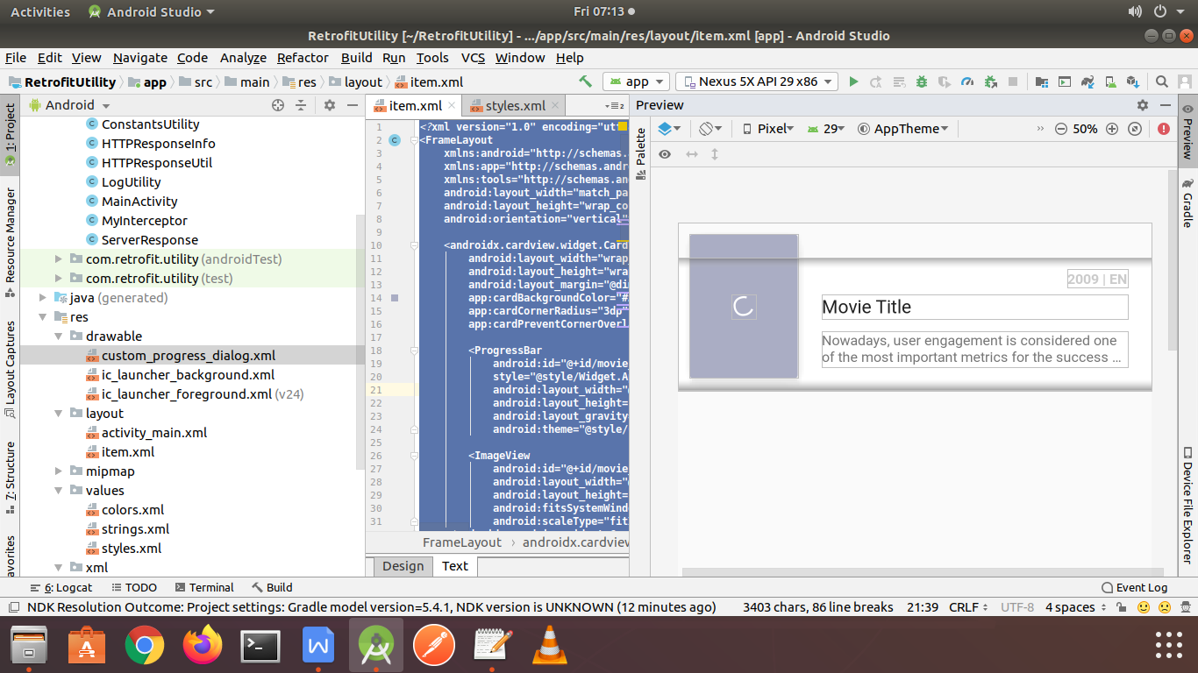

activity_main.xml

*<?***xml version="1.0" encoding="utf-8"***?>*<**FrameLayout  
 xmlns:android="http://schemas.android.com/apk/res/android"  
 xmlns:tools="http://schemas.android.com/tools"  
 android:layout_width="match_parent"  
 android:layout_height="match_parent"  
 tools:context=".MainActivity"**>  
  
 <**androidx.recyclerview.widget.RecyclerView  
 android:id="@+id/main_recycler"  
 android:layout_width="match_parent"  
 android:layout_height="match_parent"  
 android:clipToPadding="false"  
 android:paddingBottom="16dp"  
 android:paddingTop="16dp"**/>  
  
 <**ProgressBar  
 android:id="@+id/main_progress"  
 android:layout_width="wrap_content"  
 android:layout_height="wrap_content"  
 style="?android:attr/progressBarStyleLarge"  
 android:indeterminateDrawable="@drawable/custom_progress_dialog"  
 android:indeterminate="true"  
 android:layout_gravity="center"**/>  
</**FrameLayout**>

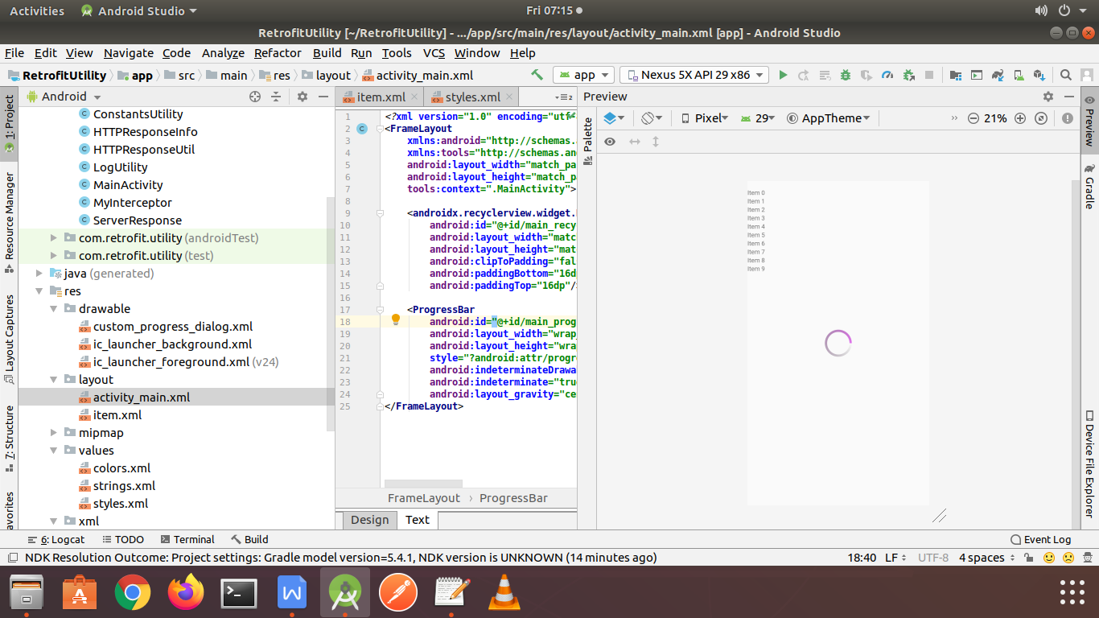

Example :

employee_background.xml

*<?***xml version="1.0" encoding="utf-8"***?>*<**shape xmlns:android="http://schemas.android.com/apk/res/android"  
 android:shape="rectangle"** >  
  
 *<!-- View background color -->* <**solid  
 android:color="#fff"** >  
 </**solid**>  
  
 *<!-- View border color and width -->* <**stroke  
 android:width="1dp"  
 android:color="#aaa"** >  
 </**stroke**>  
  
 *<!-- The radius makes the corners rounded -->* <**corners  
 android:radius="2dp"** >  
 </**corners**>  
  
</**shape**>

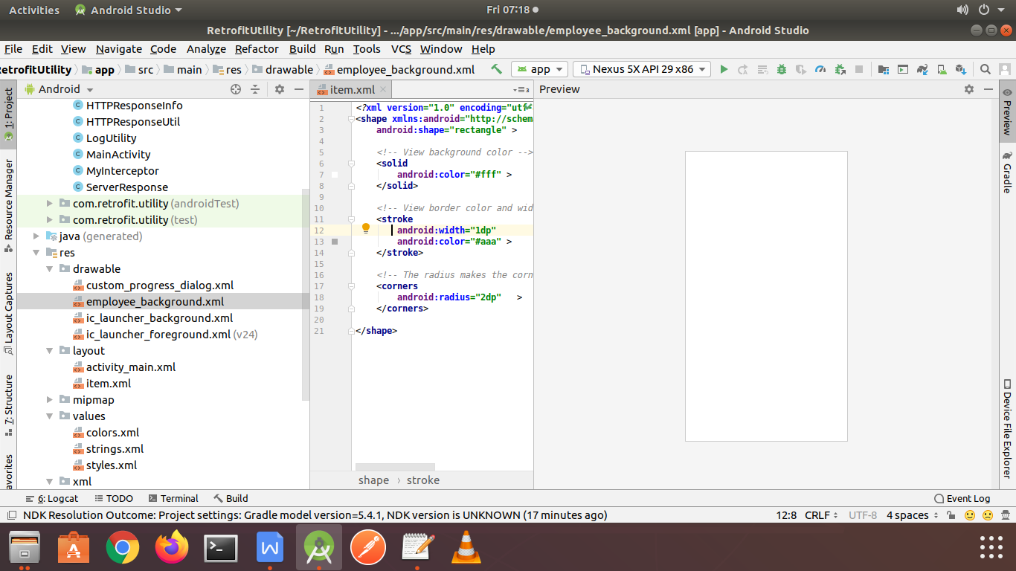

item.xml

*<?***xml version="1.0" encoding="utf-8"***?>*<**RelativeLayout xmlns:android="http://schemas.android.com/apk/res/android"  
 android:layout_width="match_parent"  
 android:layout_height="wrap_content"  
 android:layout_marginBottom="8dp"  
 android:layout_marginLeft="8dp"  
 android:layout_marginRight="8dp"  
 android:layout_marginTop="8dp"  
 android:background="@drawable/employee_background"  
  
 android:paddingBottom="13dp"**>  
  
 <**TextView  
 android:id="@+id/employeeName"  
 android:layout_width="wrap_content"  
 android:layout_height="wrap_content"  
 android:layout_alignParentLeft="true"  
 android:layout_alignParentStart="true"  
 android:layout_alignParentTop="true"  
 android:layout_marginLeft="17dp"  
 android:layout_marginStart="17dp"  
 android:layout_marginTop="13dp"  
 android:text="Employee Name"  
 android:textColor="@color/colorPrimaryDark"  
 android:textSize="18dp"** />  
  
 <**TextView  
 android:id="@+id/designation"  
 android:layout_width="wrap_content"  
 android:layout_height="wrap_content"  
 android:layout_alignLeft="@+id/employeeName"  
 android:layout_alignStart="@+id/employeeName"  
 android:layout_below="@+id/employeeName"  
 android:text="Designation"** />  
  
 <**TextView  
 android:id="@+id/email"  
 android:layout_width="wrap_content"  
 android:layout_height="wrap_content"  
 android:layout_alignEnd="@+id/salary"  
 android:layout_alignRight="@+id/salary"  
 android:layout_alignTop="@+id/employeeName"  
 android:text="email@domain.com"  
 android:textColor="@color/colorAccent"** />  
  
 <**TextView  
 android:id="@+id/salary"  
 android:layout_width="wrap_content"  
 android:layout_height="wrap_content"  
 android:layout_alignParentEnd="true"  
 android:layout_alignParentRight="true"  
 android:layout_below="@+id/email"  
 android:layout_marginEnd="27dp"  
 android:layout_marginRight="27dp"  
 android:text="Salary"** />  
  
 <**TextView  
 android:id="@+id/dob"  
 android:layout_width="wrap_content"  
 android:layout_height="wrap_content"  
 android:layout_alignLeft="@+id/designation"  
 android:layout_alignStart="@+id/designation"  
 android:layout_below="@+id/designation"  
 android:text="dob"** />  
  
 <**TextView  
 android:id="@+id/contactNumber"  
 android:layout_width="wrap_content"  
 android:layout_height="wrap_content"  
 android:layout_alignEnd="@+id/salary"  
 android:layout_alignRight="@+id/salary"  
 android:layout_below="@+id/designation"  
 android:text="contact"** />  
  
</**RelativeLayout**>

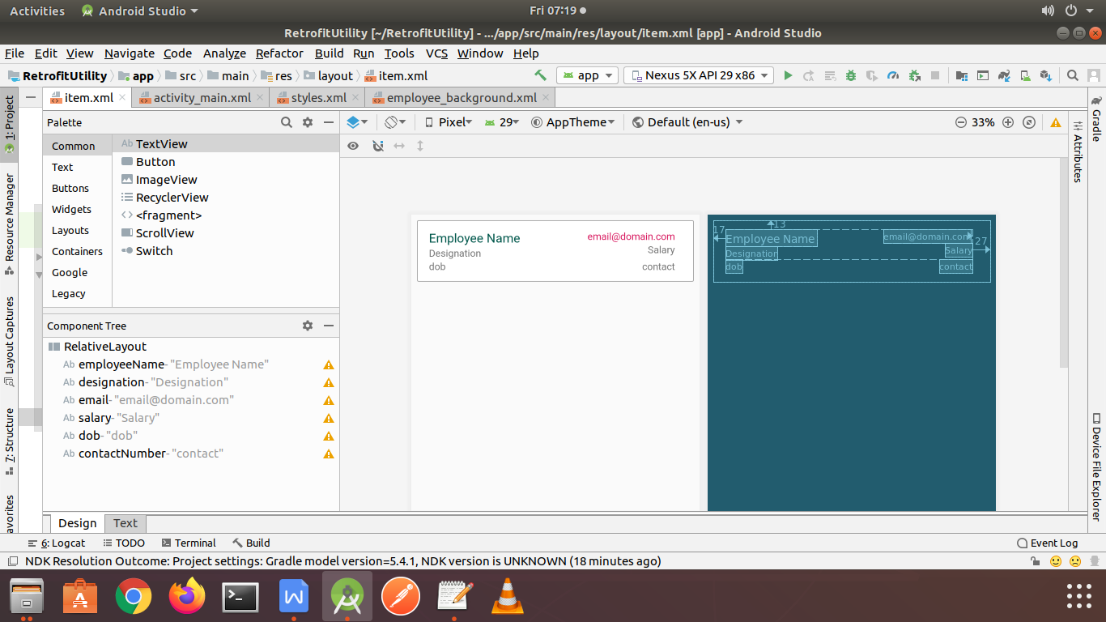

Example :

item.xml

*<?***xml version="1.0" encoding="utf-8"***?>*<**androidx.cardview.widget.CardView  
 xmlns:android="http://schemas.android.com/apk/res/android"  
 xmlns:card_view="http://schemas.android.com/apk/res-auto"  
 android:id="@+id/card_view"  
 android:layout_width="match_parent"  
 android:layout_height="wrap_content"  
 android:layout_margin="5dp"  
 card_view:cardCornerRadius="10dp"**>  
  
 <**LinearLayout  
 android:layout_width="match_parent"  
 android:layout_height="250dip"  
 android:orientation="vertical"**>  
  
 <**LinearLayout  
 android:layout_width="match_parent"  
 android:layout_height="0dip"  
 android:layout_weight="3.2"  
 android:orientation="vertical"**>  
  
 <**FrameLayout  
 android:layout_width="match_parent"  
 android:layout_height="match_parent"  
 android:layout_gravity="center_horizontal"**>  
  
 <**ImageView  
 android:id="@+id/image_card_cover"  
 android:layout_width="match_parent"  
 android:layout_height="match_parent"  
 android:layout_gravity="center"  
 android:scaleType="fitXY"**/>  
  
 <**LinearLayout  
 android:layout_width="match_parent"  
 android:layout_height="wrap_content"  
 android:layout_gravity="left|bottom"  
 android:background="@android:drawable/screen_background_dark_transparent"  
 android:orientation="vertical"**>  
  
 <**TextView  
 android:id="@+id/text_card_name"  
 android:layout_width="match_parent"  
 android:layout_height="wrap_content"  
 android:paddingBottom="16dp"  
 android:paddingLeft="16dp"  
 android:paddingRight="16dp"  
 android:paddingTop="16dp"  
 android:text="I am Rohit Yadav"  
 android:textAppearance="?android:attr/textAppearanceMedium"  
 android:textColor="#ffffff"  
 android:textStyle="bold"** />  
 </**LinearLayout**>  
 </**FrameLayout**>  
 </**LinearLayout**>  
 </**LinearLayout**>  
</**androidx.cardview.widget.CardView**>

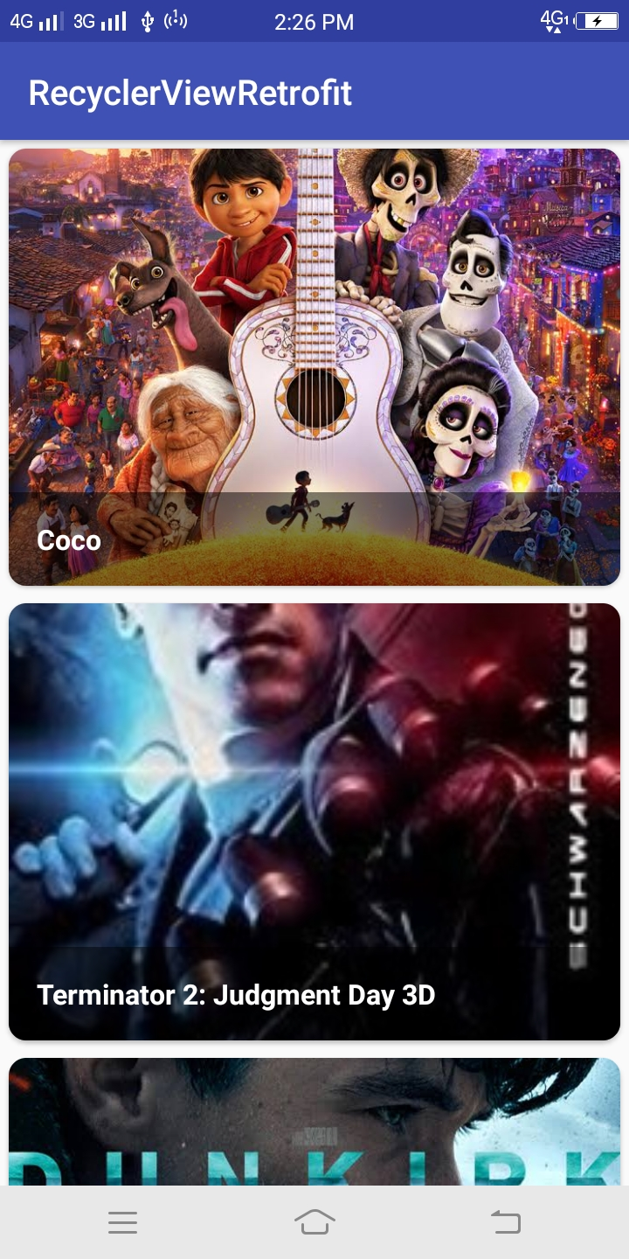

<**LinearLayout  
 android:id="@+id/buttons"  
 android:layout_width="match_parent"  
 android:layout_height="wrap_content"**>  
  
 <**TextView  
 android:id="@+id/save"  
 android:layout_width="match_parent"  
 android:layout_height="match_parent"  
 android:layout_weight="1"  
 android:background="#535766"  
 android:gravity="center"  
 android:padding="15dp"  
 android:text="SAVE"  
 android:textColor="@android:color/white"  
 android:textSize="14sp"** />  
  
 <**TextView  
 android:id="@+id/buy"  
 android:layout_width="match_parent"  
 android:layout_height="match_parent"  
 android:layout_weight="1"  
 android:background="#0BC6A0"  
 android:gravity="center"  
 android:maxLines="1"  
 android:text="BUY"  
 android:textColor="@android:color/white"  
 android:textSize="14sp"** />  
</**LinearLayout**>



*<?***xml version="1.0" encoding="utf-8"***?>*<**RelativeLayout xmlns:android="http://schemas.android.com/apk/res/android"  
 android:id="@+id/layout_bg"  
 android:layout_width="match_parent"  
 android:layout_height="@dimen/_100sdp"**>  
  
 <**ImageView  
 android:id="@+id/user_profile_image_view"  
 android:layout_width="@dimen/_100sdp"  
 android:layout_height="match_parent"  
 android:adjustViewBounds="true"  
 android:scaleType="centerInside"  
 android:src="@android:color/darker_gray"  
 android:contentDescription="@string/app_name"** />  
  
 <**LinearLayout  
 android:id="@+id/linearLayout3"  
 android:layout_width="match_parent"  
 android:layout_height="match_parent"  
 android:layout_toEndOf="@+id/user_profile_image_view"  
 android:layout_toRightOf="@+id/user_profile_image_view"  
 android:gravity="center_vertical"  
 android:orientation="vertical"  
 android:paddingStart="@dimen/_10sdp"  
 android:paddingLeft="@dimen/_10sdp"  
 android:paddingEnd="@dimen/_10sdp"  
 android:paddingRight="@dimen/_10sdp"**>  
  
 <**TextView  
 android:id="@+id/name_text_view"  
 android:layout_width="wrap_content"  
 android:layout_height="wrap_content"  
 android:text="TEXT VIEW 1"  
 android:textColor="@android:color/black"  
 android:textSize="@dimen/_20sdp"** />  
  
 <**TextView  
 android:id="@+id/description_text_view"  
 android:layout_width="wrap_content"  
 android:layout_height="wrap_content"  
 android:text="TEXT VIEW 2"  
 android:textColor="@android:color/black"  
 android:textSize="@dimen/_14sdp"** />  
 </**LinearLayout**>  
</**RelativeLayout**>

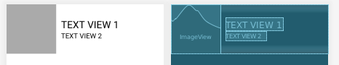

Example

item_cardview_movie.xml

*<?***xml version="1.0" encoding="utf-8"***?>*<**androidx.cardview.widget.CardView xmlns:android="http://schemas.android.com/apk/res/android"  
 xmlns:app="http://schemas.android.com/apk/res-auto"  
 xmlns:tools="http://schemas.android.com/tools"  
 android:layout_width="match_parent"  
 android:layout_height="wrap_content"  
 android:layout_gravity="center"  
 android:layout_marginLeft="@dimen/_8sdp"  
 android:layout_marginTop="@dimen/_4sdp"  
 android:layout_marginRight="@dimen/_8sdp"  
 app:cardCornerRadius="@dimen/_8sdp"**>  
  
 <**RelativeLayout  
 android:layout_width="match_parent"  
 android:layout_height="wrap_content"  
 android:padding="@dimen/_8sdp"**>  
  
 <**ImageView  
 android:id="@+id/poster_image_view"  
 android:layout_width="@dimen/_140sdp"  
 android:layout_height="@dimen/_200sdp"  
 android:contentDescription="@string/app_name"  
 android:scaleType="centerCrop"  
 tools:src="@color/colorAccent"** />  
  
 <**TextView  
 android:id="@+id/name_text_view"  
 android:layout_width="match_parent"  
 android:layout_height="wrap_content"  
 android:layout_marginLeft="@dimen/_5sdp"  
 android:layout_marginRight="@dimen/_5sdp"  
 android:layout_marginBottom="@dimen/_5sdp"  
 android:layout_toEndOf="@id/poster_image_view"  
 android:layout_toRightOf="@id/poster_image_view"  
 android:textSize="@dimen/_10sdp"  
 android:textStyle="bold"  
 tools:text="Avengers: End Game (2019)"** />  
  
 <**ImageView  
 android:id="@+id/rating_image_view"  
 android:layout_width="@dimen/_15sdp"  
 android:layout_height="@dimen/_15sdp"  
 android:layout_below="@id/name_text_view"  
 android:layout_marginLeft="@dimen/_5sdp"  
 android:layout_marginRight="@dimen/_5sdp"  
 android:layout_toEndOf="@id/poster_image_view"  
 android:layout_toRightOf="@id/poster_image_view"  
 android:src="@drawable/ic_star_yellow_24dp"** />  
  
 <**TextView  
 android:id="@+id/rating_text_view"  
 android:layout_width="wrap_content"  
 android:layout_height="@dimen/_15sdp"  
 android:layout_below="@id/name_text_view"  
 android:layout_marginEnd="@dimen/_5sdp"  
 android:layout_marginRight="@dimen/_5sdp"  
 android:layout_toEndOf="@id/rating_image_view"  
 android:layout_toRightOf="@id/poster_image_view"  
 android:fontFamily="@font/quicksand"  
 android:text="7.2"  
 android:textSize="12sp"** />  
  
 <**ImageView  
 android:id="@+id/duration_image_view"  
 android:layout_width="@dimen/_15sdp"  
 android:layout_height="@dimen/_15sdp"  
 android:layout_below="@id/name_text_view"  
 android:layout_marginEnd="@dimen/_5sdp"  
 android:layout_marginRight="@dimen/_5sdp"  
 android:layout_toEndOf="@id/rating_text_view"  
 android:layout_toRightOf="@id/rating_text_view"  
 android:background="@drawable/ic_access_time_yellow_24dp"** />  
  
 <**TextView  
 android:id="@+id/duration_text_view"  
 android:layout_width="wrap_content"  
 android:layout_height="@dimen/_15sdp"  
 android:layout_below="@id/name_text_view"  
 android:layout_marginEnd="@dimen/_5sdp"  
 android:layout_marginRight="@dimen/_5sdp"  
 android:layout_toEndOf="@id/duration_image_view"  
 android:layout_toRightOf="@id/duration_image_view"  
 android:fontFamily="@font/quicksand"  
 android:text="1h 58m"  
 android:textSize="12sp"** />  
  
 <**ImageView  
 android:id="@+id/language_image_view"  
 android:layout_width="@dimen/_15sdp"  
 android:layout_height="@dimen/_15sdp"  
 android:layout_below="@id/name_text_view"  
 android:layout_marginEnd="@dimen/_5sdp"  
 android:layout_marginRight="@dimen/_5sdp"  
 android:layout_toEndOf="@id/duration_text_view"  
 android:layout_toRightOf="@id/duration_text_view"  
 android:src="@drawable/ic_language_yellow_24dp"** />  
  
 <**TextView  
 android:id="@+id/language_text_view"  
 android:layout_width="wrap_content"  
 android:layout_height="@dimen/_15sdp"  
 android:layout_below="@id/name_text_view"  
 android:layout_toEndOf="@id/language_image_view"  
 android:layout_toRightOf="@id/language_image_view"  
 android:fontFamily="@font/quicksand"  
 android:text="EN"  
 android:textSize="12sp"** />  
  
 <**TextView  
 android:id="@+id/description_text_view"  
 android:layout_width="match_parent"  
 android:layout_height="wrap_content"  
 android:layout_below="@id/rating_image_view"  
 android:layout_marginStart="@dimen/_5sdp"  
 android:layout_marginLeft="@dimen/_5sdp"  
 android:layout_marginTop="@dimen/_5sdp"  
 android:layout_marginEnd="@dimen/_5sdp"  
 android:layout_marginRight="@dimen/_5sdp"  
 android:layout_toEndOf="@id/poster_image_view"  
 android:layout_toRightOf="@id/poster_image_view"  
 android:textSize="@dimen/_12sdp"  
 tools:text="Description"** />  
  
 <**LinearLayout  
 android:layout_width="match_parent"  
 android:layout_height="wrap_content"  
 android:layout_alignParentBottom="true"  
 android:layout_marginStart="@dimen/_5sdp"  
 android:layout_marginLeft="@dimen/_5sdp"  
 android:layout_marginBottom="@dimen/_5sdp"  
 android:layout_toEndOf="@id/poster_image_view"  
 android:layout_toRightOf="@id/poster_image_view"  
 android:orientation="horizontal"**>  
  
 <**Button  
 android:id="@+id/publish_button"  
 style="@style/Widget.AppCompat.Button.Colored"  
 android:layout_width="match_parent"  
 android:layout_height="wrap_content"  
 android:text="PUBLISH BUTTON"  
 android:textSize="@dimen/_10sdp"** />  
 </**LinearLayout**>  
 </**RelativeLayout**>  
</**androidx.cardview.widget.CardView**>

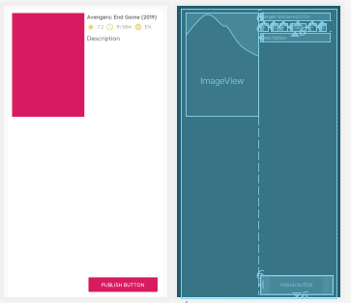

activity_main.xml

*<?***xml version="1.0" encoding="utf-8"***?>*<**RelativeLayout xmlns:android="http://schemas.android.com/apk/res/android"  
 xmlns:app="http://schemas.android.com/apk/res-auto"  
 xmlns:tools="http://schemas.android.com/tools"  
 android:layout_width="match_parent"  
 android:layout_height="match_parent"**>  
  
 <**androidx.recyclerview.widget.RecyclerView  
 android:id="@+id/rv_category"  
 android:layout_width="match_parent"  
 android:layout_height="match_parent"  
 tools:listitem="@layout/item_cardview_movie"**>  
 </**androidx.recyclerview.widget.RecyclerView**>  
</**RelativeLayout**>

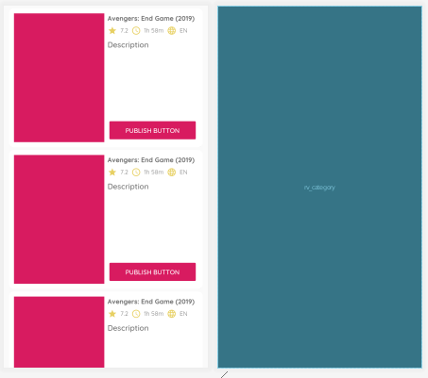

Example

item_row_president.xml

*<?***xml version="1.0" encoding="utf-8"***?>*<**RelativeLayout xmlns:android="http://schemas.android.com/apk/res/android"  
 xmlns:tools="http://schemas.android.com/tools"  
 android:layout_width="match_parent"  
 android:layout_height="wrap_content"  
 android:orientation="horizontal"  
 android:padding="@dimen/_8sdp"**>  
  
 <**de.hdodenhof.circleimageview.CircleImageView  
 android:id="@+id/circle_image_view"  
 android:layout_width="@dimen/_55sdp"  
 android:layout_height="@dimen/_55sdp"  
 android:layout_marginEnd="@dimen/_8sdp"  
 android:layout_marginRight="@dimen/_8sdp"  
 tools:src="@android:color/darker_gray"** />  
  
 <**LinearLayout  
 android:layout_width="match_parent"  
 android:layout_height="wrap_content"  
 android:layout_centerVertical="true"  
 android:layout_toEndOf="@id/circle_image_view"  
 android:layout_toRightOf="@id/circle_image_view"  
 android:orientation="vertical"**>  
  
 <**TextView  
 android:id="@+id/name_text_view"  
 android:layout_width="match_parent"  
 android:layout_height="wrap_content"  
 android:textSize="@dimen/_16sdp"  
 android:textStyle="bold"  
 tools:text="Rohit Yadav"** />  
  
 <**TextView  
 android:id="@+id/description_text_view"  
 android:layout_width="match_parent"  
 android:layout_height="wrap_content"  
 tools:text="Details"** />  
 </**LinearLayout**>  
</**RelativeLayout**>

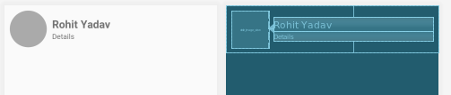

activity_main.xml

*<?***xml version="1.0" encoding="utf-8"***?>*<**RelativeLayout xmlns:android="http://schemas.android.com/apk/res/android"  
 xmlns:app="http://schemas.android.com/apk/res-auto"  
 xmlns:tools="http://schemas.android.com/tools"  
 android:layout_width="match_parent"  
 android:layout_height="match_parent"  
 tools:context=".MainActivity"**>  
  
 <**androidx.recyclerview.widget.RecyclerView  
 android:id="@+id/rv_category"  
 android:layout_width="match_parent"  
 android:layout_height="wrap_content"  
 tools:listitem="@layout/item_row_president"**/>  
  
</**RelativeLayout**>

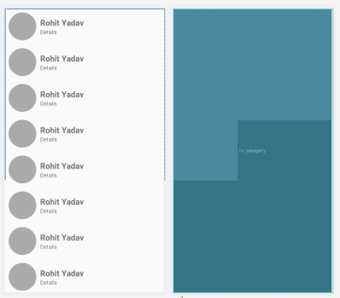

Example

Color.xml

<**color name="colorGreyText"**>#AAAAAA</**color**>  
<**color name="dividerColor"**>#9c888f92</**color**>  
<**color name="custom_progress_bg_color"**>#f5f6f7</**color**>  
  
*<!-- no internet colors -->*<**color name="no_internet"**>#a7a7a7</**color**>  
<**color name="no_internet_txt"**>#546066</**color**>  
<**color name="white"**>#FFFFFF</**color**>  
*<!-- no internet colors -->*

ripple_effect.xml

*<?***xml version="1.0" encoding="utf-8"***?>*<**selector xmlns:android="http://schemas.android.com/apk/res/android"**>  
 <**item android:state_pressed="true"**>  
 <**shape android:shape="rectangle"**>  
 <**solid android:color="@android:color/transparent"** />  
 </**shape**>  
 </**item**>  
 <**item**>  
 <**shape android:shape="rectangle"**>  
 <**solid android:color="@android:color/transparent"** />  
 </**shape**>  
 </**item**>  
</**selector**>  
  
*<!-- #6ee6e5e5 -->*

Activity_main.xml

*<?***xml version="1.0" encoding="utf-8"***?>*<**LinearLayout xmlns:android="http://schemas.android.com/apk/res/android"  
 xmlns:app="http://schemas.android.com/apk/res-auto"  
 android:id="@+id/mainLay"  
 android:layout_width="match_parent"  
 android:layout_height="wrap_content"  
 android:orientation="vertical"  
 android:foreground="@drawable/ripple_effect"  
 android:clickable="true"**>  
  
 <**RelativeLayout  
 android:layout_width="match_parent"  
 android:layout_height="wrap_content"  
 android:layout_marginBottom="12dp"  
 android:layout_marginTop="12dp"  
 android:clickable="false"**>  
  
 <**ImageView  
 android:id="@+id/item_image"  
 android:layout_width="50dp"  
 android:layout_height="50dp"  
 android:background="@color/colorPurple"  
 android:layout_alignParentLeft="true"  
 android:layout_centerVertical="true"  
 android:layout_marginLeft="8dp"** />  
  
 <**LinearLayout  
 android:layout_width="0dp"  
 android:layout_height="wrap_content"  
 android:layout_marginLeft="16dp"  
 android:layout_toLeftOf="@+id/right_arrow"  
 android:layout_toRightOf="@+id/item_image"  
 android:orientation="vertical"**>  
  
 <**TextView  
 android:id="@+id/item_title"  
 android:layout_width="wrap_content"  
 android:layout_height="wrap_content"  
 android:ellipsize="end"  
 android:lines="1"  
 android:text="Item Title"  
 android:maxLines="1"** />  
  
 <**TextView  
 android:id="@+id/item_des"  
 android:layout_width="wrap_content"  
 android:layout_height="wrap_content"  
 android:ellipsize="end"  
 android:lines="1"  
 android:maxLines="1"  
 android:text="Text"  
 android:textColor="@color/colorGreyText"** />  
  
 <**TextView  
 android:id="@+id/item_date"  
 android:layout_width="wrap_content"  
 android:layout_height="wrap_content"  
 android:layout_gravity="right"  
 android:text="24/03/2020"  
 android:textColor="@color/colorGreyText"** />  
  
 </**LinearLayout**>  
  
 <**ImageView  
 android:id="@+id/right_arrow"  
 android:layout_width="wrap_content"  
 android:layout_height="wrap_content"  
 android:layout_alignParentRight="true"  
 android:layout_centerVertical="true"  
 app:srcCompat="@drawable/ic_arrow_right"** />  
 </**RelativeLayout**>  
  
 <**View  
 android:layout_width="match_parent"  
 android:layout_height="0.5dp"  
 android:background="@color/dividerColor"  
 android:clickable="false"**/>  
</**LinearLayout**>

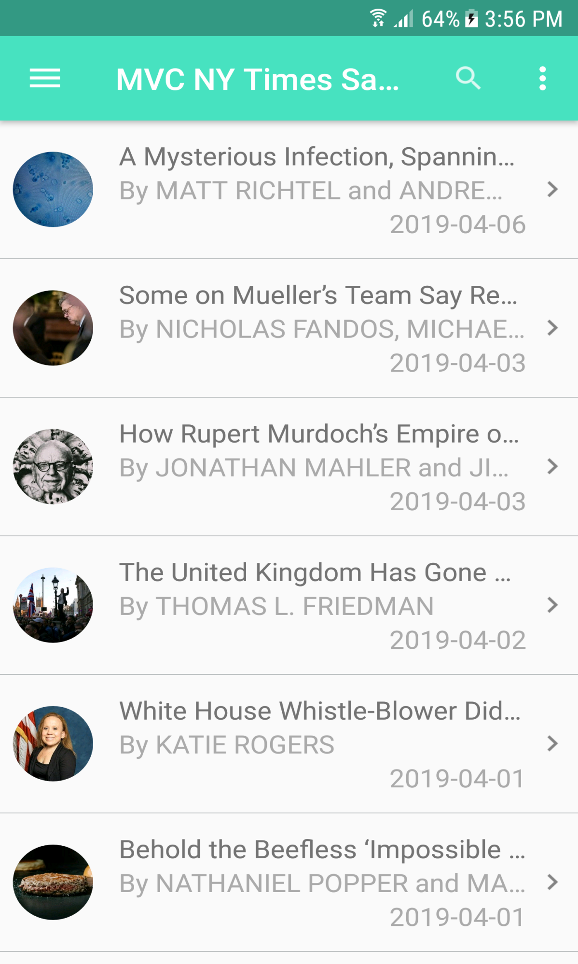

*<?***xml version="1.0" encoding="utf-8"***?>*<**LinearLayout xmlns:android="http://schemas.android.com/apk/res/android"  
 xmlns:app="http://schemas.android.com/apk/res-auto"  
 android:layout_width="match_parent"  
 android:layout_height="wrap_content"  
 android:background="#ffffff"  
 android:gravity="center_vertical"  
 android:orientation="horizontal"**>  
  
 <**ImageView  
 android:id="@+id/image"  
 android:layout_width="70dp"  
 android:layout_height="110dp"  
 android:layout_marginBottom="5dp"  
 android:layout_marginLeft="10dp"  
 android:layout_marginRight="8dp"  
 android:layout_marginTop="5dp"  
 app:srcCompat="@drawable/ic_launcher_background"**/>  
  
 <**LinearLayout  
 android:layout_width="0dp"  
 android:layout_height="wrap_content"  
 android:layout_marginLeft="6dp"  
 android:layout_weight="1"  
 android:orientation="vertical"**>  
  
 <**TextView  
 android:id="@+id/mv_name"  
 android:layout_width="wrap_content"  
 android:layout_height="wrap_content"  
 android:text="MOVIE NAME"  
 android:textColor="#000000"  
 android:textSize="15sp"** />  
  
 <**LinearLayout  
 android:layout_width="wrap_content"  
 android:layout_height="wrap_content"  
 android:orientation="horizontal"**>  
  
 <**TextView  
 android:layout_width="wrap_content"  
 android:layout_height="wrap_content"  
 android:text="RATE "  
 android:textColor="#55000000"  
 android:textSize="14sp"** />  
  
 <**TextView  
 android:id="@+id/tv_people"  
 android:layout_width="wrap_content"  
 android:layout_height="wrap_content"  
 android:text="9.0 "  
 android:textColor="#FFCE42"  
 android:textSize="18sp"** />  
  
 <**TextView  
 android:layout_width="wrap_content"  
 android:layout_height="wrap_content"  
 android:text=" | REVEIEW "  
 android:textColor="#55000000"  
 android:textSize="14sp"** />  
  
 <**TextView  
 android:id="@+id/tv_professional"  
 android:layout_width="wrap_content"  
 android:layout_height="wrap_content"  
 android:text="6.7"  
 android:textColor="#FFCE42"  
 android:textSize="18sp"** />  
 </**LinearLayout**>  
  
 <**TextView  
 android:id="@+id/mv_dec"  
 android:layout_width="wrap_content"  
 android:layout_height="wrap_content"  
 android:layout_marginTop="8dp"  
 android:text="Description"  
 android:textColor="#99000000"  
 android:textSize="11sp"** />  
  
 <**TextView  
 android:id="@+id/mv_date"  
 android:layout_width="wrap_content"  
 android:layout_height="wrap_content"  
 android:layout_marginTop="10dp"  
 android:text="20/03/2020"  
 android:textColor="#99000000"  
 android:textSize="11sp"** />  
 </**LinearLayout**>  
  
</**LinearLayout**>

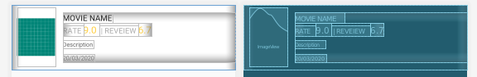

*<?***xml version="1.0" encoding="utf-8"***?>*<**LinearLayout xmlns:android="http://schemas.android.com/apk/res/android"  
 xmlns:app="http://schemas.android.com/apk/res-auto"  
 xmlns:tools="http://schemas.android.com/tools"  
 android:layout_width="match_parent"  
 android:layout_height="match_parent"  
 android:layout_gravity="center"  
 android:background="@android:color/darker_gray"  
 android:gravity="center"  
 tools:context=".MainActivity"**>  
  
 <**androidx.cardview.widget.CardView  
 xmlns:card_view="https://schemas.android.com/apk/res-auto"  
 android:id="@+id/card_view"  
 android:layout_marginTop="5dp"  
 android:layout_marginLeft="5dp"  
 android:layout_marginRight="5dp"  
 android:layout_gravity="center|top"  
 card_view:cardPreventCornerOverlap="false"  
 card_view:cardCornerRadius="20dp"  
 android:layout_width="match_parent"  
 android:layout_height="400dp"**>  
 </**androidx.cardview.widget.CardView**>  
</**LinearLayout**>

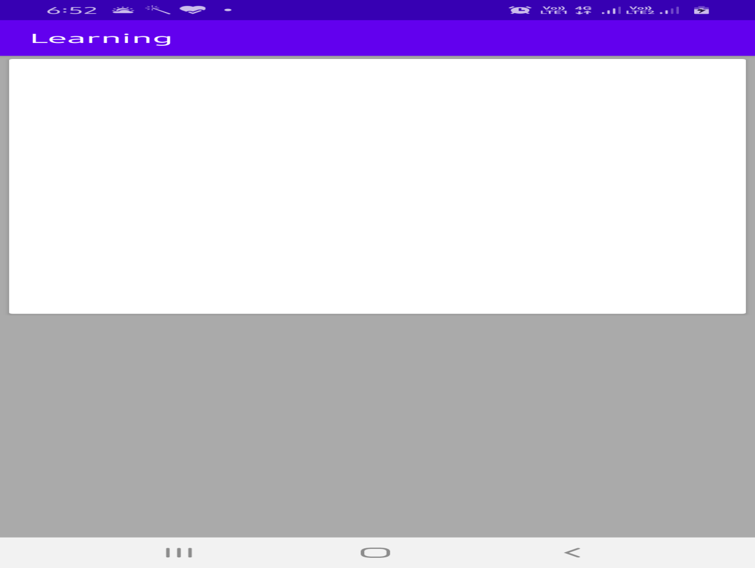

<**androidx.constraintlayout.widget.ConstraintLayout  
 android:layout_width="match_parent"  
 android:layout_height="wrap_content"  
 android:paddingLeft="@dimen/_8sdp"  
 android:paddingTop="@dimen/_16sdp"  
 android:paddingRight="@dimen/_8sdp"**>  
  
 <**androidx.cardview.widget.CardView  
 android:id="@+id/cardview"  
 android:layout_width="0dp"  
 android:layout_height="0dp"  
 android:layout_marginStart="@dimen/_80sdp"  
 android:layout_marginLeft="@dimen/_80sdp"  
 android:layout_marginTop="@dimen/_8sdp"  
 android:layout_marginEnd="@dimen/_16sdp"  
 android:layout_marginRight="@dimen/_16sdp"  
 android:layout_marginBottom="@dimen/_8sdp"  
 app:layout_constraintBottom_toBottomOf="parent"  
 app:layout_constraintLeft_toLeftOf="@+id/image_thumbnail"  
 app:layout_constraintRight_toRightOf="parent"  
 app:layout_constraintTop_toTopOf="parent"** />  
  
 <**ImageView  
 android:id="@+id/image_thumbnail"  
 android:layout_width="@dimen/_100sdp"  
 android:layout_height="@dimen/_100sdp"  
 android:layout_marginStart="@dimen/_8sdp"  
 android:layout_marginLeft="@dimen/_8sdp"  
 android:background="@android:color/darker_gray"  
 android:elevation="@dimen/_4sdp"  
 android:scaleType="centerCrop"  
 android:src="@drawable/h"  
 app:layout_constraintLeft_toLeftOf="parent"  
 app:layout_constraintTop_toTopOf="parent"** />  
  
 <**TextView  
 android:id="@+id/text_price"  
 android:layout_width="0dp"  
 android:layout_height="wrap_content"  
 android:layout_marginTop="@dimen/_8sdp"  
 android:layout_marginEnd="@dimen/_8sdp"  
 android:layout_marginRight="@dimen/_8sdp"  
 android:layout_marginBottom="@dimen/_8sdp"  
 android:gravity="end"  
 android:maxLines="1"  
 android:text="From £%1$.2f"  
 android:textAlignment="textEnd"  
 android:textAppearance="@style/TextAppearance.AppCompat.Body1"  
 android:textColor="@color/colorAccent"  
 android:textStyle="bold"  
 app:layout_constraintBottom_toBottomOf="parent"  
 app:layout_constraintLeft_toLeftOf="parent"  
 app:layout_constraintRight_toLeftOf="@+id/cardview"  
 app:layout_constraintTop_toBottomOf="@id/image_thumbnail"** />  
  
 <**TextView  
 android:id="@+id/text_name"  
 android:layout_width="0dp"  
 android:layout_height="wrap_content"  
 android:layout_margin="@dimen/_8sdp"  
 android:elevation="@dimen/_2sdp"  
 android:ellipsize="end"  
 android:maxLines="1"  
 android:text="Dummy Text"  
 android:textAppearance="@style/TextAppearance.AppCompat.Title"  
 app:layout_constraintLeft_toRightOf="@+id/image_thumbnail"  
 app:layout_constraintRight_toRightOf="@id/cardview"  
 app:layout_constraintTop_toTopOf="@id/cardview"** />  
  
 <**TextView  
 android:id="@+id/text_description"  
 android:layout_width="0dp"  
 android:layout_height="wrap_content"  
 android:layout_margin="@dimen/_8sdp"  
 android:elevation="@dimen/_2sdp"  
 android:ellipsize="end"  
 android:maxLines="3"  
 android:text="A handy Lorem Ipsum Generator that helps to create dummy text for all layout needs.A handy Lorem Ipsum Generator that helps to create dummy text for all layout needs.A handy Lorem Ipsum Generator that helps to create dummy text for all layout needs.A handy Lorem Ipsum Generator that helps to create dummy text for all layout needs.A handy Lorem Ipsum Generator that helps to create dummy text for all layout needs."  
 app:layout_constraintLeft_toRightOf="@+id/image_thumbnail"  
 app:layout_constraintRight_toLeftOf="@+id/button_ticket"  
 app:layout_constraintTop_toBottomOf="@+id/text_name"** />  
  
 <**ImageButton  
 android:id="@+id/button_ticket"  
 style="@style/Widget.AppCompat.Button.Colored"  
 android:layout_width="@dimen/_56sdp"  
 android:layout_height="wrap_content"  
 android:layout_marginBottom="@dimen/_8sdp"  
 android:elevation="@dimen/_4sdp"  
 android:src="@drawable/ic_local_play_white_24dp"  
 android:theme="@style/AppTheme.ColoredButtonOverlay"  
 app:layout_constraintBottom_toBottomOf="@id/cardview"  
 app:layout_constraintRight_toRightOf="parent"** />  
  
</**androidx.constraintlayout.widget.ConstraintLayout**>

